THE ECONOMICS OF ADULT ADOPTION IN JAPAN  
  
  
  
by  
  
MORRIS REEVES

Professor Steven Nafziger, Advisor

A thesis submitted in partial fulfillment  
of the requirements for the  
Degree of Bachelor of Arts with Honors  
in Economics  
  
  
  
  
  
WILLIAMS COLLEGE  
  
Williamstown, Massachusetts

MAY 9, 2018

**Acknowledgments**

I am grateful to my advisor, Professor Steven Nafziger, for his feedback and guidance throughout the research process, and for teaching me in his Economic History course. I would like to thank Professor William Gentry for his comments and suggestions as a second reader. I would also like to thank Professor Tara Watson, the Director of Research, for conducting the economics thesis program and providing clarity and structure to the research process. Finally, I am grateful to the Japanese and Asian Studies departments at Williams College for their support since my freshman year in enabling me to learn Japanese and critically explore topics on the history, political science, and culture of East Asia.

**Contents**

1. Introduction p. 3
2. Adult Adoption Rates in Contemporary Japan p. 11
3. Adoption and Adaptation in Japanese History p. 17
4. Comparative History of Adult Adoption p. 27
5. Conceptual Framework: Demand and Supply of Adult Adoption p. 36
6. Empirical Analysis p. 65
7. Conclusion p. 83
8. References p. 85
9. Appendix and Figures p. 90
10. Data Sources (for Section VI) p. 102

**I. Introduction**

Strikingly, over 35% of the 31,275 adoptions in Japan between January and April of 2010 were of adults, defined as those twenty years old or above.[1] In contrast, adult adoption is rarely used in the United States, comprising less than 1% of adoptions.[2] Why does Japan have an exceptionally high rate of adult adoption?

Anthropologists, legal scholars, and historians have long explored the institution of adult adoption in Japan from a cultural, legal, and historical perspective, tracing its extensive use as far back as the seventeenth century.[3] As a mechanism for altering family composition and, more formally, the number and identity of heirs, adult adoption comprises part of the broader literature on family structure and succession in Japan. Within the context of Japan, a prominent debate in this literature is the extent to which the stem or *ie* (literally, “house”) family structure, characterized by the married eldest son residing with his parents and eventually inheriting the family house, persists in postwar Japan, despite its *de jure* abolishment through the provision of equal succession in the 1948 Civil Code.[4] Two opposing viewpoints on the determinants of family structure in Japan include a cultural perspective, which posits family structure as a reflection of culture and tradition, and a “structural” perspective, which frames family structure as an adaptation to the contemporary socioeconomic environment.[5] Numerous news articles present adult adoption in Japan within the former perspective: adult adoption is ostensibly a “habit,” an “old tradition” for “carrying on the bloodline” with primarily “mercantile” reasons.[6] Further, many of these sources place an inordinate emphasis on a single motive for adult adoption, exemplified by an article that boldly, though incorrectly, claims in its title that “98% of all Japanese adoptions are employers adopting the adult men on their staff, not children.”[7]

The historical persistence of adult adoption in Japan belies the wide variation in the rate, motives, and composition of adult adoption across regions over time, warranting a greater emphasis on adult adoption as a means for pragmatic adaptation to economic conditions, consistent with the approach in Paulson (2010).[8] Indeed, the persistence of adult adoption in the face of changing social attitudes, urbanization, and rapid economic growth in postwar Japan raises the question of whether adult adoption has persisted in spite of, or because of, its purported traditionalism. Yet the study of adult adoption from a “structural” or economic perspective remains largely unexplored, and bears important implications across several fields in economics, including welfare provision, family firm management, and the taxation of intergenerational wealth transfers. This economic perspective is increasingly relevant as changes in the way heirs are taxed have taken place in Japan in recent years, including the 1988 Inheritance Tax Act and the 2013 Tax Reform, and as cases of fraud involving adult adoption have subjected the purpose of adult adoption to greater scrutiny.[9] Furthermore, Becker’s (1991) argument that the family becomes less connected as market and government mechanisms to “protect against the hazards of old age” expand and the earnings and employment opportunities of women grow presents an interesting set of hypotheses with which to test the role of adult adoption as a non-market mechanism for social insurance.[10]

Against this backdrop, this paper reassesses the frequency of adult adoption in Japan, reframes adult adoption as a mechanism for pragmatic socioeconomic adjustment within historically shaped preferences, and connects adult adoption with the literature on bequest motives. I refocus the debate over the reasons behind Japan’s high adult adoption rate into one centered around the adult adopter and adoptee who form and register their adoptive relationship through mutual consent: why do adopters in Japan adopt adults, and why do adult adoptees choose to be adopted? I approach the question from an economic perspective, not in the sense of focusing exclusively on the “material aspects of family life, to incomes and spending patterns,” but rather by consciously addressing the topic of adult adoption as “the behavior of different individuals…coordinated by explicit and implicit markets.”[11] The focus on characteristics unique to Japan in the existing literature on adult adoption begs the question, “What aspects of Japan, supplanted in other contexts, might give rise to similar adult adoption rates?” To examine the motives underlying the high adult adoption rate in Japan and how these motives have changed, I compare historical variation across countries and within Japan in factors that affect the demand and supply of adoption.

The implicit market for adult adoption is predicated on reciprocity between adoptive parent and adult adoptee: an understanding of adult adoption begins with a departure from the connotation of parental altruism and charity that adoption commonly carries in the United States.[12] The benefits to adult adoptees from adult adoption largely stem from the implicit or explicit assignment of claims to the adopter’s inheritance. A critical legal difference between Japan and the United States is that there is no legal provision specifying how much or to whom bequests are to be given in the United States; in contrast, the Japanese Civil Code guarantees a legal claim to a minimum share, termed a “statutory share,” of the bequest to each of the children and spouse of the deceased which they may sue for.[13] This is not to say that the incentives for adult adoption are therefore uniquely Japanese: the institutional and legal environment of adult adoption and the existence of an implicit market for adult adoption are not identical. The statutory share assigns a legal claim to a share of the bequest, not the actual share itself, and the majority of states in the United States allow some form of adult adoption.[14] That is, the assignment and receipt of claims to inheritance through adoptive relationships is a choice, not a given, and prospective adopters in the United States may adopt adults and leave bequests to these adult children if they so choose. The question that arises is why many prospective adopters and adoptees in Japan voluntarily enter adoptive relationships relative to the United States, a question that is intricately tied to the motives of the elderly in planning bequests.[15]

Adult adoption is closely related to the strength of the “strategic bequest” motive in Japan cited in the literature on bequests: adult adoption enables heads of households to strategically alter the division of their wealth among heirs.[16] As I will discuss in later sections, several studies note that the strategic bequest motive is stronger in Japan than in the U.S., where bequests tend to be divided more equally and are less conditional on the amount of care or attention provided by children.[17] By defining legal heirs, adult adoption serves a similar, though not identical, function to wills for potential adopters in Japan.[18] While heirs rely on informal, ex-ante assurances of bequests in the case of handwritten wills, which may or may not be realized due to legal invalidation or unexpected changes in the content of the will, adult adoption entails no such information asymmetry: adoptees are legally guaranteed the statutory share.[19] Consequently, adult adoption enables an immediate exchange of inheritance expectations in return for fulfillment of a particular role within the household, including but not limited to succession to family businesses and the provision of elderly care.[20] I argue that tradition is an indirect, not a direct motive for adult adoption: insofar as traditions shape expectations of family roles, including maintenance of family graves, elderly care, and family business succession, adult adoption may represent an implicit form of compensation.[21] Indeed, the frequent uneven division of bequests in Japan, even in the absence of a will or a living parent, noted by Hamaaki, Hori, and Murata (2016) may reflect an implicit acknowledgement among heirs of the validity of dividing bequests based on differences in the burden of these roles.[22]

However, since the most common procedure for dividing inherited assets in Japan is through negotiation among surviving family members, legal guarantees of the statutory portion of inheritance through bequests may only be necessary if the amount to be inherited is large enough to induce disagreement among heirs, in which case a legally binding claim would be particularly valuable when multiple heirs exist.[23] In this sense, the statutory share prescribed in the Civil Code of Japan simultaneously aids heads of households in strategically assigning legal rights to inheritance to adult adoptees, while theoretically restricting heads of households in non-statutory divisions of inheritance among existing heirs. Throughout this paper, then, it is important to note that, according to the law, the statutory shares take precedence over wills, but that in practice, wills and informal negotiations among heirs may take precedence over statutory shares if heirs do not demand their statutory shares. The practice of dividing estates through negotiation may amplify the role of social norms regarding family roles: “as unequal bequests are still accepted as the traditional norm by family members…inheritances in Japan are often allocated unevenly among children (through family negotiations among heirs), reflecting the values shared by the family.”[24] Nonetheless, the actual distribution of bequests in Japan is very similar to the statutory shares, indicating that the statutory shares serve as a reference for negotiations among heirs.[25]

Given these interlinked institutional and ostensibly social factors, such as the statutory share and the strategic bequest motive, my aim in this paper is therefore to elucidate how the institutional environment in Japan, namely the taxation of inheritance and the concept of statutory shares, shift the demand and supply of adoptions, but also to demonstrate that the willingness of prospective adopters and adoptees to exchange inheritance expectations for household services through adoptive relationships is *endogenous* to economic conditions. Doing so requires a frame of comparison: how the frequency and form of adult adoption has varied with differences in economic conditions associated with different times and places. Much of the existing English-language literature on adult adoption emphasizes an exogenous or dynastic role of adult adoption for the preservation of the family line or family business. Yet adult adoption is not restricted to the propagation of family ideals: rather, as described above, adult adoption may induce behavior in adoptees through the expectation of future bequests.

I divide my discussion of the economic basis of adult adoption into three broad categories. Firstly, by guaranteeing a portion of inheritance for those who might not otherwise have a claim to it, adult adoption may serve as implicit compensation for elderly care provision by relatives.[26] Secondly, adult adoption solves the tradeoff faced by retiring heads of family firms between preserving family control and maintaining managerial quality.[27] Thirdly, adult adoption enables heads of households to control the division of their wealth after death while reducing the inheritance tax liability faced by their children. Inter vivos transfers (gifts) hand partial control of wealth over to successors and are heavily taxed in Japan, while testamentary transfers (wills) are subject to inheritance tax. Adult adoption enables heads of households to retain their wealth while reducing inheritance taxes.[28] I argue that the high adult adoption rates in Japan relative to other countries are intricately linked to these three factors: a high rate of filial coresidence and elderly care provision within the family, a large proportion of the self-employed, and high inheritance taxes.[29]

I propose that the net decline in the adult adoption rate within Japan from approximately 67% in 1982 to 39% in 2010 (see Appendix, Figure I) is closely tied to changes in each of these same factors. Firstly, the percentage of estates subject to the inheritance tax declined in the 1990s, and a major tax change in 1988 limited the number of adoptees that count towards the basic deduction for the inheritance tax to up to two adoptees.[30] Secondly, the rate of filial co-residence has continued to decline while the number of elderly care homes and elders in elderly care homes has increased.[31] Finally, the rate of family firm succession has decreased since the 1980s, although this rate is expected to increase in the near future with the retirement of managers from the baby boom generation.[32]

In Section II, I begin by reassessing the frequency of adult adoption in contemporary Japan to correct misunderstandings commonly found in news and journal sources, and to capture changes in the postwar adult adoption rate based on available estimates. I then investigate the prewar, historical context of the practice of adoption in Japan in roughly chronological order in Section III. The history of adoption is indispensable to understanding the endogeneity of economic conditions and adult adoption, and for understanding why adoption in Japan is less singularly centered around the welfare of the adoptee, as in the United States.[33] In the first part of Section III, I explore the use of adult adoption as an heirship strategy among different socioeconomic groups, including samurai families, farmers, and merchants in Tokugawa Japan.[34] In the last part of Section III, I shift my focus to the role of adult adoption since the 1948 Civil Code of Japan. I highlight contemporary qualitative evidence, such as changes in tax laws and the prevalence of websites detailing tax savings from adoption, that suggest that the role of adoption in Japan is changing.

In Section IV, I then turn to the comparative legal history of adoption in Japan relative to the U.S. and Western European countries.[35] This serves two purposes. Since the legislation of adoption constitutes an “upper bound” that constrains the ways in which legally effected adoption can be used, an understanding of the legal context of adoption disentangles the legal feasibility of adoption from the economic desirability of adoption. Further, examining changes in adoption practices in other countries underscores that adult adoption cannot simply be explained by cultural constants: in fact, the intended beneficiary of adoption in the U.S. was originally the adopter, not the adoptee.[36]

Drawing from this historical context, I then present a conceptual framework for the market for adult adoption within three conceptual areas in Section V: elderly care provision, self-employment and business succession, and intergenerational wealth transfers. I explore the burden of elderly care provision and its relationship to filial co-residence in Japan. I describe how adult adoption is conceptually consistent with Bloom and Van Reenen’s (2007) research that links variation in the quality of management practices with productivity and profitability and underscores the role of the historical succession practices in the contemporary management of family firms. I also examine how differences in the taxation of estates in Japan relative to the U.S. incentivizes increasing the number of heirs through adult adoption.[37]

In Section VI, I explore whether the association between prefectural characteristics and prefectural adoption rates is consistent with the conceptual framework presented in Section V. The few existing empirical studies in the literature utilize variation in the incidence of adoption across time to infer parental motivations for adoption in Japan. For example, Moriguchi (2010) examines changes in parental motivations for child adoption over time. Similarly, Mehrotra et al. (2013) track family firm performance across time to assess the performance of family firms run by non-blood heirs. To the best of my knowledge, this is the first paper that utilizes prefectural variation in adoption rates within Japan to explore households’ economic motivations for adoption. I find that the number of self-employed elderly people per 10,000 people is positively and significantly associated with the adoption rate, although the result is no longer significant with the inclusion of regional fixed effects. I also find that the number of small employers per household is positively and significantly associated with the number of adoptions per household.

Section VII concludes by linking this paper with the existing literature and discussing avenues for future research.

**II. Adult Adoption Rates in Contemporary Japan**

*The Fluctuating Adult Adoption Rate in Postwar Japan*

Several English language sources cite the rate of adult adoption in Japan as 98% of all adoptions, or equivalently, the rate of child adoption as only 2% of all adoptions in Japan.[38] However, while the adult adoption rate is indeed high, survey evidence reveals that the adult adoption rate is not nearly as high as claimed. Adoptions in Japan consist of two categories: adoptions which require the permission of the family court (*katei saibansho)* and adoptions which do not. All cases of adoption require that the adopter have attained the age of majority. Further, adopters cannot adopt an ascendant or a person of greater age.[39] Yet while all adoptions which require the permission of the family court are adoptions of minors (below 20 years old), the converse is not true: not all adoptions of minors require the permission of the family court. Under Article 798 of the Civil Code of Japan, adoptions of lineal descendants of either the adoptive parent or the adoptive parent’s spouse do not require the permission of the family court, even if these lineal descendants are minors.[40]

The 98% figure commonly cited represents the proportion of all adoptions that do not require the permission of the family court, *not* the proportion of adult adoptions. While statistics on the composition of adoptions in Japan are scarce due to the privacy of *koseki* (family registry) records, existing data on the number of adoptions which require family court permission are available from the Supreme Court of Japan’s judicial statistics (司法統計), and data on the total number of adoptions are available from family registry statistics (戸籍統計). Data on the actual number of adult adoptions are available from surveys conducted in 1957 (Yamahata), 1982 (Tanaka and Miura), and 2010 (Ministry of Justice).

The most recent 2010 survey, conducted by the Ministry of Justice on a national level between January and April of 2010, reveals that 11,952, or approximately 38.2% of the 31,275 adoptions registered during this time window were of adults. International adoptions (adoptions of non-Japanese citizens) comprised only 537 cases, or 1.7% of the total. [41] Assuming that this short time window is representative of the annual adult adoption rate and given the fact that 98.7% of all adoptions in 2010 did not require the permission of the family court according to the family registry statistics, roughly 60.5% of adoptions in 2010 were adoptions of lineal descendants under 20 years old, 38.2% of adoptions were of adults (which includes both related and unrelated adoptees), and the remaining 1.3% were adoptions of related or unrelated minors who were not lineal descendants of either spouse. In the 1982 survey, 67% of adoptions were of adults.[42] In the 1957 survey by Yamahata, 52% of adoptions were of adults.[43] While Paulson (2010) provides estimates of adult adoption based on original surveys, the surveys were administered to college-age students from a non-random sample of regions in Japan, rendering the results unlikely to be representative of national adoption rates.[44]

From these figures, it is evident that while the proportion of adoptions of minors who are not lineal descendants of either spouse has apparently decreased throughout the postwar period, the proportion of adoptions of adults has fluctuated, presumably reaching a peak sometime in the 1980s (see Figure I). Similarly, the proportion of adoptions of lineal descendants of either spouse has fluctuated from a low in 1957 (among available data) to a high in 2010. It is important to note that the precise timing of these lows and highs is uncertain. However, by compiling estimates of adult adoption rates together with available data on family court and non-family court adoptions, I draw attention to the variability of the adult adoption rate in Japan during the postwar period to dispel the notion of a convergence of adult adoption towards 98% of all adoptions that is commonly cited in the literature.

*The Composition of Adult Adoptions*

Who adopts and who is adopted? Adult adoptions include both the adoption of adult lineal descendants (i.e. related adults), and unrelated adults. While data on national adoption rates are few and far between, Aihara and Nakagawa (1963) provide detailed statistics on the composition of adult adoption in the jurisdictions of Sapporo, Otaru, and Iwanai bureau offices in Hokkaido prefecture (in northern Japan) based on official family registry records between January and December of 1961.[45] Aihara and Nakagawa find that approximately 20% of adoptions in 1961 were of adults, which they note is lower than the national estimate of adult adoption of 52% in 1957 (as cited above).[46] The study consisted of two parts: a compilation of statistics from the legal affairs bureaus of Sapporo, Otaru, and Iwanai in 1961, and a survey administered in 1963 sent to the adopters and adoptees found in statistics from 1961. The authors preface their survey results by describing the low response rate to their survey, with 65 adopters and 70 adoptees responding to their survey (out of 306 cases of recorded adult adoptions in 1961), underscoring the empirical limitations posed by the private nature of adoptions. Nonetheless, their survey is immensely valuable in that it focuses exclusively on adult adoption and conveys both the varieties and motives of adult adoption from both the adopter and adoptee’s perspective in concrete terms. The statistics cited below (from the survey, unless specified otherwise) are intended to convey the mechanism of adult adoption and underscore the presence of economic motives, rather than to serve as nationally representative statistics on the composition of adult adoptions. Given that Hokkaido is a rural prefecture, the survey may overestimate the importance of the transmission of land and agricultural labor in the household.

As with marriage, adult adoption can be conceived of as a market consisting of a supply side (adoptees) and a demand side (adopters). On the demand (adopter’s) side, most adopters were between 40 to 69 years old, comprising 85.2% of those surveyed: 36% of those surveyed were between 60 to 69 years old, while 28% were between 50 and 59 years old. Adopters with spouses comprised 52% of the total, while elderly women without spouses comprised 38% of the total.[47] Regarding the employment status of adopters, 41% of adopters were employed in agriculture or commerce, while 25% of adopters were unemployed, of which 80% were elderly women without spouses. The importance of family business succession motives in adult adoption is reflected in fact that managers comprised 44.3% of all adopters.[48] However, adopters’ survey responses to the motives behind adult adoption indicate that family business succession is but one of many overlapping motives, which share the common theme of economic security in old age.[49] The motives for adoption are reproduced in English in full below:

*Adopters’ Motives for Adult Adoption (by Gender of Adoptee)[50]*

|  |  |  |  |
| --- | --- | --- | --- |
|  | Male Adoptee | Female Adoptee | Total (% of 61 respondents) |
| A. Since I have no children (or not enough) | 17 | 10 | **27 (44.3%)** |
| B. Since I have only daughters and no sons | 11 | 0 | 11 (18.0%) |
| C. To find a husband for my daughter | 14 | 0 | 14 (22.9%) |
| D. I want the adoptee to look after me in old age | 14 | 6 | **20 (32.8%)** |
| E. I want the adoptee to continue the family business | 8 | 0 | 8 (13.1%) |
| F. I want to hand over my property | 6 | 1 | 7 (11.5%) |
| G. Since I don’t want to end the *ie* (“family line”) | 17 | 4 | **21 (34.4%)** |
| H. I looked after the adoptee since he/she was young and I want to put him/her into my family register | 3 | 4 | 7 (11.5%) |
| I. Since there are no (or too few) workers | 7 | 1 | 8 (13.1%) |
| J. Since the adoptee is my spouse’s child | 4 | 5 | 9 (14.8%) |
| K. Other | 3 | 2 | 5 (8.2%) |

*Source: Aihara and Nakagawa (1963), Seinenyoshi no jittai (II),* *p. 106.*

From the motives above as well as the gender composition, it is apparent that the economic and ostensibly cultural reasons behind adult adoption are not mutually exclusive. The three dominant reported motives of seeking children, avoiding the termination of the family line, and seeking care in old age reflect the widely-held expectation that a (typically male) successor succeed to the family name, the family business, and the family property and care for the parents.[51] Notably, with the exception of elderly care (D), the adoption of those formerly under the care of the adopter (H) and the adoption of stepchildren (J), there is a clear preference for male adoptees even when the adopters have no children. In this context, Bachnik’s (1983) conception of the Japanese household (“*ie*”) as both a “socioreligious group, which includes the *ie* history and its ancestors” and a “group enterprise, including its property and its physical house” is particularly apt.[52] That is, from the adopter’s perspective, continuing the family line is not solely about the dynastic or “socioreligious” continuity of lineage or the provision of children for its own sake; rather, it appears that the recruitment of a successor through adult adoption is fundamentally a means of securing economic security in old age through the provision of elderly care and the maintenance of family property and, if applicable, the family business.[53]

The tendency to adopt those of known character within the family or residing in the same house further underscores adopters’ conception of adult adoption as a means for recruitment to the position of household head, since it suggests that adopters seek to avoid principal-agent problems associated with the entrustment of property, businesses, and the responsibility of elderly care. Of adoptions surveyed, 50.9% were within the family, of which nephews and nieces were the most frequent (21.3% of the total), followed by stepchildren (14.8%), grandchildren and other relatives (5%), siblings (3.2%), and cousins (1.6%). 47.5% of adoptions were outside of the family, of which a large portion were of sons-in-law (“*mukoyoshi*”). Further, nearly 46% of adoptions involved the adoptee residing with the adopter for over a year and 21.3% involved at least 1 month of coresidence, while roughly 26% of adoptions did not involve coresidence.[54] Most tellingly, when asked whether the system of adult adoption should be abolished and replaced with a contract specifying who will inherit the house and a contract specifying who will provide care in old age, the vast majority replied in the negative, with the three principal reasons being “I seek a reliable person who I’ve lived with to succeed the house,” “if I do not provide/care for an adoptee now, I cannot make them care for me in old age,” and “I am uneasy with having only a promise.”[55]

On the supply side, most adoptees were between 20-29 years old, comprising 70% of those surveyed. Most adoptions involved the adoption of a man (71.7%): 83.3% of male respondents (71.2% of all adoptees from the judicial bureau statistics) were non-first born children, while 64.6% of male respondents had more than 5 brothers or sisters. Most (91.2%) of adoptees from the judicial bureau statistics were legitimate children. In contrast to adopters employed in manufacturing and commerce, who tended to be managers, adoptees’ birth parents tended to be employees.[56] Finally, 84.6% of all adoptees from the judicial bureau statistics had at least one living parent.[57] The dominant reasons for becoming an adoptive child according to the survey were “so that the adoptive parent’s family line did not end,” “to provide elderly care since I am indebted to the adoptive parent(s),” and “to succeed to the adoptive parent’s family business,” although these survey responses may not reflect adoptees’ true motives, including a stable life and the inheritance of property, as Aihara and Nakagawa suggest.[58] However, it is noteworthy that 13.3% of respondents cited the reason that “since I have several siblings, I do not have to succeed the (birth) family business.”[59]

While caution is necessary when extrapolating from Aihara and Nakagawa’s findings (in 1963) to a national level or to contemporary Japan, the composition and stated motives of adult adoption reveal that adult adoption is interconnected with coresidence, social welfare, family businesses, and inheritance. Further, the survey suggests that adult adoption is partly driven on both the demand and supply side by the expectation that a single heir succeed the position of head of household, reflected in the fact that most adoptees surveyed were non-first born children with multiple siblings, the vast majority of adoptees had at least one surviving parent, and several adopters cited the continuation of the family line as a motive for adoption.

**III. Adoption and Adaptation in Japanese History**

The historical and legal literature in Japan indicates that even during the Tokugawa period, adult adoption was not solely motivated by its official purpose of continuing the family, but rather also motivated by economic factors including labor and enterprise expansion that bear similarities to practices today.[60] The 1898 Meiji Civil Code and the 1948 Civil Code largely preserved and even expanded the scope of these functions by reducing class barriers and keeping the purpose of adult adoption ambiguous, paving the way for the use of adult adoption for the legal benefits associated with parent-child relationships, including reducing inheritance taxes, in postwar Japan.[61]

*Tokugawa Japan: Adult Adoption and the Demand for Successors*

Adoption was officially recognized in Japan at least as early as the seventeenth century. Although its use and extent of regulation varied by class, existing studies suggest that adult adoption was commonly used. While data on early adoption rates are limited, the use of adoption among samurai families increased through the Tokugawa period, from nearly 26.1% of samurai families in the seventeenth century to 39.3% of samurai families in the 19th century, based on a sample of families from four *han* (Hikone, Kaga, Owari, and Sendai), which correspond to modern day Shiga, Ishikawa, Aichi, and Miyagi prefectures.[62] Similarly, among the peasant class, based on data from 1716-1869 in a small, poor village in modern day Fukushima prefecture, nearly 28% of adult males experienced adoption, the vast majority of which were adult adoptions.[63]

The official, valid reasons for adult adoption as specified in the “Civil Law Book of Personal Affairs Reasons” (*Minpo Soan Jinji-hen Riyu-sho*) included the continuation of ancestor worship, the continuation of powerful families to preserve the balance of power maintained by the government, and the maintenance of property and access to samurai stipends through a male heir.[64] Particularly among the samurai, adult adoption was an essential mechanism for reconciling the “ideal of lineal succession” with “demographic reality” within the Japanese stem family system.[65] However, the stem family system was not uniform in Japan in the Tokugawa period, and beyond the continuation of the family line, adult adoption enabled the recruitment of labor by farmers, poor merchants, and fishermen, and enabled the expansion of enterprises by wealthy merchants.[66] Indeed, conceptually, as Becker (1991) notes, kinship in traditional societies may be more important among middle-class and upper-class families, which serve as “small specialized schools that train graduates for particular occupations…and accept responsibility for certifying the qualifications of their graduates when qualifications are not readily ascertained.”[67] Therefore, while the prevalence of adult adoption in Japan during this period can be explained to a certain extent by the demographic constraints imposed by the stem family system (Kurosu, 1997) and the rigid class hierarchy under the Tokugawa government (Moore, 1970), it is likely that the prevalence of adult adoption was also due to its usefulness as a mechanism for adapting family structure to socioeconomic conditions. I discuss each of these explanations in turn.

The precise definition of the stem family in Japan is a subject of considerable debate, though there is a consensus that the stem family system is characterized by a single heir (usually the eldest son) remaining at home and succeeding the family while the other siblings leave home.[68] Anthropologists have described this system as a ‘4-P’ model of kinship organization: patriarchal, primogenital, patrilineal in that family descent is through the male line, and patrilocal in that the couple settles in the husband’s home.[69] However, Bachnik (1983) convincingly refutes this ‘4-P’ model by emphasizing the common exceptions to this ‘4-P’ rule. The stem family is not strictly patrilineal, as evidenced by the case of the daughter staying at home and marrying an adopted husband. Further, the stem family is not strictly characterized by primogeniture either, as in the case of adult adoptees succeeding the family line despite the existence of natural children.[70] Rather, Bachnik asserts that the stem family is better characterized as sustaining family continuity through recruitment to two permanent positions in each generation, one or both of which must come from outside of the family: the male household head, who succeeds to the property of the family, and his wife.[71] Bachnik identifies 5 household recruitment strategies for these two positions: male from the family/female from outside the family, female from the family/male from outside, adopted male from outside/female from outside, adopted female from outside/male from outside, and adopted male from outside/adopted female from outside.[72]

While a full discussion of the stem family is beyond the scope of this paper, it is evident that in families with more than one suitable successor, there is an excess supply of permanent members, and in families lacking a suitable successor, there is a strong demand for a permanent member to ensure family continuity. Adult adoption played an important role as a mechanism for redistributing “surplus” sons from families with multiple sons to families seeking successors.[73] It was mutually beneficial for samurai families to adopt out surplus sons to other samurai families even when the adopting family had lower income. Doing so reduced the adoptee family’s burden of supporting junior sons whose social prospects were otherwise slim, while ensuring the adopting family’s continued access to stipends through continued membership in the samurai class.[74] Without an heir, retiring heads of samurai families lost access to household income attached to serving the domain’s lord, the *daimyo*, as retainers.[75] The importance of adoption in securing continued access to stipends is exemplified in the practice among samurai of keeping a registration of adoption in case of unexpected death, to enable adoption after death through *niwaka-yoshi* (“lightning adoption”).[76]

The role of adoption in redistributing “surplus” sons into permanent positions in families in need of successors is also observed among peasants from 1716-1869 in Shimomoriya, a town in northeastern Japan, where 39.7% of all out-adoptions were among younger sons with older brothers, compared to only 16.6% among only children and 18.5% among eldest sons. Another consequence of the succession through the male household head in the stem family system was a high rate of son-in-law adoption. In Shimomoriya, among the three main types of adoption (ordinary adopted sons, sons-in-law, and adopted husbands), most adoptions were of sons-in-law (*mukoyoshi*). Evidence that in-adoptions (from outside the village) increased when the village population was in decline and decreased when the population was increasing further underscores the role of adoption in maintaining equilibrium in the ‘market’ for sons in pre-industrial Japan.[77]

Beyond these household-level family structures, the prevalence of adult adoption in Tokugawa Japan also reflects its broader sociopolitical compatibility with the class stratification structure under the Tokugawa government. Under the Tokugawa government, few restrictions were imposed upon heads of households’ adoption decisions, with the exception of the samurai class, which received stipends from the government. The samurai class was required to prioritize relatives, distant relatives, and unrelated persons of the same status, in that order, in the search for successors.[78] On an administrative level, historians have noted the role of adoption in Tokugawa Japan in ensuring the continuity of the samurai class and mitigating potential discontent from non-succeeding, elite non-first born sons.[79] Adopting samurai had to be the legal successor to the samurai stipend and could not already have a natural legal successor (unless this successor had been renounced); the adoptee was required to be of the samurai class.[80] Interestingly, a brief effort by Tokugawa officials to restore the requirement of blood relations between adopter and adoptee was quickly reversed, representing a tacit acknowledgment that the preservation of the elite samurai class was a greater priority than the biological lineage of individual households.[81] The sociopolitical importance of adult adoption is supported by the official reason of continuing powerful families to preserve the balance of power held by the government listed in the aforementioned “Civil Law Book of Personal Affairs Reasons.”[82]

Nonetheless, the relative lack of formal regulation of adoption outside of the samurai class represents one potential historical difference with the tradition in Roman law, which required the enactment of a specific law by an assembly, the *Comitia curiata*,for each case.[83] In Tokugawa Japan, adult adoption was also a mechanism for adapting family structure and size to socioeconomic conditions, underscored by the differences in the role of adoption among different social classes. For example, first sons of poor families in fishing villagers were occasionally adopted out to more wealthy merchants, fishermen, or inn-keepers. Similarly, in agricultural communities, families seeking more labor when the eldest child became an adult used the labor of the child’s wife or husband, compensating the couple by making them successors, a mechanism by adopters which also served to secure their elderly care in the future.[84] In fishing or agriculture, there were cases of boys raised to maturity in exchange for their eventual labor fishing or farming, which occasionally led to eventual adoption.[85] Finally, among merchants, adult adoption enabled the recruitment of sons to establish branch families to expand their enterprises.[86] These differences in the demand side of adoption share the common theme of recruiting household members to a defined role based not solely on custom or social norms, but also on the continuation of the economic foundation of the household.

To synthesize, the frequency of adult adoption in Tokugawa Japan cannot solely be explained as an outcome of a uniquely Japanese stem family “ideal” or a class hierarchy espoused by the Tokugawa government. Paulson (2010) cogently describes the multidimensional role of the family:

…at different times, among different classes, and with different emphasis, the family in Japan has been used for ancestor worship, for mutual aid and social security, for political and economic power, as social control, population management and political indoctrination, as a productive unit, a labor pool, for status differentiation, and as a means of retaining property intact.[87]

While the consideration of adult adoption solely for the provision of a successor concerned the upper-class samurai, whose stipends directly depended upon it, other classes had recourse to adult adoption as a means for permanent recruitment into the household-as-economic-unit, whether to labor, elderly care, and/or enterprise branch managers. It seems, then, that the relationship between the stem family and adoption must be reevaluated. The stem family is equally an “ideal” as it is a form of economic organization and social insurance, which compensates adoptees for their contributions to their adoptive family through their eventual claim to inheritance.[88] This theme persists in the Meiji period following the Tokugawa period and even to the present albeit to varying degrees.

*The Meiji Civil Code*

Legislation on adoption in Japan following the Tokugawa period can be broadly divided into two periods: the late 19th century, and the period of legislative revision under the influence of the U.S. following World War II.[89] In both periods, the government produced legislation not with the intent of codifying existing domestic legal principles, but rather to position Japan “in the context of western legal systems.”[90] Debate over family law provisions centered around the contrast between traditional conceptions of the family in Japan, and the emphasis on individual rights and obligations codified in western legal practice. In the late 19th century, Japan sought to remove extra-territoriality provisions in its treaties with western powers by referencing western legal systems in developing its Meiji Civil Code, which was enacted in 1898 only after significant debate over differences between English common law and the German and French codes.[91] In the second period of legislative revision after World War II, additional provisions aimed to protect the adoptee’s interests were included in the Civil Code by Japanese jurists under the consultation of foreign legal advisors, although Japanese jurists continued to conceive of the typical adoptee as an adult without the need for protective safeguards.[92] Importantly, as Bryant notes, “limitation of the institution of adoption as a bulwark of the house system was not perceived as a pressing goal.”[93]

*Adult Adoption in Postwar Japan: Tax Reforms and Tax Considerations*

One similarity between early and contemporary adult adoption practices is the use of adoption for family firm succession. Several prominent Japanese firms have made extensive use of adopted sons: Panasonic, Suzuki Motors, Taisho Pharmaceuticals, Matsui Securities, Toyota, Canon, and Kikkoman.[94] Fruin (1980) notes the role of adoption motivated by economic considerations in a case study of lineages and households associated with Kikkoman Shoyu Company Ltd., a Japanese soy sauce (shoyu) manufacturer. In one of six cases of adopted son-in-law marriage from the 17th to the 20th century, marriage and adoption coincided with “a household branching for the purpose of founding a new shoyu enterprise,” while in the other five cases, adopted son-in-law marriage functioned to preserve the continuity of family control in a shoyu enterprise.[95] In this context, adoption may have strengthened ties and facilitated the development of close business relationships between households.[96]

Nonetheless, the observation made by Hozumi (1912) that, “what is done in Europe and America by will is done in Japan by adoption,” suggests that the search for heirs is more nuanced than biological continuation of the family or demographic factors alone.[97] A natural consequence of the statutory share in the Japanese Civil Code is that changes in the taxation of inheritance taxes or gifts may exogenously affect changes in adoption practices, even if it may not affect other motives, such as the provision of elderly care and family business succession.

Recent newspaper articles and tax policy changes since the late 1980s suggest that one difference between pre- and postwar adult adoption practices in Japan is considerations regarding the maximization of intergenerational wealth transfers. One statistic cites that “about 40 percent of estates valued at more than 500 million yen after the deductions involve adoptions.”[98] According to an account by an adviser specializing in inheritance taxes, 10% of inquiries received are about lowering an individual’s tax burden through adoption. [99] Further, the Tokyo Regional Tax Bureau found a failure to pay enough inheritance tax in 98.5% of cases investigated at the end of 1988.[100] There are also numerous Japanese websites detailing possible tax savings from adoption (over 1 million results for “節税養子”(tax savings adoption) on Google as of December 2017). The history of transfer taxation in Japan is therefore relevant to household decisions pertaining to heirship.

The transfer tax in Japan, first established in 1905, was an estate tax until 1949: the properties of the decedent was the tax base. However, with the change in the transfer tax from an estate to an accession tax in 1950, the tax was imposed on the recipients of inherited properties, based on the cumulative value of the properties over the recipient’s lifetime.[101] In 1953, this cumulative taxation method was repealed and the accession tax was divided into a gift tax and an inheritance tax. Heirs were individually taxed based on the property received: the tax burden consequently depended on the distribution of wealth among heirs.[102] With the revision in 1958, the calculation of the inheritance tax was changed to be calculated based on the number of *statutory* heirs, rather than the distribution of wealth among nonstatutory or statutory heirs.[103] In Japanese civil law, statutory heirs (*houtei sozokunin*) refer to the legally prescribed successors whose statutory shares determine the inheritance tax liability; the composition and shares of these statutory heirs depends on three mutually exclusive priority groups: lineal descendants, lineal ascendants, and “lateral” relatives (the brothers and sisters of the decedent). If any higher priority groups are alive at the time of succession, those in the lower priority groups will not become a successor.[104] The later 1988 tax reform closed a loophole in this tax system by limiting the number of adoptees that can be used to calculate to up to two adoptees if the deceased does not have a biological child, and up to one if the deceased has a biological child.[105] Since 1988, the inheritance tax schedule has been adjusted several times, from a basic deduction of 50 million yen plus 10 million yen multiplied by the number of statutory heirs to 30 million yen plus 6 million yen multiplied by the number of statutory heirs in 2015 (see Appendix, Figure IV).

Since changes in inheritance taxation affect the possible tax savings from adopting additional statutory heirs, a purely demographic approach is insufficient in explaining changes in adult adoption rates. While these isolated observations may overemphasize the role of tax considerations in adult adoption in Japan, the Supreme Court’s decision that the intention to adopt a person can coexist with the motive of saving on taxes in a 2017 court case involving the adoption of a minor grandson by the head of a household near the end of his life suggests that these considerations will remain important in the future.[106]

While the preceding discussion underscores the historical continuity in the relationship between economic conditions and adult adoption practices, the question of what explains present and past differences in adult adoption rates *across countries* remains. Why do other countries, such as the U.S. and countries in Western Europe, not have a high rate of adult adoption today?

**IV. Comparative History of Adult Adoption:** Family, Succession and the Law

At first glance, an observer might conjecture that the common use of adult adoption relative to child adoption in Japan is simply an outcome of some cultural constant: perhaps kinship and family lineage have been and continue to be exceptionally important in Japan. There are several problems with this hypothesis. While the use of adult adoption in Japan may seem exceptional in the present day, a comparative history reveals that the institution of adult adoption is not unique to Japan. As early as the first century B.C., Cicero commented on legal incidents of adrogation, a form of adult adoption, in ancient Rome: “the age of the adopting party was never inquired into, as it was in the case of Gnaeus Aufidius and Marcus Pupius…these adoptions…were followed by the adopted party inheriting the name, the wealth, and the family rites of his adopter.”[107] In Roman law and European legal systems based on Roman law, as in Tokugawa Japan, the original, official purpose of adoption was to continue the family line.[108]

Moreover, in France and Germany, as in Rome, the original, primary purpose of adoption was to provide an heir as well. Under the German Civil Code of the turn of the nineteenth century, adults or minors could be adopted, provided that the adopting parent was at least 50 years old, was at least 18 years older than the child, and had no legitimate descendants.[109] Under the French Civil Code of the late 1800s, only adults could be adopted, and the adopter had to be older than 50: “Adoption can never take place before the adopted is of full age.”[110] Moreover, adult adoption was formally legalized and acknowledged prior to full child adoption in several Western European countries, including France (1804), Italy (1865), Germany (1900), and Sweden (1917).[111] Secondly, child adoption rates (measured as child adoptions per 1000 births) in Japan and the US were similar in the early 1950s, but declined in Japan thereafter: there were over 43,000 child adoptions in Japan in 1949.[112] Even in the case of the U.S., child adoption gained broad social acceptance only in the late 1940s.[113] Thirdly, these cultural constants do not capture the domestic variation in adult adoption rates within Japan geographically and across time (see Appendix, Figure IIc and III).

Rather than cultural constants, much of the cross-country differences in adoption practices are the result of an interplay between changing local economic conditions and social and legal norms regarding the boundaries of the family. Differences among countries in adult adoption rates in the present are partly a function of the legality of adult adoptions, and reflect path dependence in the legal history of adoption. While both European legal systems based on Roman law and Japan recognized adoption centuries ago, Anglo-American legal systems were much slower in recognizing legal adoption. England only legally recognized adoption in 1926 with the enactment of the Adoption of Children Act; before this Act, informal adoptions occurred, but adoptees lacked succession rights.[114]

England’s delayed legal recognition of adoption contributed to the delayed introduction of adoption statutes in the U.S., the earliest of which is believed to be that of Mississippi in 1846.[115] As a consequence, while the focus of informal adoption practices in pre-nineteenth century U.S. was the continuation of family lineage and the economic benefits to adoptive parents, adoption legislation coincided with the industrial revolution and social welfare reform.[116] According to one account, the heavy emphasis on the welfare of the child found in U.S. adoption practice is a “uniquely American contribution.”[117] Notably, however, when Sweden, France, England-Wales, and Italy successively recognized child adoption in the twentieth century, the emphasis and impetus similarly revolved around the protection and welfare of abandoned children and war orphans.[118] Nonetheless, in the case of all four countries and the U.S., the introduction or reintroduction of adoption law occurred in the nineteenth and twentieth centuries, after the advent of industrialization.

Therefore, the divergence of U.S. and Japanese adoption practices may stem partially from differences in the timing of legal changes: statutes on adoption coincided with social welfare reform associated with the industrial revolution in the U.S., but stretch back to preindustrial times in the case of Japan. These differences in timing affected the content and focus of adoption law, which affect economic motivations for adoption by changing the relative procedural costs of adult adoption relative to child adoption. While American law influenced Japan’s legislative revisions in the wake of World War II, the prominent role of mediation in dispute resolutions in Japan mitigated much of this effect, keeping the focus of adoption in Japan on the adopter.[119] This is because mediation through family courts, a prerequisite for litigation of disputes over the succession and the dissolution of adoptions, enables dispute resolution without reference to formal legal rules, dissipating potential “tension between Western and Japanese legal concepts.”[120] In contrast to Japan, where adopters have greater discretion and are not required to specify the reasons for adult adoption, several states in the U.S. restrict the adoption of adults, and adult adoption generally requires a petition and an adoption hearing in court.[121] For example, the Kansas Probate Code states that, “A petition for adult adoption shall state…the facts showing the reasons for the adoption.”[122] Similarly, the Louisiana Civil Code states that, “the court…may authorize the adoption of a person who has attained the age of majority if the court finds after a hearing that the adoption is in the best interest of both parties.”[123]

However, these legal differences and their historical legacy are proximate rather than ultimate causes for the use or nonuse of adoption: while legal statutes and past precedent certainly shape the feasibility of adult adoption, these legal statutes presumably must themselves have been shaped by the significance of adoptive arrangements in the family. One such explanation is that early adoption practices were shaped by conceptions of legitimacy and the importance of blood relations. The difference between Anglo-American legal systems and Japan in the timing of adoption legislation may reflect an emphasis on legitimate children and blood heirs in England, and the influence of England on U.S. jurisprudence. The Institutes of the Lawes of England, published in the early seventeenth century, specifies that, “by the common law he is only heire which succeedeth by right of blood,” in contrast to adrogation and early adoption practices in ancient Rome.[124] Similarly, the disappearance of adoption from many Western European legal systems from the early Middle Ages to the late eighteenth century is attributable to wariness of bringing strangers into the family, particularly out of fear of spoiling one’s lineage with “the illegitimate children of fallen women.”[125] The Catholic Church also shaped adoption practices by rejecting the adoption of illegitimate children, legitimate children, and adults, ostensibly to allow the Church to inherit the assets of those without heirs.[126]

In contrast, the conception of the household in Japan historically has not been restricted to blood ties: the continuity of a household was (and largely remains) conceived in terms of both its continuity as a group enterprise (with successors inheriting property and the duties of a successor) and its continuity as a kinship structure (with family ties).[127] One notable outcome of this flexible interpretation of the household is the frequency of instances of adopted sons superseding biological sons in household headship in Japan; estimates from postwar ethnographic studies range from 25-34% of families studied.[128]

In this sense, social norms regarding the inclusion of non-relatives into the family have an important economic dimension, since they define the criteria for membership in the household-as-group-enterprise. The North-South gradient in child adoption rates in Western Europe noted by Mignot (2018) has striking similarities with accounts of the historical role of adoption in agricultural families cited by Hayami and Satomi (2009) and Paulson (2010), and with the distribution of coresidence in Japan described by Kato (2013). For most of the twentieth century, the child adoption rate in Sweden and England-Wales exceeded that of Germany, which in turn exceeded that of France and Italy, despite the lack of any particularly strong linguistic, legal or religious similarity between Sweden and England-Wales.[129] The source of this North-South gradient is associated with historical differences in the openness of households to bringing in servants: while most agricultural households in the north took in adolescents from other families as “life-cycle servants” from the 16th to 19th centuries, fewer agricultural households in the south did so, and for a shorter duration. Consequently, northern households were ostensibly more comfortable with the inclusion of non-kin members.[130]

The distribution of patrilocal coresidence and family size across Japan exhibits a similar North(east)-South(west) gradient, lending credence to the association between the economic role of household members and family structure implied by Mignot (2018). According to 2001 data from the NFRJ-S01 (the 2001 National Family Research of Japan Special Survey), patrilocal co-residence upon marriage was twice as likely among residents in Tohoku/Northern Kanto (North East Japan) and Chubu (Central East Japan) than in Southern Kanto (near Tokyo), and even less likely in Kinki (Central West Japan).[131] Historical data suggest that these patterns have persisted since at least the early Meiji period. In 1886, the average number of people per household and the number of couples per household in the northeast was highest in the northeastern region and lower in the southwestern region, despite the fact that the fertility rate in the northeast was lower than both the central and southwestern regions.[132] Similarly, from 1946 to 1955, the average number of people per household for farm households was higher in the northeast than in the southwest.[133] This finding is consistent with the historical prevalence of a single-household stem family structure in the northeast and a nuclear or multi-household stem family in the southwest.[134] As Kato (2013) notes:

It is very interesting that [the NFRJ-S01] figures correspond to the family regionality elucidated by sociologists and anthropologists who had investigated rural families and village – that is, two types of the stem family in Japan: the North Eastern type and the South Western type.[135]

Analogous to Mignot’s theory of life-cycle servants in Western Europe, historical evidence suggests that these regional differences in intergenerational coresidence are shaped by historical differences in family and migrant labor.

In pre-industrial Japan during the Tokugawa period, small-scale agriculture based on family labor and independent small farmers became more common relative to the large-scale farms and subordinate labor of the pre-Tokugawa period.[136] In the northeast of Japan, where agricultural families faced difficult natural conditions and sought to avoid economic crisis by maintaining a high proportion of working-age relative to total household members, households often adopted son-in-law or sons to maintain households, the age at first marriage was quite early, and births per couple were relatively low. The population in this region was sustained through the inflow of servants and spouses from surrounding areas with growing populations, consistent with the finding of Kurosu (1970) of population balancing through in-adoptions in Shimomoriya.[137] Moreover, a distinctive practice of the northeast, *dekasegi,* involved leaving to work away from home for long periods after marriage, which, in addition to evidence of sex-selective infanticide in the northeast, likely dampened the birth rate.[138] In contrast, in the southwest of Japan, where families faced more favorable natural conditions, few left for cities on service, and sex-selective infanticide was less prominent.[139] Finally, in the comparatively urbanized central region of Japan, the early migration of less affluent villagers to nearby cities and towns contributed to their later marriage and led to an imbalance between the demand and supply of children between more and less affluent villagers who exhibited different rates of migration. This imbalance was partially resolved through adoptions from wealthy families with “excess” children.[140]

These geographical comparisons provide several insights into the factors that influence the demand and supply of adult adoptions. On the one hand, the demand and supply of adoption are directly constrained by laws in place and historical precedent. Yet within these legal bounds, the demand for adult adoption (as well as family structure) is influenced by the extent to which the household depends upon working age members within the household to be economically self-sufficient across the head of household’s lifetime, which is a function of occupation, geographic conditions, and, as to be discussed later, social welfare. As noted in the prior section, in Tokugawa Japan, several agricultural families seeking labor employed the labor of the eldest child’s wife or husband, compensating the couple through bequests; in fishing and agriculture, several families raised boys to maturity in exchange for their eventual labor fishing or farming, occasionally resulting in adoption.[141] Further, while a history of migration may increase the demand for adoption *ceteris parabus* by altering social norms regarding non-kin members within the household, as Mignot suggests, the account of central Japan above provided by Hayami and Kurosu (2009) indicates that out-migration may also dampen the supply of potential adoptees.[142] On the supply side, the survey of Aihara and Nakagawa (1963) described in the previous section suggests that adoptees enter adoptions based on opportunity cost. The fact that 83.3% of male adoptees (who responded to the survey) were non-first born children, 64.6% of male adoptees had more than 5 brothers or sisters, many adoptees’ parents in agriculture and commerce were employees while many adopters in the same industries were managers, and 34% of adopters adopt to continue the family line strongly implies that adoptees seek the socioeconomic ascension associated with heirship.[143]

While this discussion has presented a conceptual relationship between coresidence, adoption, and the economic role of household members, a prominent question that remains is the distinction between household membership and adoption. Given that household heads may choose to bring working age members into the physical household for assistance with agricultural or other family-based labor, why would they formally choose to bring them into their family through adoption? Historically, in the case of samurai, for whom heirship was directly tied to status, the answer is clear: to ensure continued access to stipends, as already described. More broadly, part of the reason conceivably lies in the intrinsic value many household heads place on the continuation of the family line, independent of any implied economic incentive: approximately 44% of the adopters surveyed by Aihara and Nakagawa listed the continuation of the family line as their only motive for adult adoption.[144] This is consistent with the “dynasty model,” in which individuals primarily care about the “perpetuation of the family line or the family business,” rather than themselves or their children.[145] However, it is improbable that rational heads of households neglect their own material wellbeing in old age; that is, the “dynasty model” does not tell the full story. Indeed, survey data from the Preference Parameters Study of Osaka University from 2003 to 2013 suggests that the pure dynastic motive in Japan is not nearly as strong as implied by news articles on adult adoption: the proportion of Japanese respondents planning to leave an inheritance to their child(ren) “only if they carry on the family business” was 1.06%, the second lowest among countries surveyed, relative to China (7.50%), India (2.38%), and the U.S. (0.26%).[146]

Rather, the key distinction between simple presence in the household and adoption is inheritance, which (in the case of postwar Japan) not only entails tax benefits to increasing the number of heirs, as discussed in the following section, but also allows heads of households to incentivize prospective heirs to provide services (such as elderly care and the management of family businesses) that provide economic stability for adopters in old age.[147] This inheritance can be conceived of as the ex post price at which heads of households secure economic security and attention in old age, above and beyond what their descendants might “naturally” provide through altruism or social norms.[148]

*Summary: Adult Adoption as Adaptation to Economic Conditions*

The prevalence of adult adoptions in Japan is partly shaped by an interaction between social and legal norms, as Bryant (1990) argues. The historical and legal literature on adult adoption indicates that adult adoption and succession planning has an important economic dimension, including succession among the samurai, whose stipends directly depended on securing an heir, and the search for labor, elderly care, and/or enterprise branch managers among other classes. While Japanese legislation on adoption in the Meiji and postwar period was influenced by European and U.S. legal codes, the emphasis of adult adoption on its benefits for households and household heads remained unchanged, and even expanded: early postwar adoption rates indicate that adult adoption rates were as high as 52% as early as 1957.[149] However, the extent to which adult adoption continues to act as a mechanism for socioeconomic adjustment and the extent to which this mechanism explains variation within Japan in rates of adoption remains an unexplored area, and presents an opportunity to transcend arguments emphasizing an ostensibly timeless stem family “ideal” in Japan. I now consider a conceptual framework of the market for adoption, based on the observation in this section that adult adoption was formerly the main form of adoption in several Western European countries, and that the rate of adult adoption in Japan appears to have declined since the early 1980s.

**V. Conceptual Framework:** The Demand and Supply of Adult Adoption

From the comparative history of adult adoption within Japan and across countries, it is apparent that family structure is endogenous, not exogenous to socioeconomic conditions. Adult adoption is not historically unique to Japan, nor has the significance of adoption been equivalent across regions or even across social classes within Japan. This section will expand upon this theme by demonstrating that the importance of adult adoption depends upon the role of a successor in the family, which is a function of the importance of family production, geographic conditions, social welfare, inheritance taxation, and social norms.[150]

I examine the economic basis of adult adoption in postwar Japan by considering three aspects inextricable from the role of the successor: elderly care, enterprise succession, and inheritance tax reduction.[151] By connecting adult adoption to the literature on demographic and social change in postwar Japan and in the U.S., Japan’s high adult adoption rate can be explained by distinct characteristics of Japan’s economy in each of these three areas, which reflect the rapidity of its postwar economic growth and demographic transition.[152] I conjecture that the apparent paradox between the decline in adult adoptions since the 1980s in Japan and Japan’s increasingly elderly population (which might be expected to increase the demand for adult adoption) primarily reflects a fall in supply resulting from the rising opportunity costs of intergenerational coresidence faced by potential adoptees, including regular company employment and changing social norms.[153] On the demand side, increases in social welfare provision and the 1988 inheritance tax reform likely dampened the demand for adult adoption.[154]

A common theme throughout the literature on family arrangements in Japan is that social norms and expectations are a lagged reflection of socioeconomic conditions, and that family arrangements (including adult adoption) are a compromise between externally or self-imposed conceptions of the obligations associated with successorship, and personal economic circumstances.[155] A conceptual framework linking adult adoption (from the perspective of the adopter) and each of the aforementioned three aspects of successorship is presented in the figure below.[156] The three aspects are among the adoptive motives cited by adopters themselves, categorized by Aihara and Nakagawa (1963) based on survey data from Hokkaido prefecture.[157]



The figure outlines the relevance of each of these motives from the perspective of an adopter, depending on the existence of an heir and the existence of an enterprise successor, if the adopter owns an enterprise. For example, when an heir exists *and* an enterprise successor exists, tax reduction is likely to be a particularly relevant motive for adult adoption. On the other hand, when an heir does not exist, elderly care is likely to be a driving motive.[158] I deliberately define “enterprise” broadly to include both the work of the self-employed, such as farming and shopkeeping often staffed within the family, and incorporated businesses consisting of employees. The role of adult adoption in the latter category has been documented by Mehrotra et al. (2013), but a discussion of the former category is noticeably absent from the literature on adult adoption. Another note relating to the figure is that heirs and enterprise successors are distinct but potentially overlapping roles: enterprise successors are often heirs, but heirs may not be enterprise successors if, for example, they lack the necessary qualifications, or if they do not wish to follow the same occupation as their ascendants.[159] Further, the three motives are not mutually exclusive: for example, an adopted enterprise successor may also be expected to provide elderly care, or to marry such that elderly care is provided by the spouse.[160] Similarly, if an heir already exists but does not reside near the adopter, then an additional heir may be expected to provide elderly care, while reducing the collective inheritance tax faced by the heirs.

*Elderly Care: Social Expectations and Socioeconomic Circumstances*

As a mechanism for bringing working-age members into the family, adult adoption is naturally sensitive to the role of adult children with respect to their parents. This role is shaped by social norms and economic conditions, and is reflected in living arrangements. Recalling Aihara and Nakagawa’s survey data, coresidence is conceived of as both a screening mechanism for adopters to evaluate adoptees, but also a necessary arrangement if adoptees are to provide elderly care for their adoptive parents: 46% of adoptions involved the adoptee residing with the adopter for over a year, and 32.8% of adopters cited, “I want the adoptee to look after me in old age” as a motive for adult adoption.[161] This section demonstrates that coresidence rates and bequest behavior in Japan coincide with a strong parental demand for filial elderly care, which fuels the demand for adult adoption. Filial provision of elderly care is a compromise between social expectations and the economic opportunities available to the elderly and their children.[162]

The proportion of people aged 65 and over living with their children (referred to more broadly as “coresidence” throughout) is strikingly high in Japan relative to other countries, although this proportion has declined throughout the postwar period, as evident in the figure constructed by Yamashige (2013), reproduced in English below:

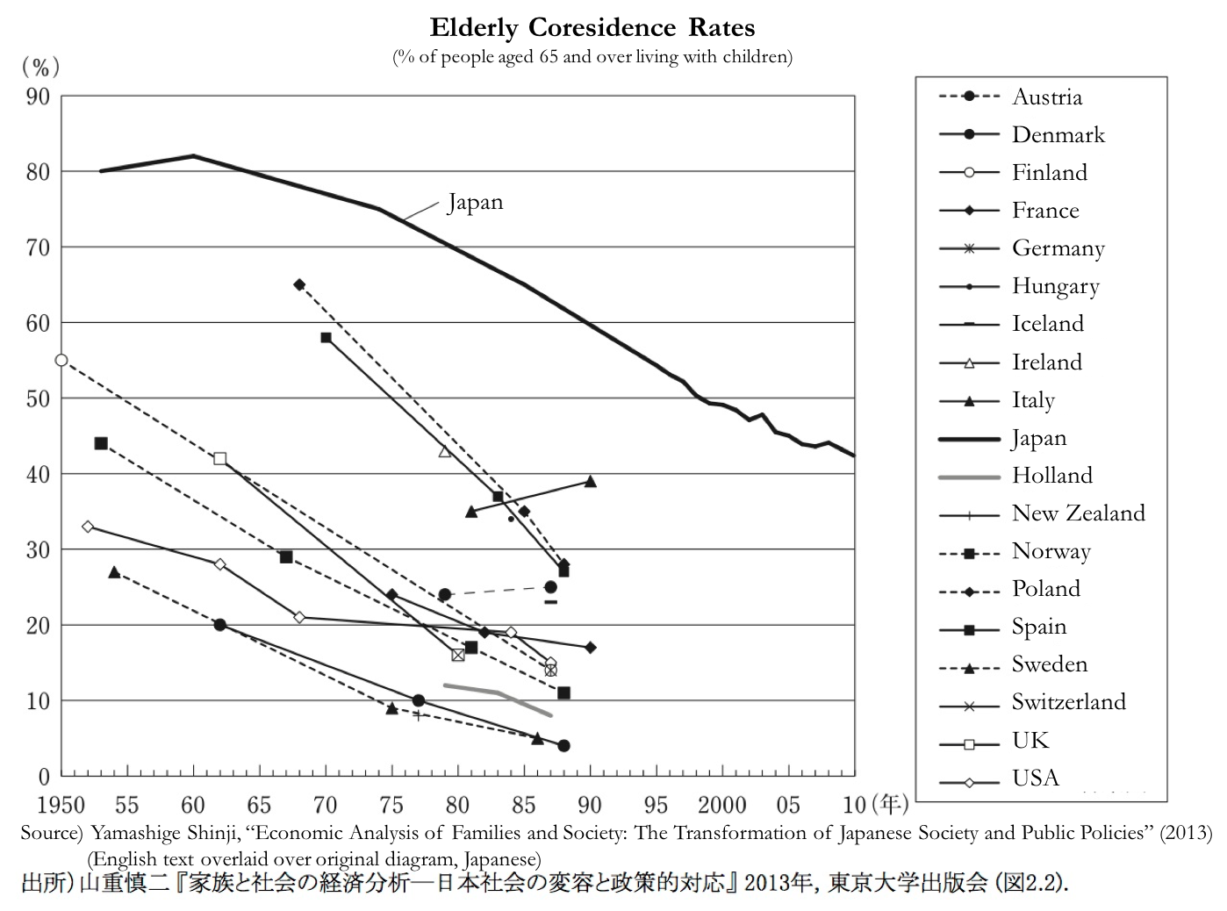

In the early 1950s, the rate of elderly coresidence in Japan was as high as 80%, relative to less than 35% in the United States. By the end of the twentieth century, the rate declined to less than 50% in Japan, and less than 15% in the United States.[163] More recently, in 2009, the rate of elderly coresidence in Japan was 43%.[164] What explains the persistence of an ostensibly “traditional” family pattern in contemporary Japan?

As with adult adoption, high rates of elderly coresidence have not been historically unique to Japan: Ruggles (2007) documents that the rate of elderly coresidence was as high as 70% in the United States in the mid-19th century.[165] Furthermore, almost all countries in the figure above, including Japan, experienced a downward trend in coresidence throughout the postwar period. This historical pattern implies that filial piety and the Confucian ideal are insufficient explanations for high coresidence in Japan: as Takagi and Silverstein (2011) note, “filial piety has become more of a guide than a rule, and arguably more of a commodity than an ideology in Japanese society.”[166] From a methodological perspective, it is consequently necessary to separate elderly care provided altruistically based on social norms alone, and elderly care that is economically rational from the perspective of both parties, particularly when caregivers are compensated through unevenly divided inheritance.[167] In this context, a far more feasible explanation for coresidence in Japan is that norms, economic conditions, and coresidence are codetermined: changes in the material conditions of the elderly and their adult children alter their living arrangements, which result in a gradual, lagged change in social norms.[168]

According to Ruggles (2007), two theoretical perspectives on the dynamic relationship between coresidence and economic conditions are the “affluence hypothesis” and the “economic development hypothesis.” The affluence hypothesis states that intergenerational coresidence declines as the incomes of the aged rise, which allows the elderly to pay for independent residence from their children: ostensibly, the aged only live with their children out of necessity, if they become (or are) impoverished or infirm.[169] In contrast, the economic development hypothesis states that increases in wage-labor opportunities outside of the household reduces the importance (and value) of inheriting the occupation and property of elderly parents, inducing adult children to live independently.[170] Historical evidence in the United States and more recent evidence in Japan contradict the affluence hypothesis. In nineteenth century America, independent residence was “concentrated among the infirm and the impoverished,” and the elderly remained in their own homes in most cases: few intergenerational households were formed through elderly parents moving in to the residence of their children.[171] Recent studies provide stronger support for the economic development hypothesis. In contemporary Japan, using a nationally representative sample of older parents in 1999, Takagi and Silverstein (2011) find that elderly parents who were affluent relative to their children tended to “purchase piety,” not privacy. Married children with relatively affluent parents tended to reside with their parents in parent-headed households, and less-educated children tended to reside with their higher-income parents.[172] Similarly, Yashiro (1996) finds that the probability of children coresiding with their parents declines in the children’s income.[173] Coresidence, and with it, expectations of elderly care and the demand and supply for adult adoption, are a function of the relative wealth of parents and the opportunities available to their children.

The implication of the economic development hypothesis is that the burden of elderly care shifts from adult children to businesses, unions, the state, private sector organizations, and the elderly themselves as a society transitions from an agrarian to an urban-industrial society.[174] One explanation is that during this transition, the old-age dependency ratio rises as the population undergoes a demographic transition in which both birth and death rates fall, inducing adult children to seek to reduce the burden of elderly care.[175] Beyond this demographic explanation, from a socioeconomic perspective, as production becomes less family-based and labor becomes more mobile, the economic basis of parental authority erodes.[176] Becker (1991) describes this evolution of the family from “traditional societies” to “modern societies” in a manner consistent with the economic development hypothesis. In more stationary, “traditional” societies with limited information, the family insures members against uncertainty.[177] Children learn their economic roles by working with their parents, whose economic and social basis for authority is substantiated by their accumulated knowledge and experience.[178] In this setting, coresidence makes both “economic and social sense” and solves information asymmetries: the family is analogous to a school, which trains children for certain occupations and “[certifies] the qualifications of their graduates when qualifications are not readily ascertained.”[179] An example of such a setting is the U.S. in 1850, when 60% of the population lived on farms, and both commercial manufacturing and the service sector were characterized by household production. Adult children aided their parents in old age in exchange for inherited property and a lifetime occupation.[180] With the rise of wage labor, mass education, and increases in the earning power of adult children, adult children were no longer dependent on this intergenerational contract, resulting in a decline in coresidence.[181]

A discussion of the economic development hypothesis is notably absent from the existing literature on adult adoption, and raises doubts about the uniqueness of the Japanese context. For example, the well-cited paper by Mehrotra et al. (2013) claims that, “Japan unquestionably has a unique concept of adoption” and that “adoption as a form of succession is a uniquely Japanese practice and may differentiate its family businesses fundamentally from those elsewhere.”[182] Yet the similarity in coresidence rates between the US of the mid-19th century and Japan of the 1980s and the fact that adult adoption was formally legalized prior to child adoption in several Western European countries, including France (1804), Italy (1865), Germany (1900), as noted above, strongly suggests that adult adoption must be reevaluated in terms of the economic development hypothesis.[183] Indeed, Frédéric Le Play’s account of the stem family in 1872 is strikingly similar to the ostensibly timeless and “uniquely Japanese” succession practices and family structure in postwar Japan: in Le Play’s definition of the stem family, the father “selected one child to remain near the parental homestead to work on the farm and eventually inherit it, thus continuing the family line.”[184] If adult adoption is driven by the demand for coresident successors to succeed family businesses and provide elderly care for elderly parents, high adult adoption rates would be expected to be associated with macroeconomic features consistent with “traditional societies.” I first describe the relationship between elderly care provision and family business succession before returning to this point.

The decline in coresidence rates in Japan throughout the postwar period and in adult adoption rates since the 1980s is consistent with the narrative of the economic development hypothesis. The persistence of a relatively high rate of adult adoption in contemporary Japan parallels the lag between socioeconomic conditions and family change (including coresidence and expectations of elderly care) cited by several scholars, including Ruggles (2007), Ogawa and Retherford (1993), and Takagi and Silverstein (2011): “cultural inertia [operates] as a brake on changes in family behavior, keeping generations together even after the material basis for coresidence had vanished.”[185] Nonetheless, as with the economic development hypothesis, a feature underemphasized in the English language literature on adult adoption is the *interdependence* of elderly care and family firm (or farm) succession.[186] In the context of the U.S., Ruggles (2007) argues that the establishment of the Social Security program ostensibly had little impact on family structure relative to the increased earning power of adult children: economic development rendered the labor provided by adult children unnecessary from the perspective of their elderly parents.[187] However, as Aihara and Nakagawa (1963) suggest, elderly parents likely seek the continuation of the family business or family line and the labor of their adult children not for its own sake, but rather for the economic stability that family business continuity provides in old age.[188] Consequently, in the exchange of care in old age for inherited property and a lifetime occupation implicit in the “traditional society” of the economic development hypothesis, “care” must be defined broadly to encompass not just nursing services but also the economic stability provided by the income of children.

Conceivably, filial elderly care, as defined above to encompass both nursing services and economic stability provided by adult children, is particularly important when life expectancy is uncertain and public pension benefits are low. The proportion of the institutionalized elderly (above age 65) was roughly 5% in the U.S. in 1987, relative to only 1.6% in Japan in 1985, while the proportion of the elderly above 60 years old living in three-generation households in 1990 was roughly 1% in the U.S. relative to 32% in Japan.[189] In such a context, the family acts as an incomplete annuities market, and the exchange of inheritance for elderly care can be conceived of as “implicit insurance contracts”: by sharing consumption resources with their children, aging parents can insure against running out of consumption resources due to uncertainty over their longevity.[190] This uncertainty is highly applicable to postwar Japan, which experienced life expectancies rapidly rising from 54 to 82 years for females and 50 to 76 years for males from 1947 to 1990.[191] Another indication of the importance of the “implicit insurance contract” is asymmetric rates of spousal coresidence: in 1990, 42% of elderly women lived with their husbands, while 85% of elderly men lived with their wives.[192] Yet another is the high labor force participation among elderly Japanese. As Raymo et al. (2004) explain, “Because self-employed workers are eligible only for the relatively limited benefits provided by the basic public pension plan (*kokumin nenkin*), economic necessity is presumably another important reason for higher levels of labor force attachment among the self-employed.”[193] Apart from low public pension benefit levels, low job flexibility is another possible explanation for the high labor force participation of elderly self-employed Japanese.[194] With limited sources of insurance outside of the household coupled with rapidly increasing life expectancies, it is conceivable that the provision of care within the family has heightened importance.

The economic development hypothesis suggests that the demand for successors (and with it, the demand for an adult adoption) depends on the demand for filial elderly care (including nursing services and economic support in old age), which in turn depends on the degree of social welfare provision and the importance of family-based production. The high coresidence rates and adult adoption rates in postwar Japan are driven by a strong demand for successors, challenging the common assumption that the “selfish life-cycle” (or strategic motive) and the “dynastic motive” are independent.[195] Even if individuals are hypothetically assumed to be completely selfish and care only about themselves, ensuring the perpetuation of the family business or family line may provide economic stability in old age in the absence of alternative sources.

If adult adoption is driven by the demand for coresident successors, high adult adoption rates would be expected to be associated with the importance of family-based production characteristic of the “traditional society” described by Becker. By comparing this “traditional society” to postwar Japan, my intention is not to characterize postwar Japan in normative terms as an anachronistic society; rather, by bringing attention to the significant differences in the economic role of family members in early postwar Japan and the United States, I refute the notion that the importance of a successor (to the property and occupation of parents and to the responsibility of elderly care) is a uniquely Japanese phenomenon, and in doing so I frame the practice of adult adoption in more universal terms.

Turning to the prominence of family-based production, agricultural employment (as a percentage of total employment) has consistently been noticeably higher in Japan than in the U.S. in the postwar period, illustrated in Figure A below.[196] In 1970, agriculture comprised 17% of employment in Japan, relative to only 4% in the U.S; by 2000, these figures declined to 5% and 2% respectively. The rate of decline is also noticeable, with the proportion of agricultural employment in Japan falling by nearly 59% between 1970 and 1990, relative to 25% in the U.S. over the same period. Similarly, the self-employed and family employees (working in businesses run by a self-employed family member) comprised 32.3% and 25.3% of total employment in Japan in 1953, as shown in Figure B below.[197] The percentage of family employees declined particularly rapidly from 1953 to 1973, and after 1964 the proportion of family employees fell below the percentage of the self-employed. This suggests that during Japan’s high economic growth years from the mid-1950s to the mid-1970s, family members were shifting away from family employment towards regular company employment. If taken as a proxy for the supply and demand for successors respectively (ignoring inheritance taxation, social welfare, or incorporated family business succession), this suggests that the supply of potential successors and caretakers fell as the opportunity costs of coresidence and family employment rose. This corresponds to the rapid rise in the proportion living in urban areas from 37 to 77% between 1950 and 1990 and the large shift in female employment from “farming and unpaid family work to paid employment outside the home.”[198]

**Figure A Figure B**

As with coresidence, bequest motives in Japan also reflect a strong parental demand for filial elderly care. Numerous surveys highlight the strength of this “strategic bequest” or “exchange” motive in Japan. In the Preference Parameter Survey of Osaka University, conducted from 2003-2013 using a nationwide sample in the U.S. and Japan, 20.5% of respondents in the Japanese survey planned to leave a larger portion of their bequest to children providing more care, relative to only 2.5% in the United States.[199] The relationship between care and bequests appears to be implicitly understood not only by the elderly but also by their adult children: 30.6% of respondents expecting bequests lived with their elderly parents, relative to 17.75% among those not expecting bequests.[200] Similarly, in the “Family and Lifestyle Survey” conducted between 2011 and 2014, among respondents who replied that it was unnecessary to stick to the statutory division of bequests, 41.5% cited distributing bequests “so that the surviving parent is well taken care of” while 45.1% cited distributing bequests “in consideration of children that lived with or took care of parents.”[201]

On a cross-country comparative level, Horioka (2014) finds that the unconditional bequest motive, characterized by responses stating that “I plan to leave an inheritance to my child(ren) no matter what,” is lowest in Japan (26.6% of respondents) relative to China (34.24%), the U.S. (58.17%), and India (68.98%).[202] Comparing across sectors within Japan, a 1990 Bank of Japan survey found that while most Japanese parents with real and financial assets want to leave bequests to their children, the proportion is higher among the self-employed, particularly farming, households and the older generation.[203] In a 1992 survey by the Management and Coordination Agency, 40% of elderly respondents stated that they would leave bequests only if their children cared for them after retirement.[204] Collectively, these findings indicate that bequest behavior, coresidence, occupation, and elderly care remain interlinked to a considerable degree in contemporary Japan.

The direction of causality between bequests, elderly care, and social norms is not obvious: for example, the finding in Horioka (2014) that those expecting bequests live with their elderly parents does not necessarily imply that bequests induce elderly care. Conceivably, social norms regarding the inheritance of responsibilities of the successor, often the eldest son, coincide with the inheritance of property, and successors may partially be motivated by altruism. Nonetheless, even within the anthropological literature on the relationship between parents and their adult children, unequivocal primary source accounts of the economic exchange implicit in this relationship provides further evidence for the strategic bequest motive. Interviews with women coresiding with in-laws by Traphagan (2003) provide one such account: “the old people around this area have the attitude that they raised their children and will give over the family fortune to the eldest son or successor, so he has the responsibility to take care of them. It is a transaction…It’s like they are buying their health care for the future.”[205]

Differences in coresidence associated with differences in parental wealth also support the strategic bequest motive. Using data from the 1986 Comprehensive Survey of Living Conditions conducted by the Ministry of Health, Labour, and Welfare, Ohtake and Horioka (1994) find that housing wealth is positively and significantly associated with the probability of parent-child coresidence.[206] Yet the terms of the intergenerational exchange of services are not necessarily one-directional: in many cases, in addition to housing, the elderly provide childcare for their coresident adult children in exchange for physical and financial support.[207] Consequently, the timing of adoption bears important implications on the mutual gains from adult adoption: the second most cited reason for opposing the replacement of adult adoption with a contract specifying who will provide care in old age in the Aihara and Nakagawa (1963) survey was that, “if I do not provide/care for an adoptee now, I cannot make them care for me in old age.”[208] This response implies that the retiring elderly insure against their adult children (adoptee) reneging on implicit or explicit promises of elderly care in the future by “lending” housing or childcare resources to their children prior to retirement.

Bequests are not only conditional in Japan; they are also less equally divided than in the United States.[209] The unequal division of bequests in Japan likely increases the supply of adoptees by incentivizing non-first born children to seek the economic and social status associated with primary heirship. In the U.S., Wilhelm (1996) finds that the majority of bequests are divided equally: 88% of decedents with multiple children split their estates roughly equally among their children, 76.6% split their estates such that each child received within two percent of the average inheritance among children in the family, and 68.6% split their estates exactly equally among their children.[210] Similarly, in the 1999 National Longitudinal Surveys of Mature Women and Young Women, 92.1% of respondents with children in the United States stated that their estate would be equally divided among their children.[211] Conversely, the exchange motive is insignificant in the U.S. context: children do not seem to provide attention in exchange for money transfers, nor is there an association between parental wealth and time transfers from children.[212] The literature on bequests in the U.S. suggests that disinheritance is not a credible threat to induce children to visit parents.[213] In sharp contrast, Horioka (2002) finds that in Japan, the proportion of respondents with two or more children planning to divide their estate equally among children was only 44.17% in survey conducted in 1996 by the Ministry of Posts and Telecommunications.[214]

The roots of this striking difference in bequest division lie partly in legacy of the Meiji Civil Code, which distinguished between succession to property and succession to house headship: while the former took place upon the death of a member of the household, the timing of the latter was not restricted to the death of the head of household. According to the Civil Code, successors to house headship were lineal descendants of the ancestor chosen according to a ranking based on degrees of relationship, gender, legitimacy, and age, with eldest male children taking precedence.[215] While succession to property was based solely on degree of relationship, with equal portions designated among heirs of the same rank, this portion could be varied through wills, and it was not unusual for successors to the house to succeed to all of the property.[216] The continuing use of the term “household head” (*setai nushi*) in Japanese government statistics differs sharply from Ruggles (2007) account of the use of the term in the U.S.: “Patriarchal authority has diminished to the point that they very concept of ‘Household Head’ is obsolete…the Census Bureau abandoned the term in 1980 to avoid offending the public.”[217] Despite the 1948 revision of the Civil Code, the fact that 71.2% of adoptees in the Aihara and Nakagawa (1963) study were non-first born children and 64.6% of male respondents responding to the survey had more than 5 brothers or sisters strongly suggests that the supply of adoptees is driven by single succession practices which incentivize adoptees to become primary heirs.[218] Indeed, “succession law opinionpolls” (*kazoku ho ni kansuru seiron* chosa) conducted by the Public Information Office reveal that the proportion of respondents stating that the eldest son should receive a larger portion of the parents’ estate declined by only 3% from 59% to 56% over the 12 year period from 1956 to 1968.[219]

Another proposed explanation for the difference in bequest division between the U.S. and Japan is the effect of religiosity on the strength of altruistic relative to strategic motives. Horioka (2014) notes the similarity between the ranking of Japan, China, the U.S., and India based on reported degrees of religiosity and the degree of altruistic bequest motives, measured by responses that stated a planned bequest division to children “whom [the respondent] likes more”, or children with “greater needs” or “less earning capacity.”[220] The relationship between religiosity and elderly care provision is noted by Gans et al. (2009), which finds that the provision of filial elderly care is more likely among religious children.[221] In this framework, the relatively low degree of religiosity in Japan ostensibly increases the conditionality of bequests, strengthening the exchange motive: contrary to the altruism model, parents do not seem to distribute more bequests to children who are more economically disadvantaged.[222]

However, as with elderly coresidence in Japan, the distribution of attitudes across occupational groups regarding the unequal division of bequests indicates that bequest behavior in Japan is endogenous, not exogenous to socioeconomic conditions.[223] In the 1968 “succession law opinion poll” cited above, the proportion of respondents stating that the eldest son or heir should receive a larger portion of the parents’ estate was 78% among those employed in agriculture, forestry, fishery, or business owners, relative to 63% in commerce and civil service, and 44% in clerical work.[224] Thus, while unequal bequest division may partly reflect “cultural inertia” and the norm that the eldest son typically inherits headship and the house, the economic basis for family arrangements cannot be ignored. If household production on farms and small family businesses comprise a nontrivial portion of economic activity and elderly care is provided within the family, passing a greater portion of bequests to children that coreside, succeed the family business, and provide elderly care is economically rational from the perspective of both the elderly and their successor.[225] This is particularly the case if the division of the estate would negatively affect the performance of the business or enterprise to be passed down, as noted by Paulson (2010) in the case of the self-sufficient, small farms common in Japan.[226]

In synthesis, the literature on coresidence, bequest motives, and elderly care suggests that the demand for adult adoption is driven by a demand for successors for economic security in old age, which is associated with self-employment and agriculture, unequal bequest division, and coresidence. The supply of adult adoption is driven by the same factors within the families of adoptees, which reduce the economic and social status of non-primary heirs and induce potential adoptees to seek the transmission of occupation and property associated with succession to the household of their adoptive parents.

The apparent decline in the adult adoption rate relative to the 1980s in Japan corresponds to changing attitudes toward obligations of elderly care within the family and the increase in elderly care homes, medical care service utilization, pensions, and medical coverage.[227] On the supply side, increases in educational attainment and employment outside of the home by adult children accompanied the decline in coresidence rates and self-employment, weakening the economic basis for the implicit intergenerational contract between elderly parents and their adult children.[228] Demographically, migration and lower fertility reduced the number of children that the elderly could coreside with.[229] The limits of maintaining family-based elderly care provision amidst growing economic opportunities for adult children outside of the household are apparent from the relationship between government policy and public perceptions of filial elderly care in the 1980s. A universal pension and health care system was established in 1961, although elderly dependents faced relatively high cost sharing rates and consequently medical care utilization was limited.[230] While the elderly (all people over 65) were made eligible for free medical care in the 1970s, the government reinstated cost sharing in 1983 and reduced pension benefits in 1986 due to rapidly rising costs.[231] The shift in the government’s stance from “public support to home care for the elderly” ostensibly backfired, as the relative burden of elderly care between the government and the family entered public discussion and perceptions of family-provided elderly care shifted from “custom” to “obligation.”[232] Using national surveys on perceptions and expectations of filial elderly care provision among married women below fifty years old, Ogawa and Retherford (1993) find that while expectations of receiving care from children declined steadily from 1950 to 1990, perceptions shifted rapidly from “good custom” and “natural duty” to “unavoidable” and “not a good custom” after 1986. It is noteworthy that the question posed by the survey explicitly mentioned adoptees as a potential caregiver within the family: “Are you planning to depend on your children in your old age (including adopted children, if any)?” [233] Figure D below illustrates this downward trend.

On the demand side, increases in the availability and social acceptance of institutional care for the elderly dampened, but did not eradicate, expectations of elderly care from adult children.[234] Paradoxically, the demand for institutional care increases as social norms of filial elderly care provision weaken, but the fiscal costs of public support create pressures to share the burden of care with families.[235] Nonetheless, the Golden Plan, announced in 1989 and the long-term insurance program initiated in 2000 resulted in a large expansion in in-home services and nursing home beds.[236] This rapid rise in both the number of welfare institutions for the aged (*rojin fukushi shisetsu*) and the number of occupants (*zaishosha*) after 1989, illustrated in Figure C below, coincides with the decline in adult adoptions.[237]

**Figure C Figure D**

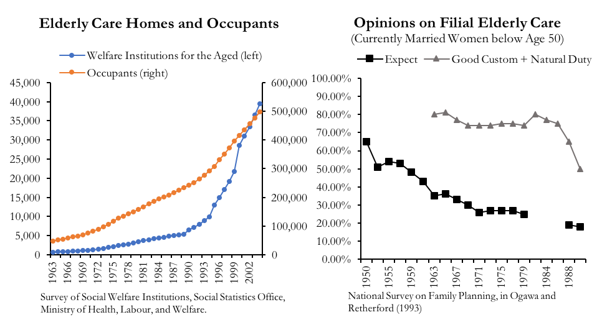

These trends support the theory presented in Ruggles (2007) that social norms and family change reflect a lagged change in occupational and economic change.[238] Even as the proportion of employment in agriculture approximately halved and the proportion of family employees fell by more than a third between 1970 and 1988, coresidence rates and opinions on elderly care fell only gradually.[239] After the rapid shift in perceptions of filial elderly care in the late 1980s accompanying growing acceptance and availability of institutional care, the demand and supply of coresident successors conceivably fell, reducing the number of adult adoptions.[240]

When reexamined through this context of coresidence, elderly care, and bequest behavior, the high rate of adult adoption in Japan becomes less startling: the fact that the rates of coresidence between the U.S. and Japan remain drastically different reflects large differences in the relationship between the elderly and their adult children.

*Family Firm Management*

The role of adult adoption in family firm management fits within the much larger economic literature on family firms and successions, and the relationship between firm performance and effective management. Bloom and Van Reenen (2007) demonstrate that management practices have a significant effect on firm productivity and profitability, and that differences in management practices can stem from differences in the methods of CEO selection in family firms.[241] Evidence suggests that the impact of management quality on performance is quite large: Bloom and Van Reenen estimate that family firm status and competition account for 57% of the gap in management quality between the U.S. and France, and 29% of the gap between the U.S. and the U.K.[242] Further, Bloom and Van Reenen find that family ownership itself does not result in lower firm performance; rather, firms selecting CEOs through primogeniture are managed significantly worse based on a managerial score across four categories: operations, monitoring, targets, and incentives.[243] This finding fits broadly with the often cited Carnegie conjecture, from a passage by Andrew Carnegie in an 1891 essay: “the parent who leaves his son enormous wealth generally deadens the talents and energies of the son, and tempts him to lead a less useful and less worthy life than he otherwise would.”[244]

While Bloom and Van Reenen do not mention adult adoption or include Japanese firms in their analysis, their finding that primogeniture has negative effects on management quality is consistent with the potential benefits of adult adoption in Japan. Within their theoretical framework, adult adoption would enable family firms to maintain the benefits from family ownership while reducing the costs associated with family firm succession. Conceptually, in addition to the amenity value from managing the family firm (which is often named after the family), concentrated family ownership reduces principal-agent problems and enables closer monitoring of managers.[245] On the cost side, selecting managers from among (natural) family members reduces competition for managerial positions, caps the possible ability of managers, and reduces investment in human capital in the early life of children assured of succession to managerial positions in the future.[246]

Mehrotra et al. (2013) note the role of adult adoption in reducing these costs: adult adoption expands the potential pool of managerial applicants to choose from, promotes investment in human capital by removing the guarantee of firm succession, and similarly elicits effort within the firm by presenting the possibility of firm succession.[247] Using panel data on 1,367 listed Japanese firms from 1949-1970, they find that firms run by founders outperformed firms run by non-blood heirs, which outperformed firms run by professional managers, controlling for firm age, firm size, and firm leverage.[248] To mitigate potential selection and reverse causality issues, Mehrotra et al. track firm performance changes in the two years before and after succession events.[249]

It is likely that adult adoption does not merely reduce the potential costs associated with family firm succession as Mehrotra et al. document, but it also increases the benefits relative to hiring a professional manager from outside of the family. Namely, the legal structure of adult adoption may reduce principal-agent problems by requiring mutual agreement or judicial determination to dissolve the adoptive relationship.[250] In other words, adult adoption might reduce the risk of manager opportunism by making the manager a family member in a contract similar to a marital relationship, increasing the social and judicial costs of early exit from the managerial position. Moreover, while further empirical verification is necessary, existing studies using survey data on CEOs suggest that firm-level variation in ownership is as important in shaping management philosophies as industry-level or cross-country differences.[251] Using survey data from 22 emerging economies, Mullins and Schoar (2016) find that CEOs and founder of firms with greater family involvement are more stakeholder-oriented, while CEOs of non-family firms are more oriented toward shareholder-value-maximization.[252] Similarly, Sakano and Lewin (1999) argue that whereas dramatic organizational changes tend to occur early in the tenure of new CEOs in the U.S., the impact of CEO succession on immediate organizational change is not true of Japan, where “the social contract of lifetime employment makes downsizing infeasible for moral and pragmatic reasons.”[253] Assuming that these findings are robust, it is conceivable that the adoptive relationship acts as a social contract that incentivizes strategies that maximize firm longevity (regardless of whether these strategies are successful).

Furthermore, the utility placed on the amenity value from managing the family firm may be a function of historical succession practices: one unexplored possibility behind family firm executives’ incentive to adopt managers into the family is the possibility that the amenity value placed on family firm control may be higher in Japan. Bryant (1990) notes that adult adoption enables continuity of the family name associated with the business.[254] Thus, while the strong performance of adopted managers may result in family firm survival, as Mehrotra et al. suggest, it may also be the case that the amenity value placed on family control increases with family firm survival, resulting in more adopted managers. That is, regardless of whether adult adoption results in superior managerial performance relative to professionally hired managers, family firms may be willing to bear costs equal to the amenity value they place on retaining family control, provided that adopted managers exceed a minimum standard of performance. While an empirical verification of the impact of adult adoption on firm performance is beyond the scope of this paper, this “feedback” effect is implicit in Bloom and Van Reenen’s description of the historical origins underlying the high frequency of succession to the eldest son in France and the U.K. (relative to the U.S.). Primogeniture was the de facto practice in France until the Napoleonic code was introduced in the early 1800s and was obligatory under English law until the Statute of Wills; their common Norman legal origins ostensibly contributed to differences in management practices that result in (worse) firm performance in the present.[255]

The literature on family firm management is consistent with the historical use of adoption among merchants to recruit people to expand their enterprises through branch families; demand for adult adoptees was driven not only by the household head-with-few-successors, but also by the retiring household ‘head-as-executive.’ While these motives may coincide, they are not identical, as the many cases of adopted sons superseding biological sons cited by Mehrotra et al. suggest.

*Intergenerational Wealth Transfers*

Adult adoption represents a vehicle for elderly care provision and business succession, but it also represents a vehicle for the transfer of wealth. Individuals face two ways to transfer wealth: inter vivos transfers (gifts) during life and bequests upon death.[256] There is a tradeoff associated with these transfers: inter vivos transfers result in forfeiting control over the wealth transferred (and a gift tax), while bequests are subject to estate (inheritance) tax.[257] Consequently, changes over time or between countries in the way either wills or inter vivos transfers are taxed affect individual allocation decisions between intergenerational transfers.

Several papers have noted the effect of the transfer tax system on bequest behavior in Japan, including Barthold and Ito (1992), Bryant (1990), and Niimi (2016). The fundamental difference in the way bequests (used synonymously with estates and inheritance hereafter) are taxed in Japan relative to the United States is that the estate tax is imposed on the *recipients* of bequests in Japan, but are imposed on the estate of the benefactor in the United States.[258] In Japan, this tax is calculated as follows. A basic exemption that increases with the number of heirs is subtracted from the total amount of taxable properties (see Appendix). This taxable amount is then ‘allocated’ to each statutory heir (the spouse, children, lineal ascendants, and/or brothers and sisters) based on each heir’s statutory share, codified in Japanese civil law: one-half to the spouse, and one-half in total for the children (equally for each), although other allocations exist if either type of successor is not alive. A progressive tax rate schedule is applied to each of these per-heir allocated taxable amounts, which are then aggregated. This aggregated amount is then allocated to each heir based on the *actual* share acquired by each, relative to the initial total amount of taxable properties. Finally, applicable tax credits are applied for each heir.[259] As a result, increasing the number of statutory heirs decreases total inheritance taxes by both increasing the basic exemption and decreasing the per-heir allocated taxable amount which the progressive tax is imposed on (potentially leading to taxation in a lower tax bracket).[260] Furthermore, tax credits for severance payment and life insurance payment depends on the number of statutory heirs.[261]

In contrast, in the U.S., the number of heirs does not affect the calculation of the estate tax, which is imposed on the value of the estate. The taxation of gifts also differs between the two countries; Barthold and Ito (1992) argue that while the gift tax in Japan discourages inter vivos transfers meant to lessen the bequest tax, the gift tax in the U.S. generally does not discriminate between the two, imposing the progressive tax on cumulative transfers during life and upon death.[262] These two major differences in taxation imply that Japanese benefactors seeking to lessen the bequest tax are incentivized to increase the number of heirs through adoption. The enactment of tax regulations in December of 1988 reflects the frequent use of this loophole by wealthy families, since these regulations, as described previously, limit the number of adoptees that can be used to calculate deductions.[263]

While data on the number of adults adopted for inheritance tax purposes is limited by the fact that adoption with the sole purpose of inheritance tax reduction is technically illegal, data tables from the Tax Bureau of the National Tax Agency detail the frequency of cases by number of statutory heirs and bequeathed taxable income brackets.[264] In Figure E below, I graph the table of 1988, prior to the new regulations, and the 2015 table. Although the change in tax brackets and other omitted variables between the two periods imply that caution is required in interpreting these results, the graphs are consistent with the hypothesis that this loophole was well-known among wealthy families. In both cases, the maximum on the y-axis is set to the maximum observed frequency, and the major gridlines are set to roughly the same proportion in 1988 as in 2015, to mitigate potential misinterpretations resulting from scale differences. There is a bulge in bequests with four statutory heirs for estates exceeding 500 million yen in 1988 (indicated by the rectangle in the figure below) that is noticeably absent in 2015. Moreover, the graph suggests that at all levels of estate size, the frequency of bequests drops dramatically between 3 and 4 statutory heirs in 2015, but appears to plateau in 1988. This is consistent with one spouse and two children, which would be expected if tax deductions were limited to up to two adopted children following the 1988 amendment.

**Figure E. Number of Statutory Heirs and Estate Size (millions of yen) in Japan[265]**

Number of Statutory Heirs

Number of Statutory Heirs

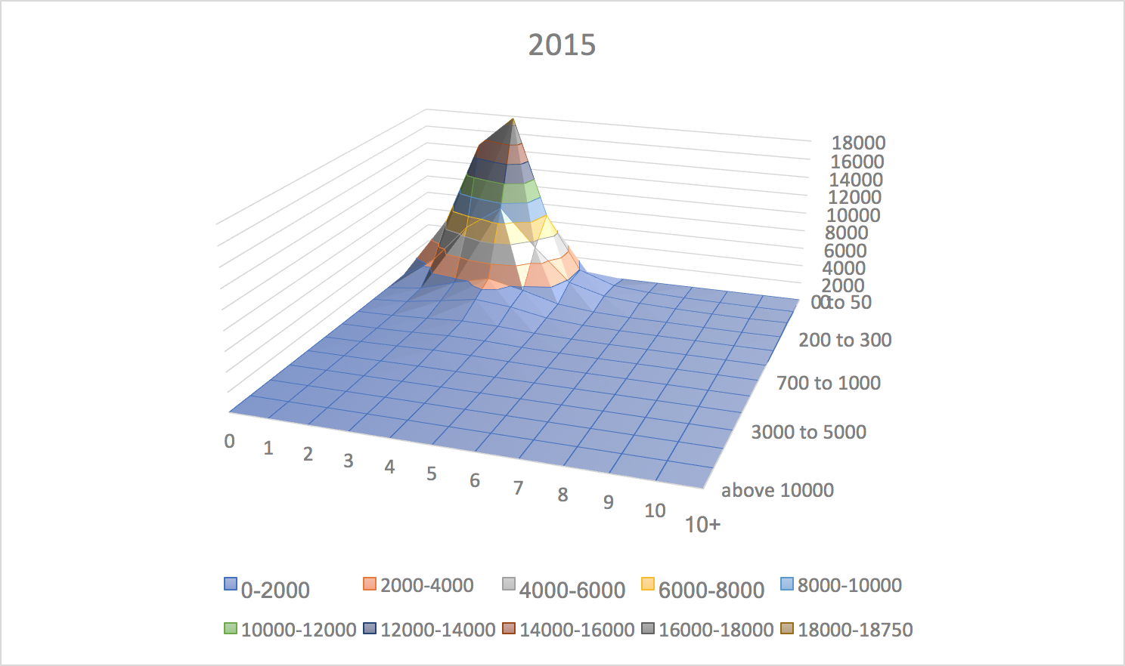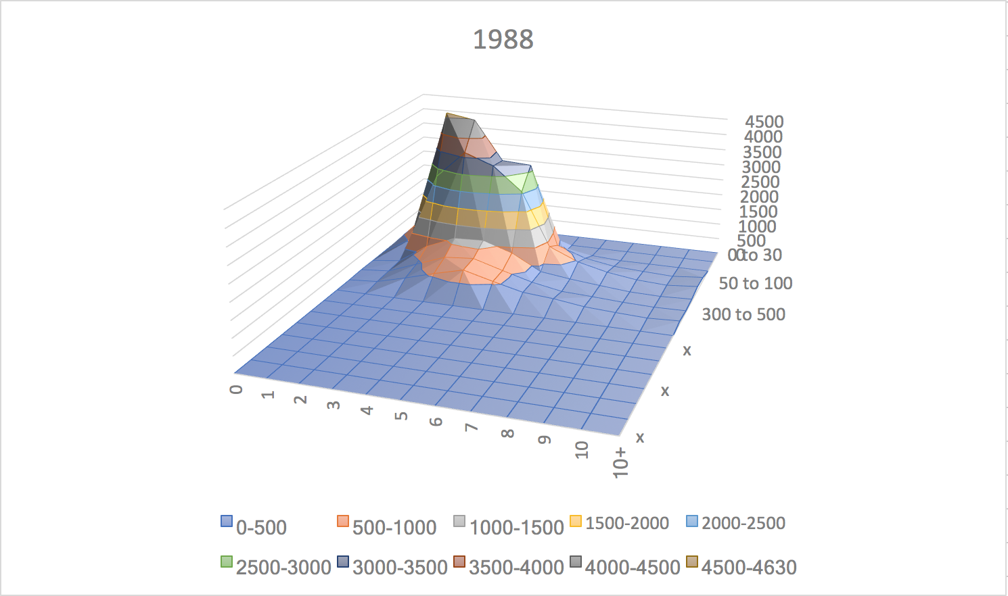

*Note:* x-axis: number of statutory heirs; y-axis: estate size; z-axis: frequency. The “x” marks on the y-axis are placeholders to ensure that the 1988 graph is scaled consistently with 2015. Since the tax brackets changed between the two periods, the 1988 data do not specify frequencies in tax brackets above 500 million. 1988 frequency data is from Barthold and Ito (1992). 2015 data is from the National Tax Agency website.

More direct evidence consistent with the relationship between tax motives and adoption comes from licensed tax accountant records. Summary statistics on an internal database of inheritance tax records published by Legacy, a licensed tax accountant corporation based in Chiyoda ward in Tokyo, reveal that between 2010 to 2013, the average proportion of cases with an adoptee was 10% for the whole sample, relative to 37% for cases involving more than 500 million yen. Similarly, the average number of successors for the former was 2.94, compared to 3.52 for the latter.[266] Between 2014 to 2017, the average proportion of cases with an adoptee was 9% for the whole sample, relative to 42% for cases involving more than 500 million yen, while the average number of successors were 2.76 and 3.75, respectively.[267]

To further test the magnitude of expected tax benefits from additional children, I utilize historical tax tables from the Ministry of Finance to model how the returns to adult adoption varies by both taxable estate size and the existing number of statutory heirs across three periods: 1994-2002, 2003-2014, and 2015 to the present. The inheritance tax schedule changed in 2003 and 2015; notably, in 2015 the per-heir basic deduction decreased (see Appendix, Figure IV). For a given estate size, I calculate the inheritance tax in the case of 1 spouse and 1 child, [1 spouse and] 2 children, 3 children, or 4 children using the calculation method described above. I then calculate the “marginal tax reduction” of an additional child for each estate size by finding the reduction in calculated tax associated with an additional child. Finally, I calculate the “rate of return” by dividing this marginal reduction by the total pre-tax estate. Cumulative rate of return is used here to refer to the sum of the rates of return up to a given number of children: the stacked lines in Figure B illustrate this sum. For example, the dark black line labeled “ROR3to4” indicates the cumulative rate of return to 4 children, which is the sum of the “return” from 1 to 2 children (ROR1to2), from 2 to 3 children (ROR2to3), and from 3 to 4 children (ROR3 to4). The assumptions of the model are outlined in Figure Va in the Appendix.

Figure Va suggests that the marginal tax reduction associated with an additional child: a) is greater when there are fewer existing children; b) increases with estate size; c) plateaus at estate sizes above a certain amount which varies by year; d) dramatically decreased with the reduction in tax brackets from 9 to 6 brackets in 2003; and e) increased in 2015 with the reduction in the basic deduction. Plotting the cumulative “rate of return” to an additional ‘child’ during the period 2003-2014 in the top half of Figure F below indicates that this “rate of return” peaks at roughly 500 million yen per household, dips down between 500 and 900 million yen per household, and decreases steadily above 900 million yen.

These preliminary findings lend support to tax-related motivations for adult adoption, which we will return to and evaluate in Section VI. The primary contribution of this exercise to the literature is a novel way to visualize the profile of decisions pertaining to the number of heirs by estate size; changes in the shape of these profiles over time may provide a useful framework for visualizing how tax changes alter bequest decisions. However, two questions remain regarding the mechanism of adult adoption: why do benefactors care about the amount of the inheritance tax if they are not the ones who have to pay them? Secondly, if inheritance tax reduction is a significant explanation for the high adult adoption rate in Japan, why would heads-as-benefactors adopt adults rather than children?

**Figure F. Number of Statutory Heirs and Estate Size (millions of yen) in Japan**

*Estimated Cumulative Rate of Return (ROR) to Additional Children by Taxable Estate Value, 2003-2014*

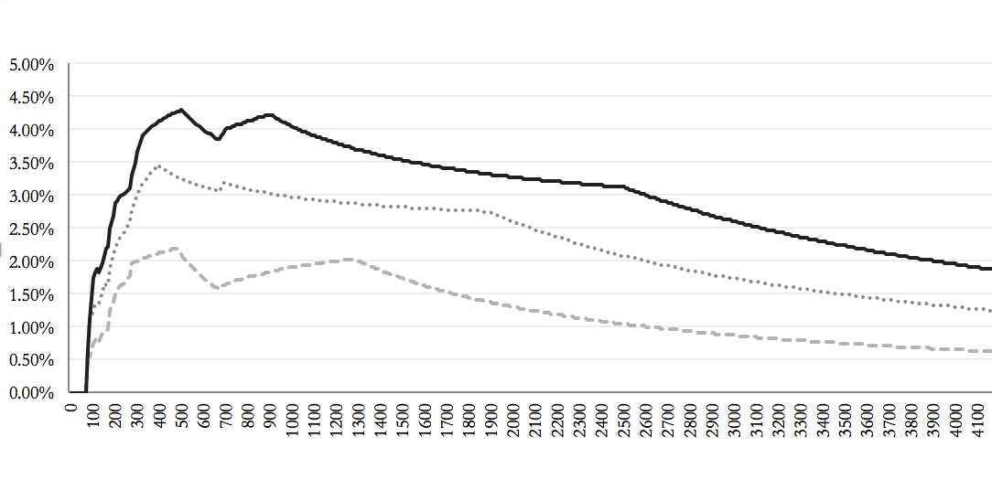

Niimi (2016) summarizes theories of bequest motives in the literature. One possible reason is accidental bequests: retired people may dissave less than expected by Modigliani’s lifecycle saving hypothesis due to precautionary saving or uncertainty, and pass on this unconsumed wealth to the next generation. Under this hypothesis, changes in the way inheritance is taxed should not affect bequest behavior.[268] Another is an altruistic or joy-of-giving motive, in which parents (are altruistic to their children, Horioka 2014) compensate for the lower earnings of their children for their children’s welfare or their own personal utility; in this scenario, changes in inheritance taxation should entice households to reallocate their transfers to or away from inter vivos transfers. Finally, there may be a wealth-in-utility motive in which benefactors enjoy being wealthy and care about the gross amount of wealth transferred, not the net amount that considers the taxation of bequests.[269]

Turning to the second question, the frequency of adult adoption relative to child adoption for inheritance tax purposes is likely an outcome of the procedural ease of adult adoption in Japan. Since it occurs on a private contractual basis, tax authorities bear the burden of proof and generally avoid investigations due to the privacy issues associated with doing so.[270] The historical use of adult adoption over wills also lowers the likelihood of legal challenge by making it more difficult to distinguish between tax evasion motives and other motives.[271] In contrast, adopting a minor requires court permission, unless the minor is a lineal descendant of the adopter. Furthermore, on a purely mechanical level, in both countries, there is a tax penalty for skipping generations in transfers: adopted grandchildren of decedents face a 20% surtax on bequeathed assets in Japan.[272] Finally, while not explicitly verified in the literature, it is intuitively likely that the social and financial costs of raising a child for tax purposes alone make adopted children an unfeasible substitute for financially independent adopted adults.

*Summary: Adult Adoption as Intergenerational Contract*

The historical and anthropological literature indicates that the official use of adoption in preindustrial Japan, ancient Rome, and parts of continental Europe was the provision of an heir to continue the family line, but also the transmission of property, occupation, and wealth. Particularly until the late 1980s, adoption provided a solution to the tradeoff between control over wealth and inheritance tax reduction, and ensured care in old age.[273] To more rigorously examine the relationship between elderly care, family businesses and self-employment, wealth, and adoptions, I now turn to an empirical analysis of adult adoption.

**VI. An Empirical Analysis of Adult Adoption**

*Motivation and Framework*

The preceding discussion of the comparative history of adult adoption and the economic development hypothesis suggests that adult adoption is a function of the prevalence of family businesses, social welfare, inheritance taxation, and social norms. Two broad categories of adopters’ motives for adult adoption emerge from this discussion. On the one hand, the demand for business successors and elderly care, encompassing not only nursing services but also financial security in old age, may drive adult adoption among families with farms or small family businesses. Survey data on the strength of the bequest motive and eldest son succession norms among the self-employed, and more direct evidence, such as the high proportion of owners among the adult-adopters in the Aihara and Nakagawa (1963) survey, support this hypothesis.[274] On the other hand, adult adoption in Japan also appears to be driven by inheritance tax considerations among the wealthy, independent of the occupation of the family. This motive is supported by the passage of the 1988 tax reform limiting the number of adoptees counting toward the basic deduction and the comparatively high proportion of adoptions among inheritance tax cases involving more than 500 million yen.[275]

On the supply side, the predominance of non-first born children among male adoptees in the Aihara and Nakagawa (1963) survey suggests that the supply of adult adoptees is associated with the difference between inheritance prospects and employment opportunities in adoptees’ birth families relative to their adopters’ families. The observed quantity of adult adoption depends upon the matching of adopters and adoptees; that is, adult adoption rates are an outcome of both the demand of adopters and the supply of adoptees.

Much of the empirical literature on adoption that exists focuses on foster child adoption. In the context of the US, Hansen (2007) estimates the impact of adoption assistance subsidies on adoptions from foster care using administrative data from the Adoption and Foster Care Analysis and Reporting System between 1996 and 2003.[276] The OLS specification regresses the adoption rate, defined as child adoptions from foster care per 1000 births in the state, on the average subsidy payment per child in the state and a vector of controls for substitutes and demographic factors, including intercountry adoption as a percentage of all adoptions, state median income, the percentage of the population between 18 and 44 years old, state child welfare spending per foster child, and the percentage of African Americans in the state population and in the foster care population.[277]

In the context of Japan, Moriguchi (2010) examines demand-side changes in parental motivations for child adoption using tabulations of judicial statistics, finding that in the 1950s, child adoptions were primarily motivated by infertility (“having too few children”); the share of infertility motives declined from 1953 to 1961 as the share of family inheritance and altruistic motives rose.[278] In a study of the determinants of living arrangements of the elderly, Yashiro (1996) utilizes data from the nationwide Basic Survey on the People’s Life 1986 and 1989, using the ratio of elderly living with their married children (and sharing consumption and income) to the total elderly as the dependent variable. Yashiro uses consumption in households headed by 40-49 year olds as a proxy for children’s income, household consumption as a proxy for permanent income, and household area per household member as a proxy for housing services.[279]

To the best of my knowledge, no existing studies utilize prefectural variation in adoption rates in Japan to explore the association between self-employment, social welfare, bequeathable wealth, and adoption rates. The specification used in Hansen (2007) is not directly applicable to the Japanese context; since over 35% of adoptions were of adults in 2010 and most adopters of adults were between 40 to 69 years old in the Aihara and Nakagawa survey (1963), the percentage of the population between 18 and 44 years old is unlikely to be a suitable proxy for the demand for adoption in Japan.[280] Moreover, there is little evidence to suggest that race plays a significant role in the matching of adoptive families and adult adoptees in the Japanese context. Further, defining the adoption rate in per-birth terms may not be suitable in the Japanese context, given the relatively low perceived substitutability of natural children and unrelated child adoptees.[281] Nonetheless, since the supply of potential adult adoptees is difficult to distinguish from the demand for child adoptees in prefectural demographic data, I maintain the focus on the demand side of adoption implicit in Hansen (2007), and consider the following model:

Adoptionsit = β1 (Elderly Self-Employed)it + β2 (Wealthy)it + β3 (Elderly Care Services)it

+ β4 (Elderly)it + β5 (Primary Industry)it + λt + ε

The dependent variable is adoptions per 10,000 people in prefecture *i* and year *t*. The primary estimates of interest are β1 and β2, which capture the two potentially overlapping categories of adopters’ motives for adult adoption described above. A high proportion (of the prefectural population) of the self-employed elderly, including self-employed farmers and shopkeepers, is expected to correspond to a greater demand for family business successors and filial elderly care, since the self-employed elderly are likely to be planning for retirement and economic security in old age. Turning to the second variable, I expect a high proportion of wealthy residents to correspond to a greater demand for inheritance tax reduction through adoption, and a greater inducement for potential heirs to enter the household insofar as wealth increases with age.

As a control for substitutes for filial elderly care provision, I include the proportion (of the prefectural population) of occupants of elderly care homes (*rojin fukushi shisetsu*) as a proxy for the availability of elderly care services, which would be expected to decrease the demand for adult adoption *ceteris parabus*. Similarly, as controls for other factors that may shift the demand for adult adoption, I include the proportion of the elderly, defined to be age 55 or older, as well as regional fixed effects for the eight regions of Japan (Hokkaido, Tohoku, Kanto, Chubu, Kansai, Chugoku, Shikoku, and Kyushu). I also include the proportion of prefectural real GDP from primary industry (agriculture, forestry, and fisheries) as a proxy for the degree of urbanization, to control for factors correlated with both adoption and the proportion of the elderly self-employed, the wealthy, and elderly care home occupants. Conceivably, in prefectures with a large proportion of primary industry production, the elderly self-employed may have less access to elderly care services and institutions for child adoption, as well as a greater demand for labor within the household and thus a greater demand for adult adoption compared to the elderly self-employed in urban areas. As Yashiro (1996) notes, urbanization also shapes elderly living arrangements: “both continued urbanization…and the associated contraction of the agricultural sector as it is replaced by the manufacturing and service sectors should contribute to…an increase in the incidence of single elderly households.”[282] Consequently, I expect that the proportion of primary industry production is positively associated with adoptions.

The purpose of this empirical exercise is to check if the theoretical and historical framework of adult adoption presented in the preceding sections is consistent with the relationship between prefectural characteristics and adoption rates, not to establish causality. A causal claim would require a natural experiment such as a change in either adoption legislation or inheritance tax legislation, for example, that differentially affects individuals. While Niimi (2016) examines one such change, namely the response of households to the 2013 Tax Reform, effective from January 1, 2015, using household survey data on planned responses to the tax change from the 2013 Survey on Households and Saving conducted by the Yu-cho Foundation (Yu-cho Zaidan), the survey does not inquire about adoption intentions.[283] Nonetheless, several of the variables considered in the model outlined above are similar to the predictors for the dependent variable, households’ planned response to the tax change, included in the specification in Niimi (2016), such as household financial assets (by quintile) and age group.[284]

*Data Sources and Summary Statistics*

While it would be desirable to use adult adoption rates as the dependent variable, prefectural-level data on the composition of adoptions are not publicly available, nor are bureau-level adoption data prior to 2006. Instead, I use data on the total number of adoptions by legal affairs bureau from 2006 to 2016 from the family registry statistics of the Ministry of Justice.[285] Using this bureau-level data, I create a dataset of adoptions by prefecture by matching the ‘legal affairs bureaus’ (*homukyoku)* to their prefectures and aggregating by prefecture. This is justified because there is one legal affairs bureau per prefecture, except for Hokkaido prefecture, which has four (see Figure IIb in the Appendix).[286] To reduce scale differences created by differences in prefectural population, I divide the number of adoptions per prefecture by the prefectural population in the same year, taken from the Population Census, and multiply this rate by 10,000 to determine the number of adoptions per 10,000 people.

From 2006 to 2016, adoptions per 10,000 people ranged from 4.722 (Tokyo in 2016) to 9.525 (Shimane Prefecture in 2009). Shimane, Miyazaki, and Shizuoka had the highest mean adoption rates (adoptions per capita) over this period, while Osaka, Chiba, and Shiga Prefectures had the lowest. The number of adoptions per 10,000 in 2007 and 2012, the subset of years for which data on the dependent variables are available, is mapped in Figure G below. Comparing the geographic distribution of the adoption rate with Yamamoto (1961), there are similarities in that Yamamoto cites a high (total) adoption rate in the western Chugoku region (which includes Shimane and Yamaguchi prefecture) and Kyushu (which includes Miyazaki prefecture). However, Yamamoto also notes a high adoption rate in the southern-central Kinki region and the northern-most Hokkaido prefecture, and a relatively low adoption rate in the Tohoku (northeast) and Kanto regions, which differs from the 2007 and 2012 data.[287] The geographical distribution of adoption rates in both 2007 and 2012 is similar, with low adoption rates in the northern Tohoku region and the southern part of the Kanto region, as well as in the Kinki region.

**Figure G. Adoption Rate by Prefecture, 2007 and 2012**

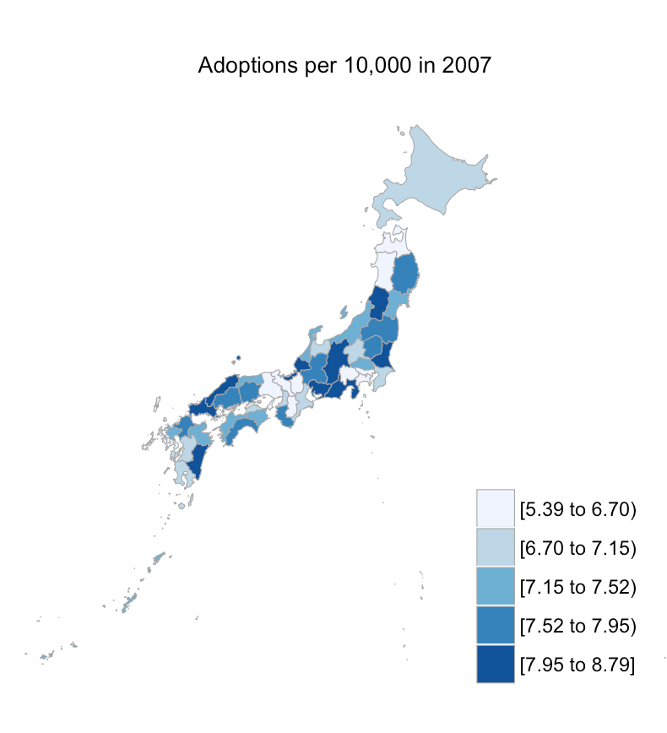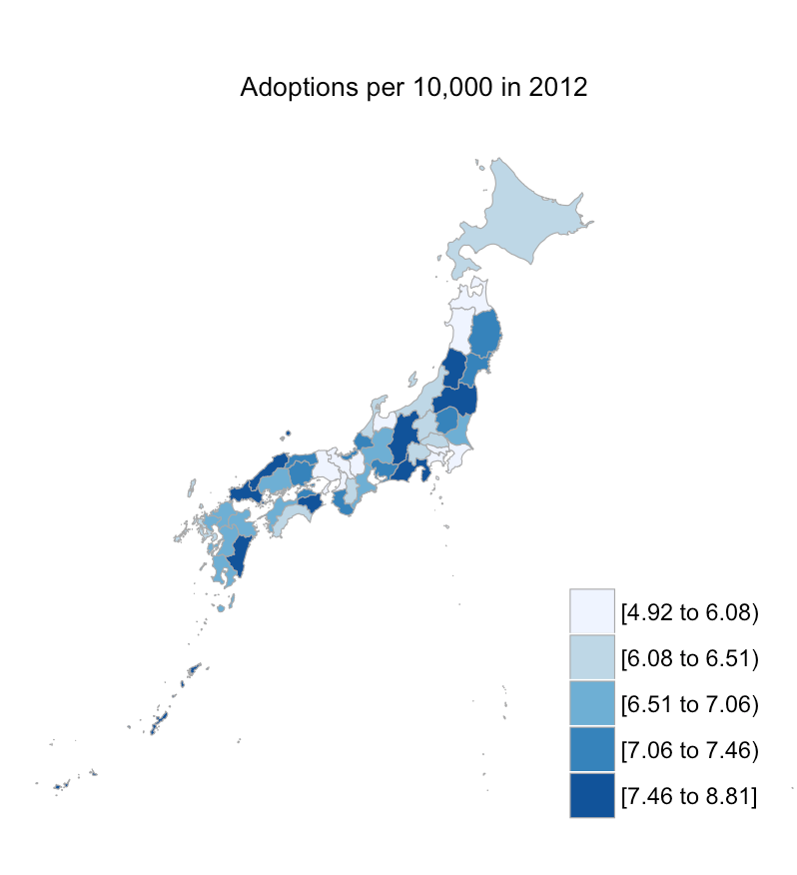

Data on the number of self-employed elderly per prefecture are from the Employment Status Survey released by the Bureau of Statistics, which details the number of “persons engaged in work by sex, age, status in employment, type of employment, and whether starting a business for oneself.”[288] I define the elderly self-employed as self-employed workers over the age of 55 since most adopters (64%) in Aihara and Nakagawa survey were between 50 and 70 years old, and since most firms have historically set the mandatory retirement age at 55, until the Act of Stablization of Employment of Elderly Persons in 1994, enforced in 1998.[289] “Self-employed” (*jiei gyoshu*) refers to people running private (unincorporated) businesses, such as shopkeepers, farmers, factory owners, medical practitioners, lawyers, and authors.[290] Since the Employment Status Survey is conducted every five years, I use the data from 2007 and 2012. Prefectural data on the total number of people over the age of 55 are from the Population Census. As with the adoption rate, I express both variables as a proportion of the prefectural population (per 10,000 people).

There appears to be no clear relationship between the number of elderly per 10,000 (prefectural population) and the adoption rate from 2006 to 2016, as shown in the scatterplot in Figure H below. In contrast, there is a positive and statistically significant relationship between the number of self-employed elderly per 10,000 and the number of adoptions per 10,000, consistent with the hypothesis that the employment status of the elderly influences adoption decisions by increasing the demand for successors for economic security in old age.[291]

**Figure H. Adoptions and the Elderly**

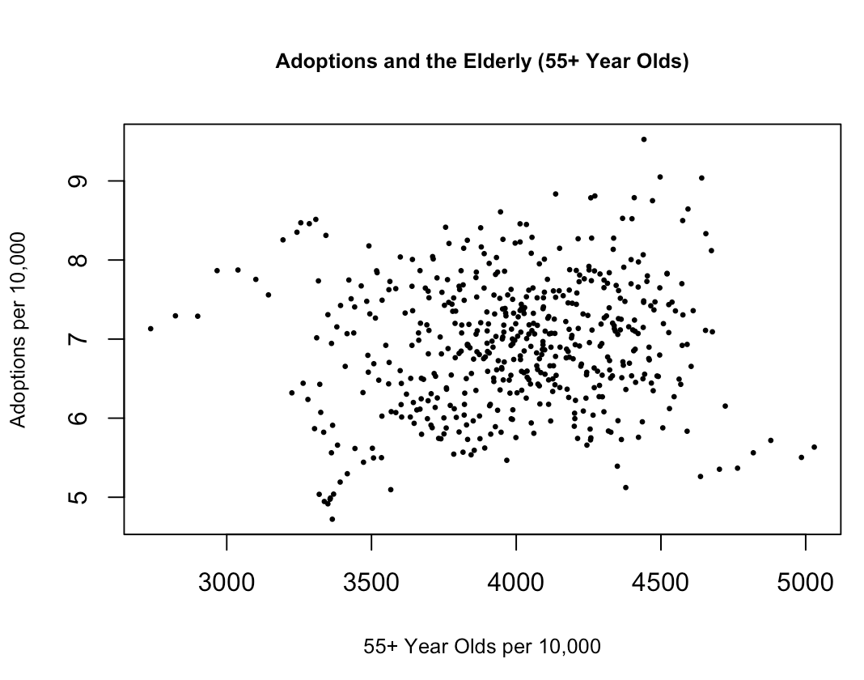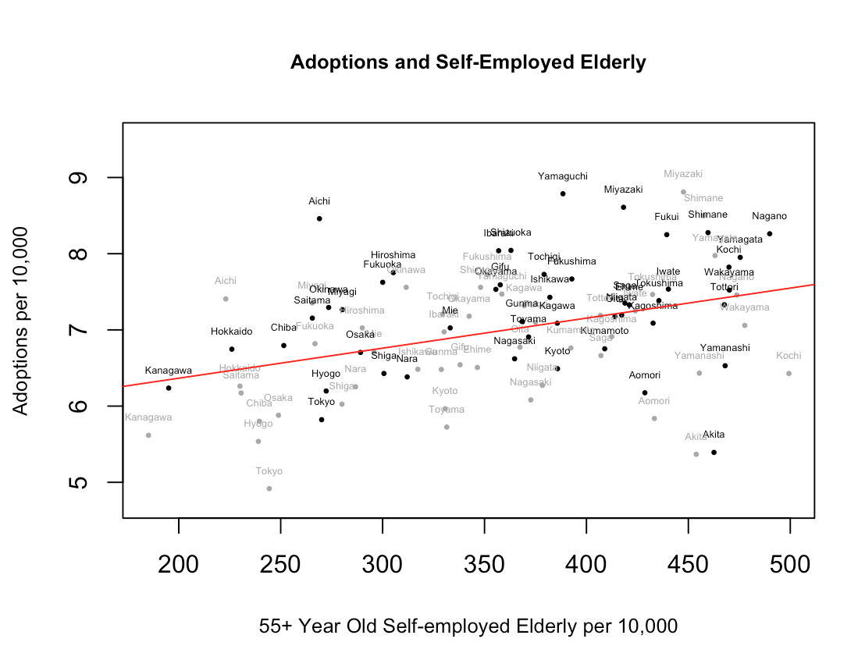

Prefectures with relatively high proportions of self-employed elderly, such as Shimane and Miyazaki prefectures in western Japan and Yamagata prefecture in northeastern Japan, also had high adoption rates. However, the relationship in the scatterplot does not consider wealth or income or the industrial composition of the prefecture, which may shift the demand for adoption by altering incentives for inheritance tax reduction and the importance of adoptees for insurance against running out of consumption resources in old age. The self-employed elderly in agriculture in Yamagata prefecture, for example, conceivably face different motives for adoption than the self-employed elderly in metropolitan prefectures such as Tokyo.

I therefore consider several proxies for the proportion of wealthy residents by prefecture. While it would be desirable to use data on the distribution of assets by age in each prefecture to determine the number of elderly with large amassed savings, data on family assets, income, and consumption from the National Survey of Income and Expenditure are at the household level. Moreover, the National Survey of Income and Expenditure is conducted every 5 years, and the years do not overlap with the years for which the Employment Status Survey are available between 2006 and 2016; the National Survey of Income and Expenditure is available in 2009 and 2014, while the Employment Status Survey is available in 2007 and 2012. As a result, the first proxy I consider is the number of people filing income tax with an income of over 50 million yen as a proportion of the population, since this data is available annually from the National Tax Agency.[292] I use this proxy as a baseline to examine the relationship between high income earners, the self-employed elderly, and adoption.

The second proxy I consider is the proportion of two or more member households with total assets over 100 million yen from the National Survey of Income and Expenditure. As described above, since the years of the survey do not align with those of the employment status survey, I use the 2009 data for 2007, and the 2014 data for 2012. The 100 million yen and above cutoff corresponds to the highest group of total assets tabulated in the data.[293] As another proxy for the number of wealthy residents by prefecture, I use the third quartile of the value of household savings minus liabilities for all households, also from the National Survey of Income and Expenditure; these data are only available in 2014, which I use as a proxy for the corresponding number in 2012.[294] Finally, I consider the average amount of accumulated savings of two-or-more-person households with at least one member not working and at least 65 years old, available from “Table 9. Monthly Receipts and Disbursements per Household by Type of Aged Household and Area” of the same survey, in order to focus on the wealth of the elderly, which would be expected to affect motives for adult adoption.[295]

The last two dependent variables I consider, namely the proportion of prefectural real GDP from primary industry and the number of occupants of elderly care homes, are from the Cabinet Office and the Survey of Social Welfare Institutions from the Ministry of Health, Labor, and Welfare respectively.[296] These variables are summarized in Figure J below.

**Figure J. Summary Statistics**

|  |  |  |  |  |  |
| --- | --- | --- | --- | --- | --- |
| Variable | Obs | Mean | Std. Dev | Min | Max |
| Adoptions per 10.000 | 517 | 6.931132 | .8168016 | 4.721814 | 9.52514 |
| Self-employed elderly per 10,000 | 94 | 359.8244 | 78.54324 | 185.1566 | 499.336 |
| Elderly per 10,000 | 517 | 3996.178 | 364.9609 | 2737.226 | 5029.703 |
| Primary industry production (% of real pref. GDP) | 423 | .0183944 | .0121828 | .0004909 | .0555299 |
| People filing income >50M yen per 10,000 | 517 | 2.697375 | 1.815744 | .7809847 | 15.32565 |
| Elderly care facility occupants per 10000 | 517 | 11.19256 | 6.021924 | 1.299074 | 30.05747 |
| Average savings (yen), elderly hh. | 94 | 1.87e+07 | 4072280 | 7885000 | 2.68e+07 |
| Prop. hh. with >100M yen in assets (2 or more  person households) | 94 | .0414594 | .0273939 | .0073193 | .1779829 |
| Third quartile of hh. net savings (all households) | 47 | 1.66e+07 | 4263571 | 5000000 | 2.39e+07 |

To test for multicollinearity among the predictors, correlations between the dependent variables are presented in Figure VI in the appendix; while some of the predictors are more correlated than others, such as the number of elderly care facility occupants per 10,000 and the number of self-employed elderly per 10,000, there is no indication that the predictors are perfect linear combinations of each other.

*Results and Discussion*

The first specification regresses the adoption rate on the elderly self-employed, elderly, proportion of primary industry, elderly care facility occupants, a year dummy for 2012, and each of the four proxies for wealthy residents as defined above, without region fixed effects. Table I presents the main findings, and Table Ia in the Appendix shows the full regression table. The proportion of the self-employed elderly is positively associated with the adoption rate, and the relationship is statistically significant, regardless of the choice of proxy for wealth, as presented in columns one to four. However, the coefficient is small in magnitude: an increase of one thousand self-employed elderly people per 10,000 people is associated with an increase in adoptions of approximately 3 per 10,000. The magnitude of the coefficient is not unreasonable, given that the difference between the minimum and maximum adoption rate from 2006 to 2016 was approximately 4.8 per 10,000. In contrast, the proportion of the total elderly is not significant and the sign is negative, consistent with the hypothesis that the demand for adoption is related not just to demographic factors but also to occupational structure, as suggested in Figure H.

The relationship between the proportion of real prefectural GDP from primary industry is not statistically significant, and the sign varies based on the proxy for wealthy residents considered. This runs counter to the hypothesis that adoption is particularly important in rural prefectures and among farming families as a mechanism for the transmission of land and agricultural techniques, and for elderly care provision within the household. However, since the variable is a percentage of prefectural real GDP rather than employment within farming, the variable may partly be capturing differences in agricultural productivity: prefectures with few but productive farm families, for example, might have both higher proportions of production from agriculture but also fewer farmers. I address this concern by replacing the self-employed elderly and primary industry variables with elderly farmers (per 10,000), which I turn to later.

**Table I. Self-employed Elderly Regression Results**

|  |  |  |  |  |
| --- | --- | --- | --- | --- |
| **DEPENDENT VARIABLE**: **Adoptions per 10,000** (2007 and 2012)  Year Fixed Effects, SE Clustered by Prefecture | | | | |
|  | *Proxy for the Number of Wealthy* | | | |
| VARIABLES | Income | Elderly HH Savings | Assets | Net Savings |
|  |  |  |  |  |
| Self-employed Elderly | 0.00336** | 0.00386** | 0.00387** | 0.00423** |
|  | (0.00166) | (0.00180) | (0.00171) | (0.00177) |
| Elderly | -0.000689 | -0.000577 | -0.000694 | -0.000908 |
|  | (0.000582) | (0.000727) | (0.000578) | (0.000848) |
| Primary industry (% pref. GDP) | -5.895 | 1.380 | -8.131 | 7.108 |
|  | (13.23) | (16.91) | (14.27) | (21.04) |
| People filing income over 50M yen | -0.120*** |  |  |  |
|  | (0.0416) |  |  |  |
| Elderly care facility occupants | 0.0286 | 0.0324 | 0.0326 | 0.0482* |
|  | (0.0218) | (0.0220) | (0.0226) | (0.0249) |
| Year 2012 | -0.306 | -0.250 | -0.253 |  |
|  | (0.204) | (0.265) | (0.202) |  |
| Average savings (yen), elderly hh (1) |  | 8.63e-09 |  |  |
|  |  | (3.86e-08) |  |  |
| Hh. with >100M yen in assets (2) |  |  | -6.223 |  |
|  |  |  | (5.219) |  |
| Third quartile of hh. net savings (3) |  |  |  | 2.35e-09 |
|  |  |  |  | (4.03e-08) |
|  |  |  |  |  |
| Constant | 8.755*** | 7.447*** | 8.495*** | 8.251*** |
|  | (1.767) | (1.717) | (1.723) | (2.390) |
|  |  |  |  |  |
| Observations | 94 | 94 | 94 | 47 |
| R-squared | 0.300 | 0.254 | 0.276 | 0.253 |

Household abbreviated to “hh.” Self-employed elderly, elderly, income over 50M yen, and elderly facility occupants are in per 10,000 population terms. “Average savings (yen), elderly hh,” “Hh. with >100M yen in assets” and “Third quartile of hh. net savings” use 2009 and 2014 figures as proxies for their values in 2007 and 2012; (1) refers to the average amount of savings of two-or-more-person households with at least one member who is at least 65 years old and not working. (2) refers to the proportion of two-or-more person households with over 100 million yen in assets. (3) refers to the third quartile of the value of household savings minus liabilities for all households.

Robust standard errors in parentheses

*** p<0.01, ** p<0.05, * p<0.1

The coefficient on the number of people filing income over 50 million yen is negative and statistically significant, which is not consistent with the hypothesis that inheritance tax considerations motivate adoptions. One potential explanation for the negative coefficient on people filing income is that the variable may reflect the number of high-income, non-elderly company employees rather than the implied wealth of the elderly. This would particularly be the case if income declined rapidly with age in the population after 55 years of age: in such a setting, a higher proportion of people filing income over 50 million yen might correspond to a lower supply of adults willing to become adoptees. Alternatively, a higher proportion of people filing income over 50 million yen may correspond to a lower supply of adoptable minors. Hansen (2007) finds that median household income in a state is negatively correlated with adoptions from foster care, although she notes that “this runs counter to evidence on adoptions in general.”[297] The other three proxies for the number of wealthy residents, namely the average savings of elderly households, households with over 100 million yen in assets, and the third quartile of net household savings are not significant, and the sign on these variables varies. These proxies for wealth may be insignificant because adoptions may only be a consideration of the very wealthy: neither the average savings, third quartile, nor the 100 million yen cutoff fully capture the high end of the wealth distribution. As discussed previously, the inheritance tax records of Legacy, a licensed tax accountant corporation based in Tokyo, indicate a higher incidence of adoption among cases involving more than 500 million yen; the same may not be true of households with lower accumulated assets between 100 and 500 million yen.[298]

The remaining predictor, the number of occupants of elderly care facilities per 10,000 people, is positive and insignificant for three of the four regressions, and do not support the hypothesis that elderly care facilities are substitutes for elderly care provision through adult adoption. A possible reason for the positive sign is that if the number of elderly care facilities is correlated with the public provision of welfare facilities and the number of institutions for child adoption, then prefectures with more elderly care facility occupants may also have better matching services for minor adoptees and consequently more adoptions. Further, in relieving adult children of the burden of elderly care, elderly care facilities may also make child adoption more feasible for those adult children. The lack of significance however, precludes conclusions regarding the association between public elderly care provision and adoption.

Taken together, the results from Table I lend credence to the association between the occupation of the elderly and the total adoption rate, although they do not substantiate the relationship between wealth and adoption implied in the inheritance tax motive discussed in earlier sections. The second specification replaces the self-employed elderly and primary industry production variables with the number of farmers per 10,000, from the Employment Status Survey, to check if the association between the elderly self-employed (which includes farmers) and adoptions remains significant.[299] The main findings are presented in Table II below.

The results of this specification resemble those of the first. Yet the coefficient on elderly farmers is positive and statistically significant in two of the four regressions, while the number of elderly per 10,000 people is not significant. The three proxies for wealth are of the same sign, although remain statistically insignificant. The fact that the coefficient on elderly farmers is insignificant when the number of people filing income over 50 million yen is included suggests that the significant association between the type of employment of the elderly and adoption in the other two columns may be capturing the effect of the income of the elderly and the non-elderly on adoption decisions. Moreover, the coefficient on the self-employed elderly in the first specification in Table I and on elderly farmers in the second regression become insignificant with the inclusion of regional fixed effects (see Table Ib and IIb). In the first specification, the coefficient on the Chugoku region is positive and significant, while the coefficient on the Kansai region is negative and significant in most of the regressions. This is consistent with the high rate of adoption in Shimane and Yamaguchi prefecture and the low rate of adoption in southern-central Japan evident in the map of adoption rates in Figure G. In the second specification, the Hokkaido and Kansai dummies are significant and negative. These significant regional dummies indicate that there are likely other factors that shape adoption decisions apart from the variables examined, such as divorce rates, age composition of the population, and the migration of adult children into or out of urban regions.

**Table II. Elderly Farmers Regression Results**

|  |  |  |  |  |
| --- | --- | --- | --- | --- |
| **DEPENDENT VARIABLE**: **Adoptions per 10,000** (2007 and 2012)  Year Fixed Effects, SE Clustered by Prefecture | | | | |
|  | *Proxy for the Number of Wealthy* | | | |
| VARIABLES | Income | Elderly HH Savings | Assets | Net Savings |
|  |  |  |  |  |
| Elderly Farmers | 0.00156 | 0.00281** | 0.00195 | 0.00379*** |
|  | (0.00132) | (0.00134) | (0.00134) | (0.00139) |
| Elderly | -0.000579 | -0.000509 | -0.000542 | -0.000877 |
|  | (0.000533) | (0.000600) | (0.000532) | (0.000646) |
| People filing income over 50M yen | -0.101** |  |  |  |
|  | (0.0397) |  |  |  |
| Elderly care facility occupants | 0.0314 | 0.0299 | 0.0344 | 0.0444 |
|  | (0.0243) | (0.0239) | (0.0252) | (0.0267) |
| Year 2012 | -0.363* | -0.286 | -0.322* |  |
|  | (0.184) | (0.213) | (0.184) |  |
| Average savings (yen), elderly hh (1) |  | 1.99e-08 |  |  |
|  |  | (2.90e-08) |  |  |
| Hh. with >100M yen in assets (2) |  |  | -3.123 |  |
|  |  |  | (5.247) |  |
| Third quartile of hh. net savings (3) |  |  |  | 1.16e-08 |
|  |  |  |  | (2.70e-08) |
|  |  |  |  |  |
| Constant | 9.027*** | 7.811*** | 8.601*** | 8.829*** |
|  | (1.777) | (1.809) | (1.750) | (2.246) |
|  |  |  |  |  |
| Observations | 94 | 94 | 94 | 47 |
| R-squared | 0.283 | 0.258 | 0.258 | 0.266 |

Household abbreviated to “hh.” Elderly farmers, elderly, income over 50M yen, and elderly facility occupants are in per 10,000 population terms. “Average savings (yen), elderly hh,” “Hh. with >100M yen in assets” and “Third quartile of hh. net savings” use 2009 and 2014 figures as proxies for their values in 2007 and 2012; (1) refers to the average amount of savings of two-or-more-person households with at least one member who is at least 65 years old and not working. (2) refers to the proportion of two-or-more person households with over 100 million yen in assets. (3) refers to the third quartile of the value of household savings minus liabilities for all households.

Robust standard errors in parentheses

*** p<0.01, ** p<0.05, * p<0.1

Since adoptions may depend on the scale of businesses rather than solely the number of the self-employed elderly, I consider the following specification as an additional exploration of the relationship between the adoption rate and small businesses, to complement the discussion above:

Adoptions = β0+ β1Elderly + β2Income + β3SmallBusiness + β4BigBusiness + ε

If the search for successors is particularly important for heads of households that run small family firms with more limited pension benefits, as implied in Raymo et al. (2004), prefectures with many small businesses and elderly people would be expected to have higher adoption rates.[300] Conversely, if larger businesses (in terms of the number of employees) tend to be professionally managed rather than transmitted through the family, more large-scale employers would be expected to be associated with fewer adoptions. Here, *Adoptions* refers to the number of adoptions per household (the total number of adoptions divided by the number of households in the prefecture); adoptions is divided by households since the data on income and the elderly are in per household terms. The number of households is from the Ministry of Internal Affairs and Communications.[301] *Elderly* is the number of people 65 years and older per household; this is the information that is provided in the data, not a deliberate redefinition of “elderly” compared to the previous specifications. *Income* refers to the average annual income per household. *SmallBusiness* is the number of private businesses with 5-9 employees divided by the number of households, and *BigBusiness* is the number of private businesses with over 300 employees divided by the number of households.[302]

The main estimates of interest are β3and β4: if adopters adopt to continue the family firm, then β3is expected to be positive. In contrast, insofar as the assumption that businesses with over 300 employees tend to be professionally managed is correct, *β4* is expected to be insignificant. Data on household characteristics (annual income, family member age composition, sex of household head, average age of household head) are from Table 13, “Monthly Receipts and Disbursements per Household by Area,” from the Statistics Bureau (Ministry of Internal Affairs and Communications).[303] Data on the number of businesses (by number of employees) are from Table C, “Economic Base,” of “Social Indicators by Prefecture” from the Statistics Bureau.[304] All variables are from the year 2014. These variables are summarized in Figure K below.

**Figure K**

|  |  |  |  |  |  |
| --- | --- | --- | --- | --- | --- |
| Variable | Obs | Mean | Std. Dev. | Min | Max |
| Adoptions per household | 47 | 0.0016364 | 0.0002491 | 0.0010071 | 0.0022103 |
| Businesses with 5-9 employees, per household | 47 | 0.0207568 | 0.0027685 | 0.0145188 | 0.0282097 |
| Business with over 300 employees, per household | 47 | 0.0001774 | 0.000058 | 0.0000821 | 0.0004542 |
| People 65 years and above per household | 47 | 0.7051064 | 0.0795332 | 0.52 | 0.88 |
| Average annual income per household | 47 | 5189106 | 520607.3 | 3851000 | 6271000 |

Table III presents the results of this specification. Consistent with the hypothesis that small firms and occupational structure influence adoption decisions, *SmallBusiness* is positive and statistically significant, while *BigBusiness* is negative and insignificant. Holding income per household, “elderly,” and the number of large businesses fixed, an increase of 1 business with 5 to 9 employees per household is associated with an increase of 0.05 adoptions per household. As with the findings in the first specification, the number of elderly people is not significant.

**Table III**

|  |  |
| --- | --- |
| **DEPENDENT VARIABLE: Adoptions per 10,000** (2014) | |
|  |  |
| VARIABLES | (1) |
|  |  |
| People 65 years and above per household | 0.000147 |
|  | (0.000573) |
| Average annual income per household | 0 |
|  | (7.69e-11) |
| Businesses with 5-9 employees (per household) | 0.0501*** |
|  | (0.0103) |
| Businesses with 300+ employees (per household) | -1.214 |
|  | (0.769) |
| Constant | 0.000551 |
|  | (0.000469) |
|  |  |
| Observations | 47 |
| R-squared | 0.395 |

Robust standard errors in parentheses

*** p<0.01, ** p<0.05, * p<0.1

Collectively, these three specifications present mixed implications regarding the credence of the association between self-employment and adoption presented in the previous section. There appears to be an association between the proportion of self-employed elderly and adoptions as well as between the number of small businesses and adoptions. However, this relationship is quantitatively small, and the inclusion of regional fixed effects makes the association insignificant. The relationship between wealth and adoptions remains unclear.

Nonetheless, this empirical exploration of factors associated with differences in adoptions per prefecture in Japan constitutes a first step toward a more dynamic view of adoption practices in Japan. As stressed earlier, there are no existing studies that I am aware of that examine the association between self-employment, social welfare, wealth, and adoption rates using prefectural variation in adoption rates. The viability of further literature depends to a large degree on the extent to which data on the composition of adoptions becomes more readily available, either through survey data or through the publication of aggregate statistics of adoption by bureau through the Ministry of Justice. While the data presented in this section are suited for exploratory data analysis and visualization, as in the map in Figure G, three large limitations hinder conclusive interpretations of the relationship between prefectural characteristics and adoption rates.

Firstly, the adoption data by prefecture are total adoption rates, not the adult adoption rate, complicating the task of distinguishing the demand for adult adoptions from that for child adoptions. If some prefectures have disproportionately high child adoption rates, prefectural characteristics that may otherwise be significant given adult adoption data will appear insignificant in regressions using total adoption rates. Secondly, for understandable reasons, the data on adoptions is provided at the bureau rather than the individual level, precluding a clear distinction between factors motivating adopters and factors motivating adoptees. A national survey of elderly household heads regarding the presence or absence of adoptees in the household and the motivations for adoption similar to Aihara and Nakagawa (1963) would provide valuable insights into the economic basis of adult adoption in contemporary Japan. Lastly, the variation in prefectural adoption rates between 2006 and 2016 is small; data on adoption rates extending for a longer timeframe, particularly since the major inheritance tax change in 1988, would help to better understand the sources of variation over time.

**VII. Conclusion**

This paper contributes to the existing literature on adult adoption by connecting adult adoption to the literature on bequest behavior, coresidence, and elderly care in Japan to reevaluate the uniqueness of the Japanese context. Through a comparative history, I underscore that the institution of adult adoption has not historically been unique to Japan, and that economic considerations, not culture alone, have shaped adult adoption decisions since Tokugawa Japan.[305] Building on the discussion of inheritance, social services, the stem family, and adoption in Paulson (2010), I link changes in rates of coresidence, opinions toward elderly care, the taxation of inheritance, and the proportion of self-employed and farmers to the decline in adult adoptions relative to the early 1980s. I suggest that the decline in adult adoptions since the early 1980s is attributable to a decline in both the supply and demand for adult adoption. On the supply side, regular company employment and changing norms toward the provision of elderly care within the family increase the opportunity costs of intergenerational coresidence faced by potential adoptees.[306] On the demand side, increases in social welfare provision and the 1988 inheritance tax reform dampen the demand for adult adoption.[307] The high rate of adult adoption in contemporary Japan relative to other countries becomes less enigmatic when placed into the context of the high rate of coresidence between the elderly and their children.[308] The picture that emerges is a complex interplay of historical precedent, inheritance tax benefits, and rapid economic change in postwar Japan, in which the intergenerational social contract between the elderly and their adult children trails behind its economic basis.[309]

Further, by modelling the marginal and cumulative tax benefits associated with increasing the number of statutory heirs and exploring the relationship between prefectural characteristics, including the proportion of elderly self-employed, farmers, household wealth, and small businesses, this paper reframes the focus of the literature on adult adoption from a national to a household-level perspective. Drawing from available family registry data on the regional variation in adoptions, I attempt to understand the relationship between prefectural characteristics and adoption rates. I find that the adoption rate is positively and significantly associated with the number of self-employed elderly (per 10,000 people), although the inclusion of regional fixed effects makes the variable statistically insignificant, and that the number of small businesses per household is positively and significantly associated with adoptions per household. While these findings are limited by the availability of data on adult adoptions, they represent an effort to transcend purely cultural or cross-country explanations for the frequency of adult adoption in Japan.

Ultimately, the centuries-old institution of adult adoption retains contemporary relevance not solely because of tradition. Rather, it remains relevant due to the benefits it imparts to actors in wide-ranging settings from elderly care and family firm succession to intergenerational wealth transfers, changes in which would conceivably spell a transformation in the institution itself.

**References**

“Adult adoption a key ingredient to success in Japanese business.” *The New Economy*, 21 Nov.

2014, <https://www.theneweconomy.com/strategy/adult-adoption-a-key-ingredient-to->success-in-japanese-business

Aihara, Toko and Yoshinobu Nakagawa. "Seinenyoshi no jittai (I): Hokkaido Ishikari/Shiribeshi

shichokannai no jittaichosa [The actual conditions of adult adoption: survey of the

Hokkaido jurisdictions of Ishikari and Shiribeshi (I)].” *Shogaku tokyu*, 14(1), 1963, p. 79-95.

Aihara, Toko and Yoshinobu Nakagawa. "Seinenyoshi no jittai (II): Hokkaido Ishikari/Shiribeshi

shichokannai no jittaichosa [The actual conditions of adult adoption: survey of the

Hokkaido jurisdictions of Ishikari and Shiribeshi (II)].” *Shogaku tokyu*, 14(2), 1963, p. 101-

122.

Bachnik, Jane M. “Recruitment Strategies for Household Succession: Rethinking Japanese

Household Organisation.” *Man*, vol. 18, no. 1, 1983, pp. 160–182.

Barthold, Thomas, and Takatoshi Ito. “The Political Economy of Tax Reform.” *NBER-EASE,*

vol. 1, p. 235-293, 1992.

Becker, Gary S. *A Treatise on the Family*. Enl. ed., Cambridge, MA: Harvard University Press,

1991.

Bloom, Nicholas, and John Van Reenen. “Measuring and Explaining Management Practices

across Firms and Countries.” *The Quarterly Journal of Economics*, vol. 122, no. 4, 2007, pp. 1351–1408.

Bryant, Taimie L. “Sons and Lovers: Adoption in Japan.” *The American Journal of Comparative*

*Law*, vol. 38, no. 2, 1990, pp. 299–336.

Cachard, Henry. *The French Civil Code, with the Various Amendments as in Force on March 15, 1895*.

London: Stevens and Sons, Ltd., 1895.

Civil Code of Japan.

h<ttp://elaws.egov.go.jp/search/elawsSearch/elaws_search/lsg0500/detail?lawId=129A>C0000000089&openerCode=1#1477

D-maps. [Map of Japan]. http://d-maps.com/m/asia/japan/japonryukyu/japonryukyu46.gif

Ernst & Young Tax Co., “Worldwide Estate and Inheritance Tax Guide: 2017.”

<http://www.ey.com/Publication/vwLUAssets/ey-worldwide-estate-and-inheritance-tax-guide-2017/$File/ey-worldwide-estate-and-inheritance-tax-guide-2017.pdf>

Friedman, David. “The Economics of Love and Marriage.” *Price Theory*, South-Western

Publishing Co., 1990, Ch. 21.

<http://www.daviddfriedman.com/Academic/Price_Theory/PThy_Chapter_21/PThy_Chap_21.html>

Fruin, W. Mark. “The Family as a Firm and the Firm as a Family in Japan: The Case of

Kikkoman Shoyu Company Limited.” *Journal of Family History* (Winter, 1980), p. 432-449.

Hamaaki, Junya, Masahiro Hori, and Keiko Murata. “The Intra-Family Division of Bequests and

Bequest Motives: Empirical Evidence from a Survey on Japanese Households.” *ESRI Discussion Paper Series,* No. 333, Sep. 2016.

Hansen, Mary Eschelbach. “Using Subsidies to Promote the Adoption of Children from Foster

Care.” *Journal of Family and Economic Issues* 28.3 (2007): 377–393. *PMC*. Web. 4 Dec. 2017.

Hayami, Akira. *Population, Family and Society in Pre-Modern Japan: Collected Papers of Twentieth-Century*

*Japanese Writers on Japan*, vol. 4 Folkestone, UK, Global Oriental, 2009.

Holtz-Eakin, Douglas, et al. “The Carnegie Conjecture: Some Empirical Evidence.” *The Quarterly*

*Journal of Economics*, vol. 108, no. 2, 1993, pp. 413–435.

Horioka, Charles Yuji. “Why do People Leave Bequests? For Love or Self-Interest?” *Discussion*

*Paper, School of Economics, University of the Philippines,* No. 2014-06, Apr. 2014.

Horioka, Charles Yuji, Emin Gahramanov, Aziz Hayat, and Xueli Tang. “Why do Children Take

Care of their Elderly Parents? Are the Japanese Any Different?” *International Economic*

*Review* vol. 59, no. 1, Feb. 2018, p. 113-136.

Huard, Leo Albert. "The Law of Adoption: Ancient and Modern," *Vanderbilt Law Review* vol. 9,

no. 4, June 1956, p. 743-764.

“*Kaigoshitemo isan nashi? Yome ga sozoku de mukuwareru niwa: yuigon kinyuu, yoshiengumi mo shiya ni irete*”

[“No inheritance, despite providing care? For daughter-in-law to be rewarded through

inheritance”]. *Nihon Keizai Shimbun* (2010), 21 June 2010.

https://style.nikkei.com/article/DGXDZO09210270U0A610C1EL1P00?channel=DF130120166126&style=1

Kato, Akihiko. “The Japanese Family System: Change, Continuity, and Regionality over the

Twentieth century.” *Max Planck Institute for Demographic Research Working Paper*, 2013-004, Mar. 2013.

Kopczuk, W. “Taxation of Intergenerational Transfers and Wealth.” *NBER Working Paper Series,*

Working Paper 18584, 2012.

Kotlikoff, Laurence J. and Avia Spivak. “The Family as an Incomplete Annuities Market.” *Journal*

*of Political Economy* vol 89, no. 2, 1981.

Kurosu, Satomi. “Adoption as an Heirship Strategy?: A Case from a Northeastern Village in pre-

Industrial Japan. ”*Japan Review*, no. 9, 1997, pp. 171–189.

Mehrotra, Vikas, Randall Morck, Jungwook Shim, and Yupana Wiwattanakantang, “Adoptive

expectations: Rising sons in Japanese family firms.” *Journal of Financial Economics*, Volume 108, Issue 3, 2013, Pages 840-854, ISSN 0304-405X.

Mignot, Jean-François. “Child Adoption in Western Europe, 1900-2015,” 2018.

Ministry of Finance. *Sozokuzei no kazeikensu wariai oyobi sozokuzei/zoyozeishu no suii* [Proportion of

cases subject to inheritance tax and the changes in inheritance and gift tax collection]*,* 2017. http://www.mof.go.jp/tax_policy/summary/property/e02.htm

Ministry of Health, Labour and Welfare. *Heisei 28 Nendo Jinkodotaitokei tokushuhokoku “Kon’in ni*

*kansuru tokei” no gaikyo* [2016 Demographics Special Report: Statistics concerning marriage], 2016, p. 10.

Ministry of Health, Labour and Welfare. *Rojinkankei shisetsu no jokyo* [Situation of institutions

related to elderly care], 2007.

http://www.mhlw.go.jp/toukei/saikin/hw/fukushi/07/kekka1-7.html

Ministry of Internal Affairs and Communications. *2014 Family Income and Expenditure Survey.*

<http://www.e-stat.go.jp/SG1/estat/List.do?bid=000001069080&cycode=0>

and http://www.e-stat.go.jp/SG1/estat/List.do?bid=000001065100&cycode=0

Ministry of Justice. *Koseki Toukei [Family Registry Statistics].*

<http://www.moj.go.jp/housei/toukei/toukei_ichiran_index.html>

Ministry of Justice. *Yoshi engumi nado ni kansuru jittaichosa kekkagaiyo [Overview of results of survey*

*concerning adoption]*, 2010. <http://www.moj.go.jp/content/000061113.pdf>

Modigliani, Franco. “The Role of Intergenerational Transfers and Life Cycle Saving in the

Accumulation of Wealth,” *Journal of Economic Perspectives,* 2(2), Spring 1988, pp. 15-40.

Moore, Ray A. “Adoption and Samurai Mobility in Tokugawa Japan.” *The Journal of Asian Studies*,

vol. 29, no. 3, 1970, pp. 617–632.

Moriguchi, Chiaki. “Child Adoption in Japan, 1948-2008 – A Comparative Historical Analysis.”

*Keizai kenkyu,* Vol. 61, No. 4, Oct. 2010, pp. 343-257.

Moriguchi, Chiaki. “Jidoufukushi to shiteno yoshiseido wo kangaeru seinenyoshitaikoku・nihon

to kodomo yoshitaikoku・america no hensen wo ou.” *HQ*, Vol. 36, Oct. 2012, pp. 26-27.

Moriguchi, Chiaki and Eunhwa Kang. “Nihon to kankoku ni okeru yoshiseido no hatten to

jidofukushi – rekishitokei wo mochiita hikakuseido bunseki no kokoromi.” *Hitotsubashi University Discussion Paper Series A,* no. 637, February 2016.

Morris, Robert. “Adoption in Japan.” *The Yale Law Journal*, vol. 4, no. 4, 1895, pp. 143–149.

Mullins, Williams, and Antoinette Schoar. “How do CEOs see their roles? Management

philosophies and styles in family and non-family firms.” *Journal of Financial Economics*, Volume 119, Issue 1, 2016, p. 24-43, ISSN 0304-405X.

National Tax Agency. *Statistics of Taxation.*

https://www.nta.go.jp/kohyo/tokei/kokuzeicho/tokei.htm

Niimi, Yoko. “To Avoid or Not to Avoid Inheritance Taxes? That is the Question for Parents:

Empirical Evidence from Japan.” *Asian Growth Research Institute Working Paper Series*, vol. 2016-13, 2016.

“98% of all Japanese adoptions are employers adopting the adult men on their staff, not

children” *Business Insider,* 12 January 2017.

Nishiyama, Shinichi. “Bequests, Inter Vivos Transfers, and Wealth Distribution.” *Technical Paper*

*Series,* Congressional Budget Office, 2000-08, 2000.

Ogawa, Naohiro and Robert D. Retherford. “Care of the Elderly in Japan: Changing Norms and

Expectations.” *Journal of Marriage and Family*, vol. 55, no 3, August 1993, p. 585-597.

Okamoto, Yuzo. “Health Care for the Elderly in Japan: Medicine and Welfare in an Aging

Society Facing a Crisis in Long Term Care.” *British Medical Journal*, vol. 305, no. 6850, August 15, 1992, p. 403-405.

Paulson, Joy Larsen. *Family Law Reform in Postwar Japan: Succession and Adoption.* Xlibris

Corporation, 2010.

Ratliff, Sarah. “Adult Adoption: Intestate Succession and Class Gifts Under the Uniform

Probate Code.” *Northwestern University School of Law*, vol. 105, no. 4, 2011, p. 1777-1806.

Raymo, et al. “Work at Older Ages in Japan: Variation by Gender and Employment Status.”

*Journal of Gerontology,* vol. 59B, no. 3, S154-S163.

Ruggles, Steven. “The Decline of Intergenerational Coresidence in the United States, 1850 to

2000.” *American Sociological Review*, 72 (6), December 1, 2007, p. 964-989.

Sakano, Tomoaki, and Arie Y. Lewin. “Impact of CEO Succession in Japanese Companies: A

Coevolutionary Perspective.” *Organization Science*, vol. 10, no. 5, 1999, p. 654–671.

Sorimachi, Megumi. “Seinen yoshiengumi no hotekikisei no hitsuyosei ni kansuru ichikosatsu

[Considerations regarding the necessity of legal regulation of adult adoption].”

*Gendai shakai bunka kenkyu* [Journal of the Study of Modern Society and Culture]no. 37, December 2006.

“*Sozoku Jirei Bunseki; Shisankademo Yuigon ga aru no wa 18%!* [Inheritance case analysis: among the

wealthy 18% leave wills]” *PR Times*, 30 June 2014. https://prtimes.jp/main/html/rd/p/000000003.000009990.html

“*Sozokunin no kazu wa? Yoshi no wariai wa? Yuigon no sakusei wariai wa? Sozokusenmon no zeirishihojin*

*Regashii ga 2018 nendo saishin sozokujireibunseki wo kohyo* [What is the number of successors? What is the proportion of adoptees? What is the proportion that write wills? The licensed tax accountant corporation Legacy publishes the 2018 inheritance case analysis]” *PR Times*,5 April 2018.

https://prtimes.jp/main/html/rd/p/000000019.000009990.html

Takagi, Emiko and Merril Silverstein. “Purchasing Piety? Coresidence of Married Children with

their Older Parents in Japan.” *Demography,* vol. 48, no. 4, November 2011, p. 1559-1579.

The Small and Medium Enterprise Agency, “*Shacho kotairitsu suii* [Changes in CEO succession

rate].” 2004. http://www.chusho.meti.go.jp/pamflet/hakusyo/H16/16chusho/hakusho/H16/html/16232100.html

The Small and Medium Enterprise Agency Finance Division, *“Chushokigyo no jigyoshokei no genjo nit*

*suite* [Regarding the Current State of SME Business Succession].” 2017. http://www.osakahyogokouso.or.jp/wp-content/uploads/2017/02/jigyo1.pdf

Traphagan, John W. and John Knight. *Demographic Change and the Family in Japan’s Aging Society.*

Albany, NY: State University of New York Press, Albany, 2003.

Umeda, Sayuri. “Many Adoptions in Japan are Not About Raising Children.” *Library of Congress.*

<https://blogs.loc.gov/law/2017/04/many-adoptions-in-japan-are-not-about-raising-children/>

“Why are so many adults adopted in Japan?” *The Economist,* 17 April 2013.

Yamashige, Shinji. “Economic Analysis of Families and Society: The Transformation of Japanese

Society and Public Policies [*Kazoku to shakai no keizaibunseki – nihonshakai no henyo to seisakutekitaio*.]” Author’s website, Figure 2.2. Accessed January 2018. <http://www.econ.hit-u.ac.jp/~yamashig/book2013a/figures.html>

Yashiro, Naohiro. “The Economic Effects of Aging in Japan.” *The Economic Effects of Aging in the*

*United States and Japan*, edited by Michael D. Hurd and Naohiro Yashiro, University of

Chicago Press, 1996, p. 89-107.

**IX. Appendix and Figures**

**Figure I**: Adoption Rates in Japan, 1952-2013[310]

Adoptions of lineal descendants of either spouse (stepchild, grandson, illegitimate child)

**Adult adoptions**

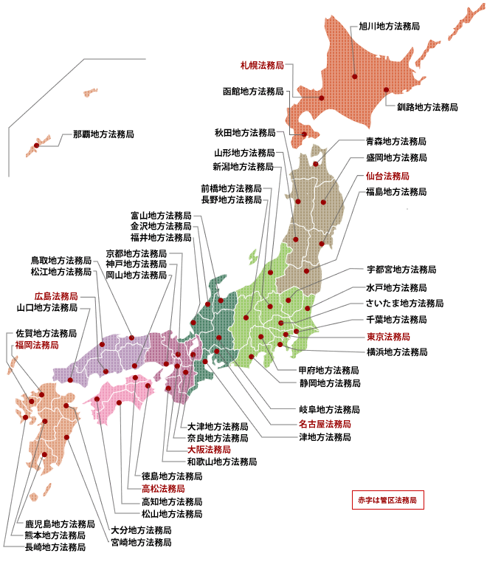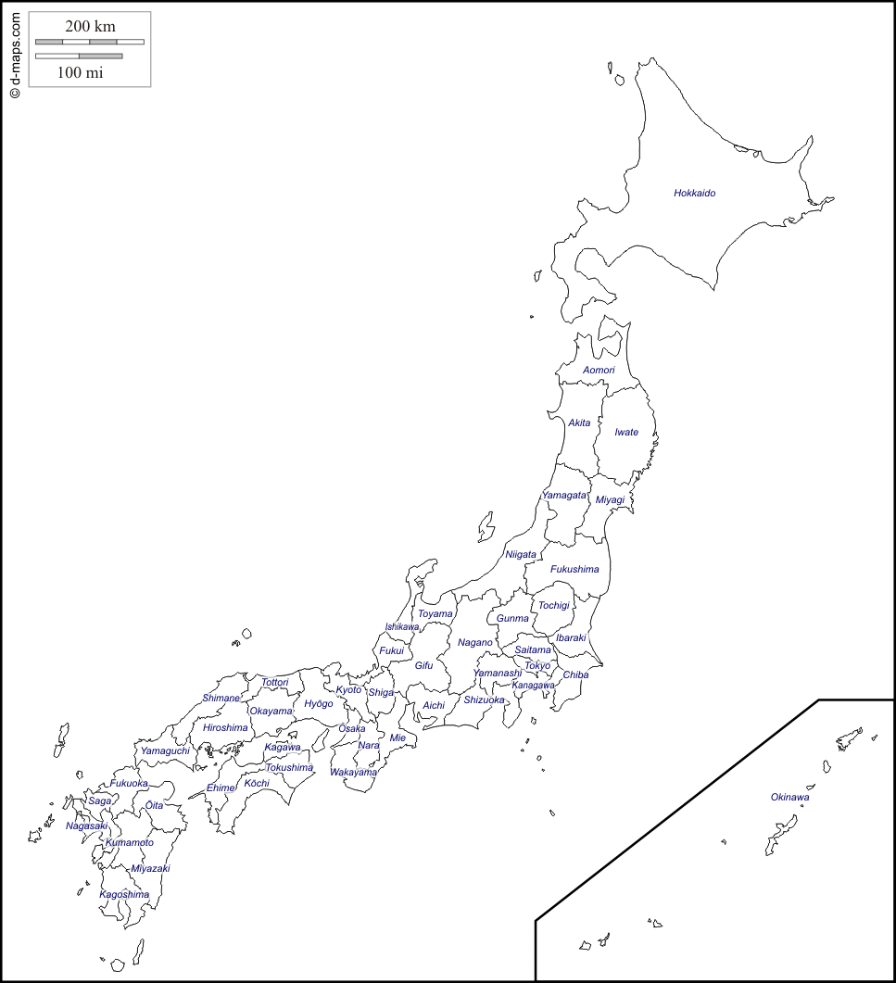**Figure IIa. The Prefectures of Japan[311] Figure IIb. Legal Affairs Bureau Offices[312]**

**Figure IIc. Adoptions Per Household by Prefecture, 2012**



**Figure III. Regional Variation in Adoption Rates (by Frequency), 2006-2016**



**Figure IV. Inheritance Tax Rate Schedules, 1994 – Present**

*All figures in millions of yen. Data on tax rate schedules from the Ministry of Finance.[313]*

*Deduction schedules from the National Tax Agency.[314]*

Basic deduction:

30 million yen + (6 million yen * number of statutory heirs)

Basic deduction:

50 million yen + (10 million yen * number of statutory heirs)

Basic deduction:

50 million yen + (10 million yen * number of statutory heirs)

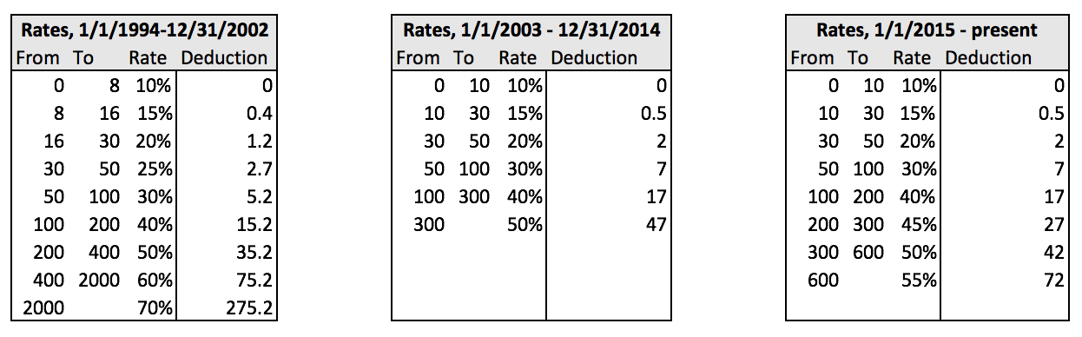

**Figure Va. Marginal and Cumulative Tax Reduction with Additional Statutory Heirs**

*All figures in millions of yen. One of the statutory heirs is assumed to be a spouse.*

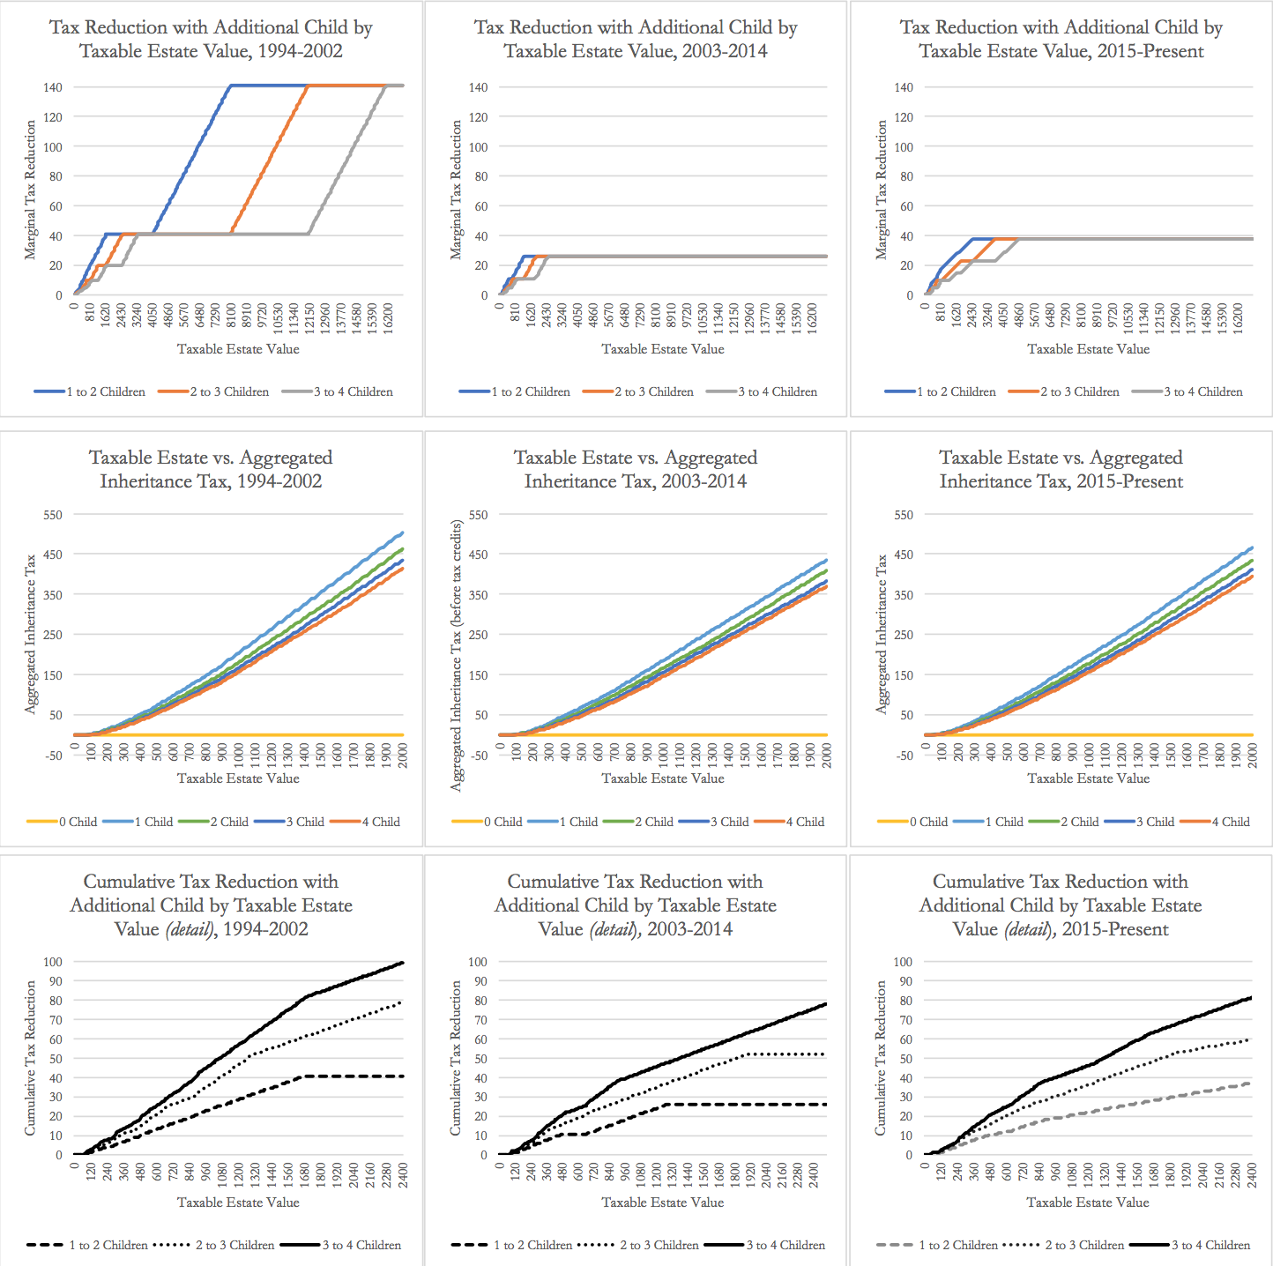

**Notes and Assumptions**

No additional exemptions beyond the basic per-child deduction and spouse tax credit are considered; hence, this constitutes a lower bound on the marginal “returns” to statutory heirs.

The actual allocation of the aggregated inheritance tax is assumed to be equivalent to the statutory allocation for the purposes of the calculation of the spouse tax credit. For example, a spouse is assumed to have a statutory and actual share of 1 with no children, and a share of 0.5 with one or more children.

Note that there are no inheritance tax benefits from having more than 2 adopted children (when there are 0 natural children), or more than 1 (when there is a natural child); the “marginal benefit” of an additional child, given 3 existing children, only applies if the existing children are all natural children. This is due to the 1988 amendment of the Inheritance Tax Act, which limited the number of adopted children of the deceased that count toward deductions.

**Figure Vb. Cumulative “Rate of Return” to Additional Statutory Heirs**

*All figures in millions of yen.*

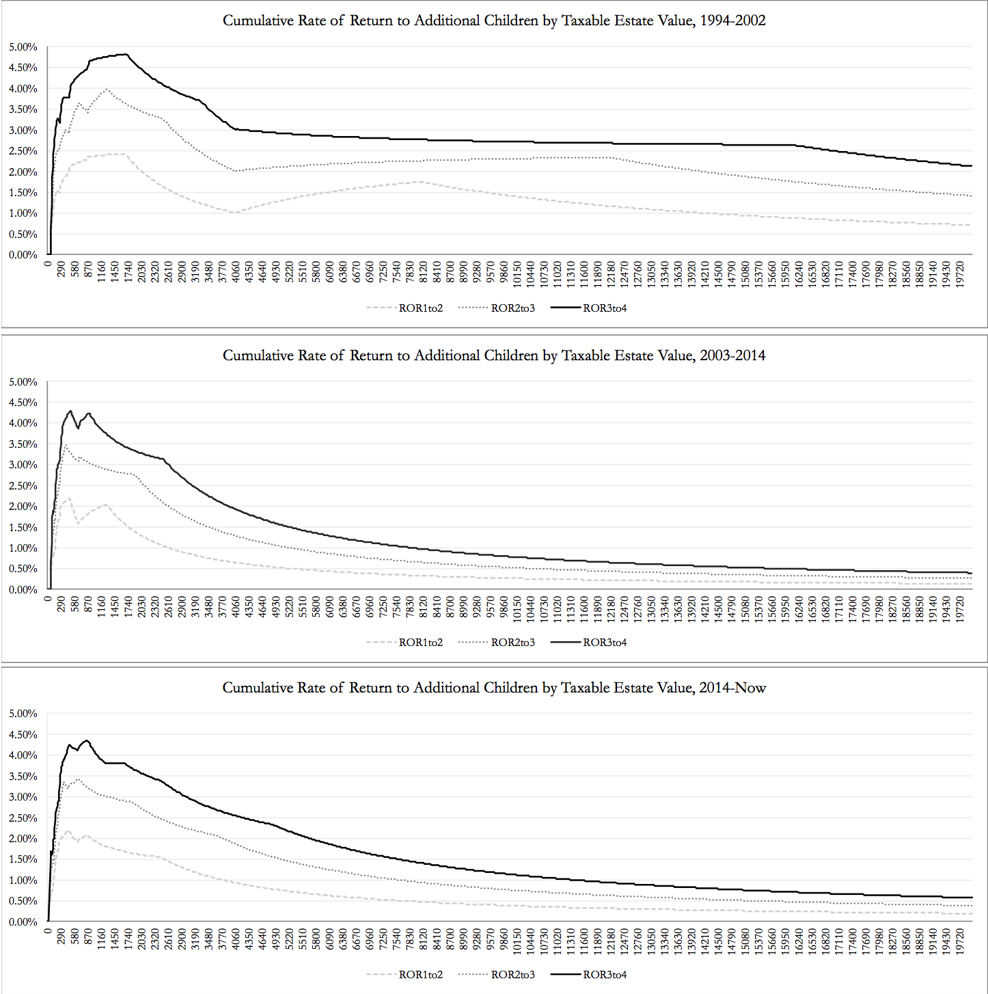

**Figure VI. Correlation Matrix of Key Variables**

|  |  |  |  |  |  |
| --- | --- | --- | --- | --- | --- |
|  | Self-employed elderly | Elderly | Primary industry (%) | Income over 50M yen | Elderly care facility occup. |
| Self-employed elderly | 1.0000 |  |  |  |  |
| Elderly | 0.6489 | 1.0000 |  |  |  |
| Primary industry (%) | 0.6050 | 0.5358 | 1.0000 |  |  |
| Income over 50M yen | -0.5078 | -0.5606 | -0.5176 | 1.0000 |  |
| Elderly care facility occup. | 0.6341 | 0.6158 | 0.4161 | -0.4540 | 1.0000 |

|  |  |  |  |  |  |  |  |  |
| --- | --- | --- | --- | --- | --- | --- | --- | --- |
| **Table Ia. Self-employed Elderly, Full Regression Results** | | | | | | | | |
| **DEPENDENT VARIABLE**: **Adoptions per 10,000** (2007 and 2012)  Year Fixed Effects, SE Clustered by Prefecture | | | | | | | | |
| VARIABLES | 1 | 2 | 3 | 4 | 5 | 6a | 6b | 6c |
|  |  |  |  |  |  |  |  |  |
| Self-employed Elderly | 0.00355** | 0.00439** | 0.00449** | 0.00395** | 0.00336** | 0.00386** | 0.00387** | 0.00423** |
|  | (0.00142) | (0.00180) | (0.00169) | (0.00163) | (0.00166) | (0.00180) | (0.00171) | (0.00177) |
| Elderly |  | -0.000263 | -0.000247 | -0.000447 | -0.000689 | -0.000577 | -0.000694 | -0.000908 |
|  |  | (0.000568) | (0.000605) | (0.000544) | (0.000582) | (0.000727) | (0.000578) | (0.000848) |
| Primary industry (% pref. GDP) |  |  | -1.597 | -6.912 | -5.895 | 1.380 | -8.131 | 7.108 |
|  |  |  | (12.95) | (14.05) | (13.23) | (16.91) | (14.27) | (21.04) |
| People filing income over 50M yen |  |  |  | -0.129*** | -0.120*** |  |  |  |
|  |  |  |  | (0.0402) | (0.0416) |  |  |  |
| Elderly care facility occupants |  |  |  |  | 0.0286 | 0.0324 | 0.0326 | 0.0482* |
|  |  |  |  |  | (0.0218) | (0.0220) | (0.0226) | (0.0249) |
| Year 2012 | -0.433*** | -0.344* | -0.347* | -0.376* | -0.306 | -0.250 | -0.253 |  |
|  | (0.0711) | (0.198) | (0.206) | (0.191) | (0.204) | (0.265) | (0.202) |  |
| Average savings (yen), elderly hh (1) |  |  |  |  |  | 8.63e-09 |  |  |
|  |  |  |  |  |  | (3.86e-08) |  |  |
| Hh. with >100M yen in assets (2) |  |  |  |  |  |  | -6.223 |  |
|  |  |  |  |  |  |  | (5.219) |  |
| Third quartile of hh. net savings (3) |  |  |  |  |  |  |  | 2.35e-09 |
|  |  |  |  |  |  |  |  | (4.03e-08) |
|  |  |  |  |  |  |  |  |  |
| Constant | 5.935*** | 6.623*** | 6.553*** | 7.991*** | 8.755*** | 7.447*** | 8.495*** | 8.251*** |
|  | (0.517) | (1.749) | (1.859) | (1.666) | (1.767) | (1.717) | (1.723) | (2.390) |
|  |  |  |  |  |  |  |  |  |
| Observations | 94 | 94 | 94 | 94 | 94 | 94 | 94 | 47 |
| R-squared | 0.218 | 0.222 | 0.223 | 0.278 | 0.300 | 0.254 | 0.276 | 0.253 |

Robust standard errors in parentheses

*** p<0.01, ** p<0.05, * p<0.1

|  |  |  |  |  |  |  |  |  |
| --- | --- | --- | --- | --- | --- | --- | --- | --- |
| **Table Ib: Self-employed Elderly, with Region Fixed Effects Added** | | | | | | | | |
| **DEPENDENT VARIABLE**: **Adoptions per 10,000** (2007 and 2012)  Year and Region Fixed Effects, SE Clustered by Prefecture | | | | | | | | |
| VARIABLES | 1 | 2 | 3 | 4 | 5 | 6a | 6b | 6c |
| Self-employed Elderly | 0.00221 | 0.00423* | 0.00393 | 0.00372 | 0.00365 | 0.00464 | 0.00388 | 0.00584* |
|  | (0.00161) | (0.00222) | (0.00282) | (0.00278) | (0.00274) | (0.00298) | (0.00285) | (0.00332) |
| Elderly |  | -0.000665 | -0.000678 | -0.000772 | -0.000782 | -0.000820 | -0.000835 | -0.00153* |
|  |  | (0.000546) | (0.000555) | (0.000549) | (0.000586) | (0.000661) | (0.000594) | (0.000843) |
| Primary industry (% pref. GDP) |  |  | 3.312 | -2.282 | -2.147 | 5.206 | -0.917 | 11.53 |
|  |  |  | (23.22) | (24.80) | (24.89) | (22.62) | (24.52) | (30.08) |
| People filing income over 50M yen |  |  |  | -0.100* | -0.0997* |  |  |  |
|  |  |  |  | (0.0551) | (0.0557) |  |  |  |
| Elderly care facility occupants |  |  |  |  | 0.00211 | 0.000855 | 0.00444 | 0.0187 |
|  |  |  |  |  | (0.0208) | (0.0204) | (0.0212) | (0.0287) |
| Chugoku | 0.490 | 0.644* | 0.645* | 0.585* | 0.573* | 0.682* | 0.579* | 0.885*** |
|  | (0.299) | (0.330) | (0.335) | (0.343) | (0.334) | (0.341) | (0.342) | (0.316) |
| Hokkaido | -0.366 | 0.0104 | -0.121 | -0.0710 | -0.0882 | 0.124 | -0.202 | 0.571 |
|  | (0.351) | (0.400) | (0.970) | (0.988) | (0.988) | (1.002) | (0.978) | (1.188) |
| Kansai | -0.640** | -0.604** | -0.606** | -0.599* | -0.600* | -0.584** | -0.625** | -0.386 |
|  | (0.289) | (0.274) | (0.274) | (0.303) | (0.306) | (0.252) | (0.305) | (0.231) |
| Kanto | -0.420 | -0.439 | -0.464 | -0.317 | -0.318 | -0.455 | -0.381 | -0.407 |
|  | (0.387) | (0.373) | (0.416) | (0.412) | (0.416) | (0.424) | (0.415) | (0.510) |
| Kyushu | -0.0168 | -0.0172 | -0.0680 | -0.0579 | -0.0651 | 0.152 | -0.174 | 0.589 |
|  | (0.331) | (0.314) | (0.375) | (0.379) | (0.387) | (0.486) | (0.401) | (0.554) |
| Shikoku | -0.129 | 0.0181 | -0.00346 | 0.0395 | 0.0267 | 0.0343 | 0.0214 | 0.354 |
|  | (0.245) | (0.247) | (0.306) | (0.315) | (0.333) | (0.322) | (0.341) | (0.481) |
| Tohoku | -0.307 | -0.213 | -0.257 | -0.229 | -0.225 | -0.0203 | -0.306 | 0.681 |
|  | (0.475) | (0.434) | (0.547) | (0.541) | (0.544) | (0.579) | (0.551) | (0.692) |
| Year 2012 | -0.462*** | -0.242 | -0.244 | -0.278 | -0.276 | -0.162 | -0.225 |  |
|  | (0.0734) | (0.195) | (0.196) | (0.195) | (0.204) | (0.262) | (0.199) |  |
| Average savings (yen), elderly hh (1) |  |  |  |  |  | 3.60e-08 |  |  |
|  |  |  |  |  |  | (4.29e-08) |  |  |
| Hh. with >100M yen in assets (2) |  |  |  |  |  |  | -5.469 |  |
|  |  |  |  |  |  |  | (6.214) |  |
| Third quartile of hh. net savings (3) |  |  |  |  |  |  |  | 6.98e-08 |
|  |  |  |  |  |  |  |  | (5.14e-08) |
|  |  |  |  |  |  |  |  |  |
| Constant | 6.597*** | 8.321*** | 8.442*** | 9.249*** | 9.291*** | 7.906*** | 9.347*** | 9.123*** |
|  | (0.693) | (1.633) | (1.776) | (1.785) | (1.915) | (1.715) | (2.007) | (2.094) |
| Observations | 94 | 94 | 94 | 94 | 94 | 94 | 94 | 47 |
| R-squared | 0.358 | 0.378 | 0.378 | 0.408 | 0.408 | 0.388 | 0.393 | 0.412 |

Robust standard errors in parentheses

*** p<0.01, ** p<0.05, * p<0.1

**Table Ib. Self-employed Elderly, with Year and Region Fixed Effects, SE Clustered by Prefecture (cont.)**

Household abbreviated to “hh.” Self-employed elderly, elderly, income over 50M yen, and elderly facility occupants are in per 10,000 population terms. “Average savings (yen), elderly hh,” “Hh. with >100M yen in assets” and “Third quartile of hh. net savings” use 2009 and 2014 figures as proxies for their values in 2007 and 2012; (1) refers to the average amount of savings of two-or-more-person households with at least one member who is at least 65 years old and not working. (2) refers to the proportion of two-or-more person households with over 100 million yen in assets. (3) refers to the third quartile of the value of household savings minus liabilities for all households.

|  |  |  |  |  |  |  |  |
| --- | --- | --- | --- | --- | --- | --- | --- |
| **Table IIa. Elderly Farmers, Full Regression Results** | | | | | | | |
| **DEPENDENT VARIABLE**: **Adoptions per 10,000** (2007 and 2012)  Year Fixed Effects, SE Clustered by Prefecture | | | | | | | |
| VARIABLES | 1 | 2 | 3 | 4a | 5a | 5b | 5c |
| Elderly Farmers | 0.00238** | 0.00271** | 0.00193 | 0.00156 | 0.00281** | 0.00195 | 0.00379*** |
|  | (0.000959) | (0.00125) | (0.00130) | (0.00132) | (0.00134) | (0.00134) | (0.00139) |
| Elderly |  | -0.000163 | -0.000300 | -0.000579 | -0.000509 | -0.000542 | -0.000877 |
|  |  | (0.000541) | (0.000508) | (0.000533) | (0.000600) | (0.000532) | (0.000646) |
| People filing income over 50M yen |  |  | -0.106*** | -0.101** |  |  |  |
|  |  |  | (0.0375) | (0.0397) |  |  |  |
| Elderly care facility occupants |  |  |  | 0.0314 | 0.0299 | 0.0344 | 0.0444 |
|  |  |  |  | (0.0243) | (0.0239) | (0.0252) | (0.0267) |
| Year 2012 | -0.460*** | -0.410** | -0.446** | -0.363* | -0.286 | -0.322* |  |
|  | (0.0690) | (0.183) | (0.177) | (0.184) | (0.213) | (0.184) |  |
| Average savings (yen), elderly hh (1) |  |  |  |  | 1.99e-08 |  |  |
|  |  |  |  |  | (2.90e-08) |  |  |
| Hh. with >100M yen in assets (2) |  |  |  |  |  | -3.123 |  |
|  |  |  |  |  |  | (5.247) |  |
| Third quartile of hh. net savings (3) |  |  |  |  |  |  | 1.16e-08 |
|  |  |  |  |  |  |  | (2.70e-08) |
|  |  |  |  |  |  |  |  |
| Constant | 6.705*** | 7.249*** | 8.260*** | 9.027*** | 7.811*** | 8.601*** | 8.829*** |
|  | (0.224) | (1.860) | (1.734) | (1.777) | (1.809) | (1.750) | (2.246) |
|  |  |  |  |  |  |  |  |
| Observations | 94 | 94 | 94 | 94 | 94 | 94 | 47 |
| R-squared | 0.219 | 0.221 | 0.257 | 0.283 | 0.258 | 0.258 | 0.266 |

Robust standard errors in parentheses

*** p<0.01, ** p<0.05, * p<0.1

|  |  |  |  |  |  |  |  |
| --- | --- | --- | --- | --- | --- | --- | --- |
| **Table IIb: Elderly Farmers, with Region Fixed Effects Added** | | | | | | | |
| **DEPENDENT VARIABLE**: **Adoptions per 10,000** (2007 and 2012)  Year and Region Fixed Effects, SE Clustered by Prefecture | | | | | | | |
| VARIABLES | 1 | 2 | 3 | 4a | 5a | 5b | 5c |
|  |  |  |  |  |  |  |  |
| Elderly Farmers | 0.00165 | 0.00262* | 0.00192 | 0.00181 | 0.00275* | 0.00221 | 0.00417** |
|  | (0.00102) | (0.00153) | (0.00162) | (0.00172) | (0.00162) | (0.00167) | (0.00174) |
| Elderly |  | -0.000503 | -0.000554 | -0.000584 | -0.000549 | -0.000641 | -0.00114* |
|  |  | (0.000540) | (0.000547) | (0.000566) | (0.000568) | (0.000572) | (0.000665) |
| People filing income over 50M yen |  |  | -0.0876* | -0.0879* |  |  |  |
|  |  |  | (0.0458) | (0.0468) |  |  |  |
| Elderly care facility occupants |  |  |  | 0.00529 | 0.00314 | 0.00580 | 0.0159 |
|  |  |  |  | (0.0232) | (0.0239) | (0.0241) | (0.0313) |
| Chugoku | 0.397 | 0.460 | 0.438 | 0.413 | 0.446 | 0.413 | 0.638** |
|  | (0.304) | (0.333) | (0.337) | (0.329) | (0.331) | (0.340) | (0.270) |
| Hokkaido | -0.580** | -0.454* | -0.568** | -0.582** | -0.358 | -0.643* | 0.218 |
|  | (0.233) | (0.242) | (0.260) | (0.271) | (0.316) | (0.324) | (0.378) |
| Kansai | -0.634** | -0.617** | -0.628** | -0.629** | -0.611** | -0.642** | -0.414* |
|  | (0.272) | (0.262) | (0.285) | (0.288) | (0.257) | (0.286) | (0.228) |
| Kanto | -0.512 | -0.602* | -0.485 | -0.478 | -0.604* | -0.541 | -0.572 |
|  | (0.332) | (0.336) | (0.338) | (0.342) | (0.339) | (0.334) | (0.390) |
| Kyushu | -0.144 | -0.219 | -0.231 | -0.237 | -0.112 | -0.336 | 0.403 |
|  | (0.328) | (0.347) | (0.359) | (0.366) | (0.432) | (0.389) | (0.464) |
| Shikoku | -0.210 | -0.137 | -0.100 | -0.124 | -0.138 | -0.131 | 0.175 |
|  | (0.261) | (0.258) | (0.267) | (0.286) | (0.282) | (0.300) | (0.346) |
| Tohoku | -0.468 | -0.486 | -0.460 | -0.435 | -0.364 | -0.529 | 0.297 |
|  | (0.488) | (0.476) | (0.471) | (0.482) | (0.493) | (0.499) | (0.521) |
| Year 2012 | -0.476*** | -0.322* | -0.370* | -0.362* | -0.292 | -0.310* |  |
|  | (0.0687) | (0.178) | (0.189) | (0.194) | (0.197) | (0.185) |  |
| Average savings (yen), elderly hh (1) |  |  |  |  | 1.79e-08 |  |  |
|  |  |  |  |  | (3.12e-08) |  |  |
| Hh. with >100M yen in assets (2) |  |  |  |  |  | -4.612 |  |
|  |  |  |  |  |  | (5.151) |  |
| Third quartile of hh. net savings (3) |  |  |  |  |  |  | 5.46e-08 |
|  |  |  |  |  |  |  | (3.69e-08) |
|  |  |  |  |  |  |  |  |
| Constant | 7.114*** | 8.809*** | 9.410*** | 9.490*** | 8.541*** | 9.593*** | 9.361*** |
|  | (0.309) | (1.856) | (1.858) | (1.909) | (1.885) | (1.997) | (2.148) |
| Observations | 94 | 94 | 94 | 94 | 94 | 94 | 47 |
| R-squared | 0.361 | 0.375 | 0.396 | 0.397 | 0.378 | 0.386 | 0.393 |

Robust standard errors in parentheses

*** p<0.01, ** p<0.05, * p<0.1

**Table IIb. Self-employed Elderly, with Year and Region Fixed Effects, SE Clustered by Prefecture (cont.)**

Household abbreviated to “hh.” Elderly farmers, elderly, income over 50M yen, and elderly facility occupants are in per 10,000 population terms. “Average savings (yen), elderly hh,” “Hh. with >100M yen in assets” and “Third quartile of hh. net savings” use 2009 and 2014 figures as proxies for their values in 2007 and 2012; (1) refers to the average amount of savings of two-or-more-person households with at least one member who is at least 65 years old and not working. (2) refers to the proportion of two-or-more person households with over 100 million yen in assets. (3) refers to the third quartile of the value of household savings minus liabilities for all households.

**X. Data Sources (for Section VI)**

File links as of May 9, 2018.

**original_bureautoprefecture:**

Legal Affairs Bureau.

http://houmukyoku.moj.go.jp/homu/static/kakukyoku_index.html

*Table created from map provided at link above. Lists the Japanese names of legal affairs bureaus, the corresponding English transliteration of the bureau name, and the corresponding prefecture.*

**original_adoptions2006:**

Ministry of Justice, *Koseki Tokei* [family registry statistics].

https://www.e-stat.go.jp/stat-search/file-download?statInfId=000001098210&fileKind=0

*Includes data on adoptions registered in 2006, by legal affairs bureau.*

**original_adoptions2007:**

Ministry of Justice, *Koseki Tokei* [family registry statistics].

https://www.e-stat.go.jp/stat-search/file-download?statInfId=000001294053&fileKind=0

*Includes data on adoptions registered in 2007, by legal affairs bureau.*

**original_adoptions2008:**

Ministry of Justice, *Koseki Tokei* [family registry statistics].

https://www.e-stat.go.jp/stat-search/file-download?statInfId=000004788978&fileKind=0

*Includes data on adoptions registered in 2008, by legal affairs bureau.*

**original_adoptions2009:**

Ministry of Justice, *Koseki Tokei* [family registry statistics].

https://www.e-stat.go.jp/stat-search/file-download?statInfId=000008205119&fileKind=0

*Includes data on adoptions registered in 2009, by legal affairs bureau.*

**original_adoptions2010:**

Ministry of Justice, *Koseki Tokei* [family registry statistics].

https://www.e-stat.go.jp/stat-search/file-download?statInfId=000012449188&fileKind=0

*Includes data on adoptions registered in 2010, by legal affairs bureau.*

**original_adoptions2011:**

Ministry of Justice, *Koseki Tokei* [family registry statistics].

https://www.e-stat.go.jp/stat-search/file-download?statInfId=000014892138&fileKind=0

*Includes data on adoptions registered in 2011, by legal affairs bureau.*

**original_adoptions2012:**

Ministry of Justice, *Koseki Tokei* [family registry statistics].

https://www.e-stat.go.jp/stat-search/file-download?statInfId=000022981889&fileKind=0

*Includes data on adoptions registered in 2012, by legal affairs bureau.*

**original_adoptions2013:**

Ministry of Justice, *Koseki Tokei* [family registry statistics].

https://www.e-stat.go.jp/stat-search/file-download?statInfId=000027231372&fileKind=0

*Includes data on adoptions registered in 2013, by legal affairs bureau.*

**original_adoptions2014:**

Ministry of Justice, *Koseki Tokei* [family registry statistics].

https://www.e-stat.go.jp/stat-search/file-download?statInfId=000031283440&fileKind=0

*Includes data on adoptions registered in 2014, by legal affairs bureau.*

**original_adoptions2015:**

Ministry of Justice, *Koseki Tokei* [family registry statistics].

https://www.e-stat.go.jp/stat-search/file-download?statInfId=000031457734&fileKind=0

*Includes data on adoptions registered in 2015, by legal affairs bureau.*

**original_adoptions2016:**

Ministry of Justice, *Koseki Tokei* [family registry statistics].

<https://www.e-stat.go.jp/stat-search/file-download?statInfId=000031626794&fileKind=0>

*Includes data on adoptions registered in 2016, by legal affairs bureau.*

**original_population2000to2015:**

Ministry of Internal Affairs and Communications, “Population Census.”

<https://www.e-stat.go.jp/en/stat-search/files?page=1&layout=dataset&toukei=00200524&bunya_l=02&tstat=000000090001&stat_infid=000013168609&result_page=1>

*Population by Age (Five-Year Groups) for Prefectures (as of October 1 of Each Year) - Total population (from 2000 to 2015)*

**original_2007farmers:**

Bureau of Statistics, “Employment Status Survey.”

<https://www.e-stat.go.jp/stat-search/files?page=1&layout=datalist&toukei=00200532&tstat=000001017285&cycle=0&tclass1=000001018594&tclass2=000001019318&stat_infid=000001234428&cycle_facet=cycle&second=1&second2=1>

*Data on the number of working people by occupation (including farming), gender, age, and prefecture.*

**original_2012farmers:**

Bureau of Statistics, “Employment Status Survey.”

<https://www.e-stat.go.jp/stat-search/files?page=1&layout=datalist&toukei=00200532&tstat=000001058052&cycle=0&tclass1=000001060135&tclass2=000001060136&stat_infid=000021430922&second2=1>

*Data on the number of working people by occupation (including farming), gender, age, and prefecture.*

**original_2007selfemployed:**

Bureau of Statistics, “Employment Status Survey.”

https://www.e-stat.go.jp/stat-search/files?page=1&layout=datalist&toukei=00200532&tstat=000001017285&cycle=0&tclass1=000001018594&tclass2=000001019318&stat_infid=000001234422&second=1&second2=1

*Data on the number of working people by employment status (including the self-employed), gender, age, and prefecture.*

**original_2012selfemployed:**

Bureau of Statistics, “Employment Status Survey.”

https://www.e-stat.go.jp/stat-search/files?page=1&toukei=00200532&tstat=000001058052&second2=1&cycle=0&tclass1=000001060135&tclass2=000001060136&layout=datalist&stat_infid=000021430913

*Data on the number of working people by employment status (including the self-employed), gender, age, and prefecture.*

**original_elderlycare2006to2016:**

Ministry of Health, Labour, and Welfare, “Survey of Social Welfare Institutions.”

https://www.e-stat.go.jp/stat-search/files?page=1&toukei=00450041&tstat=000001030513

*Data on the number of occupants and capacity of social welfare institutions by prefecture.*

**original_numelderlyincomeallhh2014:**

Ministry of Internal Affairs and Communications, “National Survey of Income and Expenditure.”

<https://www.e-stat.go.jp/stat-search/files?page=1&layout=datalist&toukei=00200564&tstat=000001073908&cycle=0&tclass1=000001073965&tclass2=000001074840&tclass3=000001077457&stat_infid=000031346279>

*Includes data on average yearly income (in thousand yen) and the number of people 65 years and older per household by prefecture for all households in 2014.*

**original_primaryindustryGDP2001to2014:**

Cabinet Office, “Table 2.4: Prefectural Production by Economic Activity”

<http://www.esri.cao.go.jp/jp/sna/data/data_list/kenmin/files/contents/main_h26.html>

*Data on the composition of prefectural GDP (including breakdown by primary, secondary, and tertiary industry) from 2001 to 2014.*

**original_thirdquartilenetsavingsallhh2014:**

Ministry of Internal Affairs and Communications, “National Survey of Income and Expenditure.”

https://www.e-stat.go.jp/stat-search/file-download?statInfId=000031379418&fileKind=0

*Data on the distribution of households by type of assets, property group of assets and prefecture for all households in 2014.*

**original_elderlyhhavgsavings2009:**

Ministry of Internal Affairs and Communications, “National Survey of Income and Expenditure.”

https://www.e-stat.go.jp/stat-search/file-download?statInfId=000008303687&fileKind=0

*Includes data on the average amount of savings (in thousands of yen) by prefecture for households with two or more people, including at least one member not working and 65 years old and over in 2009.*

**original_elderlyhhavgsavings2014:**

Ministry of Internal Affairs and Communications, “National Survey of Income and Expenditure.”

<https://www.e-stat.go.jp/stat-search/file-download?statInfId=000031346287&fileKind=0>

*Includes data on the average amount of savings (in thousands of yen) by prefecture for households with two or more people, including at least one member not working and 65 years old and over in 2014.*

**original_prophhassets2plushh2009:**

Ministry of Internal Affairs and Communications, “National Survey of Income and Expenditure.”

https://www.e-stat.go.jp/stat-search/file-download?statInfId=000008887767&fileKind=0

*Data on the distribution of assets for households with 2 or more members, by prefecture in 2009.*

**original_prophhassets2plushh2014:**

Ministry of Internal Affairs and Communications, “National Survey of Income and Expenditure.”

https://www.e-stat.go.jp/stat-search/file-download?statInfId=000031379417&fileKind=0

*Data on the distribution of assets for households with 2 or more members, by prefecture in 2014.*

**original_numhouseholds2014:**

Ministry of Internal Affairs and Communications.

【総計】平成26年住民基本台帳人口・世帯数、平成25年度人口動態（都道府県別）

<http://www.soumu.go.jp/menu_news/s-news/01gyosei02_02000062.html>

*Data on the number of households per prefecture in 2014.*

**original_2014businessbysize:**

Statistics Bureau, “Table C, “Economic Base,” of the “Social Indicators by Prefecture.”

http://www.e-stat.go.jp/SG1/estat/ListE.do?bid=000001084000&cycode=0

*Data on the number of businesses by number of employees by prefecture in 2014*

1. Ministry of Justice, *Yoshi engumi nado ni kansuru jittaichosa kekkagaiyo [Overview of results of survey concerning adoption]* (2010)*.*
2. Moriguchi (2012).
3. Moore (1970), p. 617
4. Kato (2013), p. 3; Paulson (2010), p. 15.
5. Hayami, Akira and Satomi, Kurosu, “Regional Diversity in Demographic and Family Patterns in Pre-industrial Japan” in Hayami (2009), p. 281.
6. See *The Economist* (2013) and *Business Insider* (2017)
7. *Business Insider* (2017)
8. Paulson (2010), p. 231.
9. Sorimachi (2006), p. 61.
10. Becker (1991), p. 15
11. Ibid., p. ix
12. Note that the reciprocity of adult adoptive arrangements may not hold in the case of fraudulent registrations of adult adoption without the consent of the adopters, as noted in Sorimachi (2006), p. 61.
13. Barthold and Ito (1992), p. 238-239
14. Ratliff (2011), p. 1790
15. See Hamaaki, Hori, and Murata (2016) and Horioka, Gahramanov, Hayat, and Tang (2018) on the strategic bequest motive in Japan.
16. Ibid.
17. Ibid.
18. Hozumi (1912), cited in Bryant (1990), p. 321
19. “*Kaigoshitemo isan nashi? Yome ga sozoku de mukuwareru niwa: yuigon kinyuu, yoshiengumi mo shiya ni irete*” [“No inheritance, despite providing care? For daughter-in-law to be rewarded through inheritance”] Nikkei (2010). In practice, the actual distribution of bequests is not identical to the statutory share since the estate is divided by negotiation among surviving family members (Hamaaki, Hori, and Murata, 2016).
20. Paulson (2010), p. 233
21. See Satsuki, Kawano, “Finding Common Ground: Family, Gender, and Burial in Contemporary Japan” in Traphagan and Knight (2003)
22. Horioka (2014) and the “Preferences Parameters Study of Osaka University, cited in Hamaaki, Hori, and Murata (2016), p. 120, 125.
23. Hamaaki, Hori, and Murata (2016)
24. Ibid., 18.
25. Ibid., 12.
26. Paulson (2010), p. 233
27. Mehrotra et al. (2013) p. 852; Bloom and Van Reenen (2007), p. 1359
28. Bryant (1990), p. 322
29. On filial coresidence and elderly care provision: Ogawa and Retherford (1993) and Aihara and Nakagawa (1963) *II*; on the self-employed and agriculture: Paulson (2010) and Yashiro (1996); on inheritance taxes: Barthold and Ito (1992), p. 249-250.
30. Umeda (2017); Ministry of Finance, *Sozokuzei no kazeikensu wariai oyobi sozokuzei/zoyozeishu no suii* (2017)
31. Yamashige, Shinji (2013); Ministry of Health, Labour and Welfare, *Rojinkankei shisetsu no jokyo* (2007)
32. The Small and Medium Enterprise Agency Finance Division, *Shacho kotairitsu suii* [Changes in CEO succession rate] (2004); The Small and Medium Enterprise Agency, *Chushokigyo no jigyoshokei no genjo nit suite* [Regarding the Current State of SME Business Succession] (2017)
33. Huard (1956), p. 749; Bryant (1990) p. 302
34. Kurosu (1997); Moore (1970); Paulson (2010)
35. Mignot, Jean-François (2018)
36. Ratliff (2011), p. 1779
37. 37 Barthold and Ito (1992)
38. See Mehrotra et al. (2013), p. 842; *The Economist* (2013); *Business Insider* (2017), among others
39. Civil Code of Japan, Article 792 and 793.
40. Civil Code of Japan, Article 798.
41. Ministry of Justice, *Yoshi engumi nado ni kansuru jittaichosa kekkagaiyo [Overview of results of survey concerning adoption]* (2010)*.*
42. Tanaka and Miura (1983), cited in Moriguchi and Kang (2016), p. 4
43. Yamahata (1977) cited in Paulson (2010), p. 101
44. See Paulson (2010), p. 256-7.
45. Aihara and Nakagawa (1963), *Seinenyoshi no jittai (I)*.
46. Ibid., 86-87.
47. Aihara and Nakagawa (1963)*, Seinenyoshi no jittai (II*), p. 102.
48. Ibid., p. 104.
49. Ibid., p. 121.
50. Ibid., p. 106 (unofficial translation). Respondents were free to choose multiple motives.
51. Bachnik (1983), p. 161
52. Ibid.
53. Aihara and Nakagawa (1963) *II,* p. 121.
54. Ibid., p. 111.
55. Ibid., p. 112.
56. Ibid., p. 113, p. 117.
57. Aihara and Nakagawa (1963) *I,* p. 95.
58. Aihara and Nakagawa (1963) *II,* p. 118, 120.
59. Ibid., p. 118
60. Paulson (2010), p. 169
61. Ibid., p. 171, p. 173
62. Moore (1970), p. 619.
63. Kurosu (1997), p. 175
64. Paulson (2010), p. 166
65. Kurosu (1997), p. 171
66. Paulson (2010), p. 168
67. Becker (1991), p. 344
68. Kurosu., p. 179
69. Bachnik (1983), p. 161
70. Ibid., p. 163
71. Ibid., p. 165
72. Ibid., p. 170
73. Kurosu (1997), p. 172
74. Moore (1970), p. 628
75. Ibid., p. 630
76. Paulson (2010), p. 167
77. Kurosu (1970), p. 178-180, 184, 176
78. Moore (1970), p. 626
79. Moore (1970), p. 623
80. Paulson (2010), p. 167
81. Moore (1970), p. 632
82. Paulson (2010), p. 166
83. Huard (1956), p. 745; Moore (1970), p. 632
84. Paulson (2010), p. 169
85. Ibid.
86. Ibid., 168
87. Paulson (2010), p. 192
88. Paulson (2010), p. 230
89. Bryant (1990), p. 330-331.
90. Ibid., p. 329
91. Ibid., p. 330
92. Ibid., p. 332
93. Ibid.
94. Mehrotra et al. (2013), p. 842; “Adult adoption a key ingredient to success in Japanese business” The New Economy (2014)
95. Fruin (1980), p. 436.
96. Ibid., p. 440
97. Cited in Bryant (1990), p. 321
98. Umeda (2017)
99. Ibid.
100. Bryant (1990), p. 321
101. Barthold and Ito (1992), p. 268
102. Ibid.
103. Ibid.
104. Ernst & Young Tax Co., “Worldwide Estate and Inheritance Tax Guide” (2017), p. 190
105. Umeda (2017)
106. Umeda (2017). The Supreme Court backed the adoption of a grandson by a man from Fukushima Prefecture before the man died in 2013 at the age of 82, overriding the Tokyo High Court’s ruling against him. The Tokyo High Court had said that the adoption occurred only because the man was advised to do so by his tax accountant; the Supreme Court argued that adoption for inheritance tax reduction can coexist with the intention to build a parent-child relationship.
107. Huard (1956), p. 744
108. Bryant (1990) p. 302
109. Bryant (1990) p. 330
110. Ibid. Quotation: Cachard, Henry. *The French Civil Code with the Various Amendments Thereto As in Force on March 15, 1895* (1895), p. 90 (art. 346).
111. Mignot (2018), p. 5.
112. Moriguchi (2010), p. 344; these high child adoption rates may merely reflect the impact of World War II
113. Ibid., p. 342
114. Bryant (1990), p. 301
115. Ibid.
116. Ratliff (2011), p. 1779
117. Huard (1956), p. 789
118. Mignot (2018), p. 6.
119. Bryant (1990), p. 331, p. 334
120. Ibid, p. 333-334
121. Ratliff (2011), p.1788
122. KS Stat § 59-2139 (2017)
123. LA Civil Code 212 (2017). The quotation refers to the case of adoptions of adults other than stepchildren.
124. Huard (1956), p. 746
125. Mignot (2018), p. 4.
126. Ibid.
127. Bachnik (1983), p. 162. Morris (1895), p.145-6.
128. Beardsley, Hall, and Ward (1959), Pelzel (1970), and Bachnik (1983), cited in Mehrotra et al. (2013), p. 842
129. Mignot (2018), p. 10
130. Ibid., 11.
131. Kato (2013), p. 20
132. Hayami, Akira and Satomi Kurosu, “Regional Diversity in Demographic and Family Patterns in Pre-industrial Japan” in Hayami (2009), p. 280.
133. Paulson (2010), p. 194
134. Kato (2013), p. 21, Hayami and Kurosu (2009), p. 284.
135. Kato (2013), p. 20
136. Hayami and Kurosu (2009), p. 282.
137. Ibid., p. 286
138. Ibid., p. 288
139. Ibid., p. 290
140. Ibid.
141. Paulson (2010), p. 169
142. It is worth noting that, strictly speaking, Mignot’s theory would apply to the case of unrelated adult adoption; both the Aihara and Nakagawa survey and the 2010 Ministry of Justice survey imply that most adoptions are within the family.
143. Aihara and Nakagawa (1963), p. 106, 111.
144. Ibid., p. 109
145. Horioka, “Why do People Leave Bequests? For Love or Self-Interest?” (2014), p. 4
146. Ibid., p. 15
147. Barthold and Ito (1992), p. 238; Paulson (2010), p. 197; Mehrotra et al. (2013)
148. Horioka (2014), p. 5
149. Yamahata (1977) cited in Paulson (2010), p. 101
150. Ogawa and Rutherford (1993), p. 588
151. Paulson (2010), p. 231, 233.
152. Ogawa and Rutherford (1993) and Ruggles (2007) argue that social norms lag behind socioeconomic conditions in the context of elderly care and intergenerational coresidence in the U.S., respectively. Ogawa and Rutherford (1993) note the speed of Japan’s demographic transition.
153. Ogawa and Rutherford (1993), p. 588.
154. On social welfare provision and coresidence: Yashiro (1996), p. 92; on inheritance tax reform and adoption: Umeda (2017)
155. Ibid.
156. The figure is the author’s. On tax reduction and adult adoption: Barthold and Ito (1992); on bequest behavior in Japan: Horioka (2014) and Hamaaki, Hori, and Murata (2016); (large-scale, public) enterprise succession and adult adoption: Mehrotra et al. (2013); the historical role of adult adoption and enterprise succession: Paulson (2010); elderly care and adult adoption: Aihara and Nakagawa (1963) *II,* p. 121.
157. Aihara and Nakagawa (1963) *II*, p. 109.
158. The lack of detailed national-level survey data on adult adoption hinders conclusively determining a causal relationship between motives; the figure is a conjecture based on the observations on elderly care, enterprise succession, and tax reduction in the literature (see footnote 150), and the motives cited in Aihara and Nakagawa (1963) *II*.
159. Bachnik (1983), p. 163
160. In many coresident households, the son’s wife is the principal caregiver: Ogawa and Retherford (1993), p. 588.
161. Aihara and Nakagawa (1963) *II,* p. 106, 111.
162. Ogawa and Rutherford (1993), p. 588.
163. U.S. coresidence rate from Ruggles (2007), p. 1.
164. Takagi and Silverstein (2011), p. 1560.
165. Ruggles (2007), p. 24.
166. Takagi and Silverstein (2011), p. 1561.
167. Horioka, Gahramanov, Hayat, and Tang (2018), p. 120; Ruggles (2007), p. 3
168. Ruggles (2007), p. 7; Ogawa and Rutherford (1993), p. 587.
169. Ruggles (2007), p. 2.
170. Ibid, p. 3.
171. Ibid., p. 2, 16.
172. Takagi and Silverstein (2011), p. 1559, 1560.
173. Yashiro (1996), p. 105
174. Ogawa and Retherford (1993), p. 586.
175. Ibid.
176. Ibid.
177. Becker (1991), p. 343
178. Ibid., p. 344; Ogawa and Retherford (1993), p. 586.
179. Ibid.
180. Ruggles (2007), p. 4
181. Becker (1991), p. 348; Ruggles (2007), p. 3, 5.
182. Mehrotra et al. (2013), p. 841, p. 843.
183. Ruggles (2007), p.24; Yamashige (2013); Mignot (2018), p. 5.
184. Ruggles (2007), p. 3
185. Ibid., p. 18; Ogawa and Retherford (1993), p. 589; Takagi and Silverstein (2011), p. 1577
186. Paulson (2010), p. 197.
187. Ruggles (2007), p. 16, 17
188. Aihara and Nakagawa (1963) *II,* p. 121
189. Ogawa and Retherford (1993), p. 587
190. Kotlikoff and Spivak p. 373, 380.
191. Ogawa and Retherford (1993), p. 587.
192. Yashiro (1996), p. 90.
193. Raymo et al. (2004), p. S156.
194. Ibid., p. S160.
195. See Horioka (2014) and Niimi (2016)
196. U.S. Bureau of Labor Statistics, retrieved from FRED, <https://fred.stlouisfed.org/series/JPNPEMANA> and https://fred.stlouisfed.org/series/USAPEMANA
197. Statistics Bureau, Ministry of Internal Affairs and Communications. <http://www.stat.go.jp/data/roudou/longtime/03roudou.html>

     Family employee, translated from 家族従業者, refers to people working in businesses run by a (self-employed) family member, e.g. farmers and storekeepers.
198. Ogawa and Retherford (1993), p. 587, 588
199. Horioka, Gahramanov, Hayat, and Tang (2018), p. 120
200. Ibid., p. 125.
201. Hamaaki, Hori, and Murata (2016), p. 21, 35.
202. Horioka (2014), p. 13
203. Yashiro (1996), p. 100.
204. Ibid.
205. Traphagan, “Contesting Coresidence: Women, In-laws, and Health Care in Rural Japan” in Traphagan and Knight (2003), p. 216
206. Horioka (2014), p. 8.
207. Raymo and Kaneda, “Changes in the Living Arrangements of Japanese Elderly: The Role of Dempgrahic Factors” in Traphagan and Knight (2003), p. 30; Yashiro (1996) p.
208. Aihara and Nakagawa (1963) *II,* p. 112.
209. Hamaaki, Hori, and Murata (2016)
210. Horioka (2014), p. 9-10.
211. Ibid.
212. Altonji, Hayashi, and Kotlikoff (2000) cited in Horioka (2014), p. 7
213. Nishiyama (2002), p. 897
214. Horioka (2014), p. 7, 10
215. Paulson (2010), p. 80
216. Ibid, p. 81; Hamaaki, Hori, and Murata (2016) p. 7
217. Ruggles (2007), p. 17
218. Aihara and Nakagawa (1963) *II,* p. 113.
219. Paulson (2010), p. 203
220. Horioka (2014), p. 17, p. 34
221. Cited in Horioka, Gahramanov, and Tang (2018), p. 120.
222. Hamaaki, Hori, and Murata (2016), p. 1
223. Paulson (2010), p. 200
224. Ibid, p. 203
225. Ibid., p. 234
226. Ibid., p. 194.
227. Okamoto (1992), p. 403-404; Ogawa and Retherford (1993), p. 588
228. Ogawa and Retherford (1993), p. 588
229. Raymo and Kaneda in Traphagan and Knight (2003), p. 30
230. Okamoto (1992), p. 403
231. Ibid; Ogawa and Retherford (1993), p. 590
232. Ibid., p. 590.
233. Ogawa and Retherford (1993), p. 589-590. "*Expect”* refers to the percent of respondents answering, "expect to depend on children" to, "Are you planning to depend on your children in your old age (including adoption children, if any?*”*; *Good Custom + Natural Duty"* refers tothe sum of the percent of respondents answering, "good custom" and "natural duty as children" to "What is your opinion about children caring for their elderly parents?"
234. Raymo and Kaneda in Traphagan and Knight (2003), p. 31
235. Horioka, Gahramanov, Hayat, and Tang (2018), p. 134
236. Knight and Traphagan, “The Study of the Family in Japan: Integrating Anthropological and Demographic Approaches” in Traphagan and Knight (2003), p. 16-17.
237. Survey of Social Welfare Institutions, Social Statistics Office, Ministry of Health, Labour, and Welfare. http://www.stat.go.jp/data/chouki/23.html
238. Ruggles (2007), p. 18
239. U.S. Bureau of Labor Statistics, retrieved from FRED; Statistics Bureau, Ministry of Internal Affairs and Communications; Ogawa and Retherford (1993); Yamashige (2013)
240. Jenike, Brenda Robb, “Parent Care and Shifting Family Obligations in Urban Japan” in Traphagan and Knight (2003), p. 183
241. Bloom and Van Reenen (2007), p. 1361, 1351
242. Ibid, p. 1390
243. Ibid, p. 1383
244. Cited in Holtz-Eakin, et. al (1993)
245. Bloom and Van Reenen (2007), p. 1359, 1354
246. Ibid., p. 1359
247. Mehrotra et al. (2013), p. 844
248. Mehrotra et al. (2013), p. 848
249. Ibid., p. 849
250. Bryant (1990), p. 320
251. Mullins and Schoar (2016), p. 42
252. Ibid., 24
253. Sakano and Lewin (1999), p. 668
254. Bryant (1990), p. 308
255. Bloom and Van Reenen (2007), p. 1382
256. Niimi (2016), p. 1
257. Kopczuk (2013), cited in Niimi (2016), p. 9
258. Barthold and Ito (1992), p. 236-7
259. Ernst & Young Tax Co., “Worldwide Estate and Inheritance Tax Guide” (2017)
260. Barthold and Ito (1992), p. 249
261. Ibid.
262. Ibid., p. 237
263. Umeda (2017)
264. Bryant (1990), p. 323. The validity of adoption depends upon the existence of the intent to create a parent-child relationship.
265. Data on 1988 inheritance tax tables from Barthold and Ito (1992), p. 250
266. “*Sozoku Jirei Bunseki; Shisankademo Yuigon ga aru no wa 18%!* [Inheritance case analysis: among the wealthy 18% leave wills]” PR Times
267. “*Sozokunin no kazu wa? Yoshi no wariai wa?...* [What is the number of successors? What is the proportion of adoptees? What is the proportion that write wills? The licensed tax accountant corporation Legacy publishes the 2018 inheritance case analysis]” PR Times
268. Niimi (2016), p. 11
269. Ibid., p. 11-12.
270. Bryant (1990), p. 323
271. Ibid., p. 304
272. Ibid., Ernst & Young Tax Co., “Worldwide Estate and Inheritance Tax Guide” (2017)
273. Bryant (1990), p. 322; Barthold and Ito (1992), p. 238
274. Strength of the bequest motive: Yashiro (1996), p. 100. A 1990 Bank of Japan survey found that the proportion of Japanese parents with real and financial assets seeking to leave bequests to their children was higher among self-employed households (particularly farming households) and the older generation. Eldest son succession norms: Paulson (2010) p. 203. Proportion of owners: Aihara and Nakagawa (1963) *II* p. 104.
275. “*Sozoku Jirei Bunseki: Shisankademo Yuigon ga aru no wa 18%!”* PR Times.
276. Hansen (2007), p. 5
277. Ibid., p. 6-8.
278. Moriguchi (2010), p. 354.
279. Yashiro (1996), p. 104
280. Ministry of Justice (2010). Aihara and Nakagawa (1963) *II,* p. 102.
281. Moriguchi (2012)
282. Yashiro (1996)
283. Niimi (2016), p. 3; *Kakei to Chochiku ni Kansuru Chosa* [Survey on Households and Saving]

     https://www.yu-cho-f.jp/research/questionnaire_survey/family_budget/h25/survey_report.pdf
284. Niimi (2016), p. 19, 25.
285. Ministry of Justice, *Koseki Tokei*, <http://www.moj.go.jp/housei/toukei/toukei_ichiran_koseki.html>. The data set for each year is entitled “*Homukyoku oyobi chiho homukyoku kannaibetsu todokede jiken* [Registration cases, by legal affairs bureau and regional legal affairs bureau]*”*
286. It is worth noting that adoptions may be registered either at the current place of residence of the registrant (the adopter or adoptee), or the bureau where the registrant’s *koseki* (family registry) is stored. The aggregated adoption data may not reflect the prefecture in which the adoptee and adopter reside. A key assumption in this empirical exercise is that the location of the *koseki* record corresponds to the current residence of the adopter in most cases.
287. Aihara and Nakagawa (I) (1963), p. 87
288. Bureau of Statistics, *Shugyo Kozo Kihon Chosa,*

     https://www.e-stat.go.jp/stat-search/files?page=1&toukei=00200532&tstat=000001058052&second2=1
289. Ministry of Health, Labor, and Welfare, “Overview of Employment Measures for Older Persons,”

     http://www.mhlw.go.jp/file/06-Seisakujouhou-10500000-Daijinkanboukokusaika/0000064248.pdf
290. http://www.stat.go.jp/data/shugyou/2012/index.html
291. The relationship is positive and statistically significant at the one-percent level in the combined 2007 and 2012 data, as well as in each year (2007 and 2012) considered separately.
292. National Tax Agency. http://www.nta.go.jp/publication/statistics/kokuzeicho/tokei.htm
293. National Survey of Income and Expenditure.

     <https://www.e-stat.go.jp/stat-search/file-download?statInfId=000031379417&fileKind=0> (2014);

     <https://www.e-stat.go.jp/stat-search/file-download?statInfId=000008887767&fileKind=0> (2009)
294. Ibid. <http://www.stat.go.jp/data/zensho/2014/index.htm>
295. Ibid. <https://www.e-stat.go.jp/stat-search/file-download?statInfId=000031346287&fileKind=0> (2014); <https://www.e-stat.go.jp/stat-search/file-download?statInfId=000008303687&fileKind=0> (2009)
296. Cabinet Office, “Table 2.4: Prefectural Production by Economic Activity,” http://www.esri.cao.go.jp/jp/sna/data/data_list/kenmin/files/contents/main_h26.html;

     Ministry of Internal Affairs and Communications, Survey of Social Welfare Institutions*,* https://www.e-stat.go.jp/stat-search/files?page=1&toukei=00450041&tstat=000001030513
297. Hansen (2007), p. 9
298. “*Sozoku Jirei Bunseki; Shisankademo Yuigon ga aru no wa 18%!”; “Sozokunin no kazu wa? Yoshi no wariai wa…”* PR Times
299. Employment Status Survey. <https://www.e-stat.go.jp/stat-search/files?page=1&layout=datalist&toukei=00200532&tstat=000001058052&cycle=0&tclass1=000001060135&tclass2=000001060136&second2=1&stat_infid=000021430922> (2012); <https://www.e-stat.go.jp/stat-search/file-download?statInfId=000001234428&fileKind=0> (2007)
300. Raymo et al. (2004), p. S156.
301. <http://www.soumu.go.jp/menu_news/s-news/01gyosei02_02000062.html>
302. The businesses in the dataset are *min’ei jigyosho*, translated as “private establishments” in the dataset.
303. http://www.e-stat.go.jp/SG1/estat/List.do?bid=000001065100&cycode=0
304. http://www.e-stat.go.jp/SG1/estat/ListE.do?bid=000001084000&cycode=0
305. On the history of adoption in Western Europe: Mignot (2018); Huard (1956). On the role of adoption in Tokugawa Japan: Paulson (2010), Moore (1970), Kurosu (1997)
306. On coresidence: Ogawa and Rutherford (1993), p. 588
307. On social welfare provision and coresidence: Yashiro (1996), p. 92; on inheritance tax reform and adoption: Umeda (2017)
308. On coresidence rates: Yamashige (2013)
309. On the “commodification” of filial piety: Takagi and Silverstein (2011) p. 1560; on the economic basis for parental authority: Ogawa and Rutherford (1993), p. 586; on the lag between occupational and economic change in the US: Ruggles (2007), p. 18
310. Non-Family Court and Family Court adoption data from Moriguchi and Kang (2016); 1957 adult adoption rate from Yamahata (1977) cited in Paulson (2010), p. 101; 1982 adult adoption rate from Moriguchi and Kang (2016), p. 4; 2010 adult adoption rate from Ministry of Justice, *Yoshi engumi nado ni kansuru jittaichosa kekkagaiyo* (2010)
311. D-Maps. [Map of Japan]. http://d-maps.com/m/asia/japan/japonryukyu/japonryukyu46.gif
312. Legal Affairs Bureau (法務局). http://houmukyoku.moj.go.jp/homu/static/kakukyoku_index.html
313. Ministry of Finance. http://www.mof.go.jp/tax_policy/summary/property/144.htm
314. National Tax Agency. <https://www.nta.go.jp/taxanswer/sozoku/4155.htm>

     Missing years supplemented with <http://www.kosh.sakura.ne.jp/tax/kaisei-tax1.html> and http://www.24h.co.jp/pdf/2015_04_02.pdf